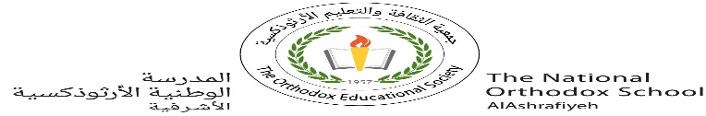

**Value*: The price of greatness is responsibility...***

The National Orthodox School

Science Worksheet

Name: Grade: 5(A+B)

Date: / /2022

***Unit 3: A Healthy Body and Vaccines***

* Sometimes, **germs** like bacteria and viruses get in our

bodies. This can make us sick.

* Our **immune system** helps us fight the germs. Then we get better, these germs can sometimes make us very sick.
* Scientists made **vaccines** to protect us from diseases by giving us immunity.

**Vaccines = Immunity**

|  |
| --- |
| So **Vaccines** are products that produce immunity to a specific disease by injecting them into our body  - **Vaccines** are made from the same germs that cause disease. But the germs in vaccines are either killed or weakened so they won't make you sick. |
|  |

**Vaccines are made in a many ways**.

|  |  |
| --- | --- |
| **Use part of the virus.** | **Use part of the bacteria.** |
| **Use dead virus.** | **Use live, weakened virus.** |

Unscramble these letters to find the words!

1. **AEYHTLH ____HEALTHY__________**
2. **EGRSM _____GERMS_________**
3. **SRIVU _____VIRUS_________**
4. **TBIECRAA ____BACTERIA__________**
5. **NUIEMM ______IMMUNE________**
6. **ECLL ________CELL______**

**- Read each statement and decide whether it is true or false.**

1- A vaccine activates our immune system without making us sick. _____T__

2- Vaccines often contain tiny amounts of dead or weakened viruses. ____T___.

3- The germs used in vaccines are not real germs. _F__

4- Measles and chicken pox diseases are caused by bacteria. ___ F __

5- Vaccines protect us against viruses only. __ F __

6- A vaccine’s main goal is to make people sick. _ F ___

7- Vaccination causes your body to react as if it had met a germ. _T___

8- Teeth cavities are tiny holes in your teeth caused by sugars and acids in your mouth. __ T ____

- How do white blood cells protect your body?

1 - ...They protect the body from germs.

2-......They attack and kill the germs that enter the body.

3- Some of the white blood cells eat up the germs.

- Name three disease that are caused by bacteria.

**1....Tooth cavity...........................**

**2...... Typoid.........................**

**3...........Cholera....................**