

**Flowchart**

**Python**

**Name: …………………. Grade / Section: ….**

**Date: …………………. 1st Semester 2022/ 2023**

1. **Write a program to calculate the Area and perimeter of a rectangle**

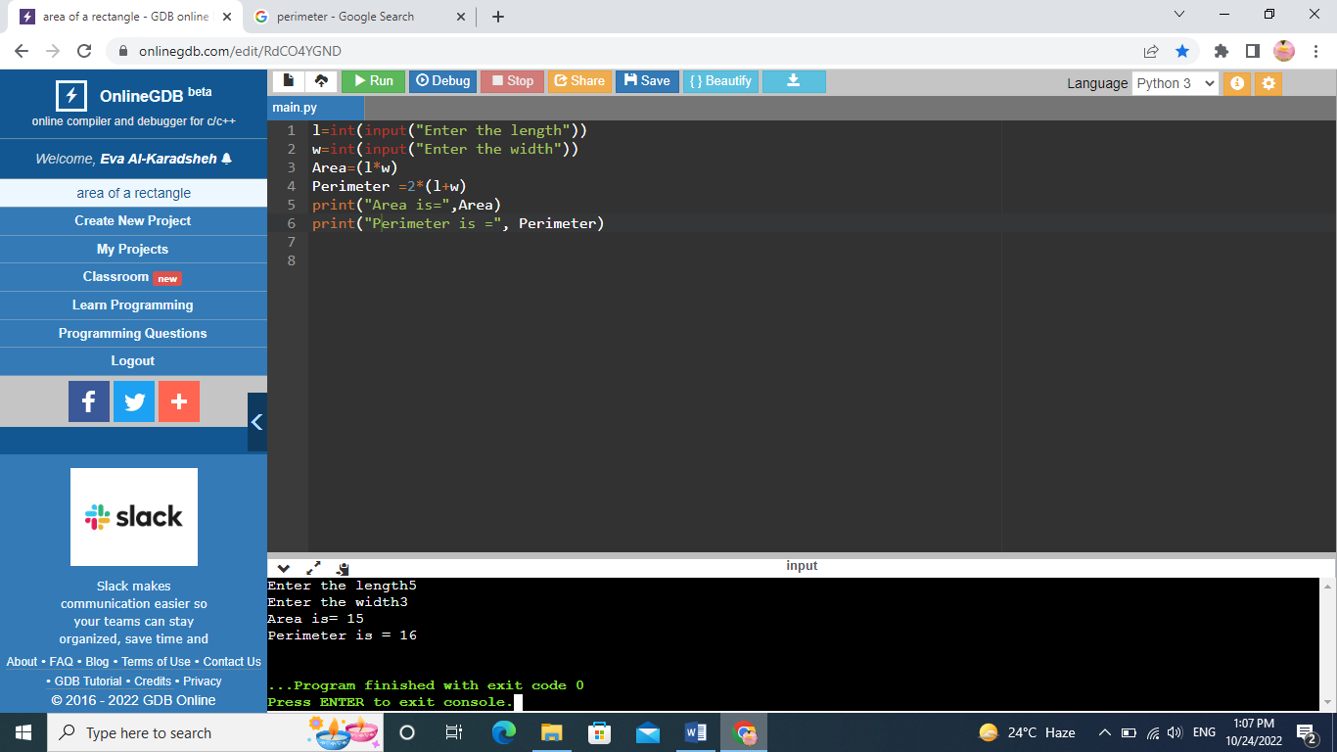

1. **Write a program to calculate the BMI (Body Mass Index).**

**BMI=W/(H*H)**

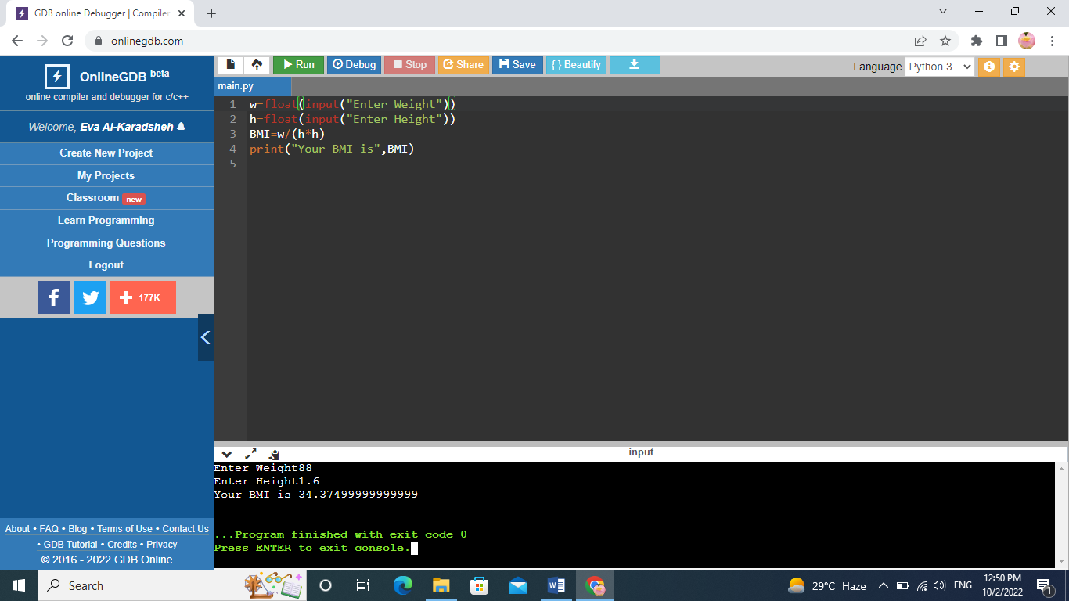

1. **Write a program to convert from Celsius to Fahrenheit degree and to Kelvin**

**k=c+273.15**

**f=1.8*c+32**

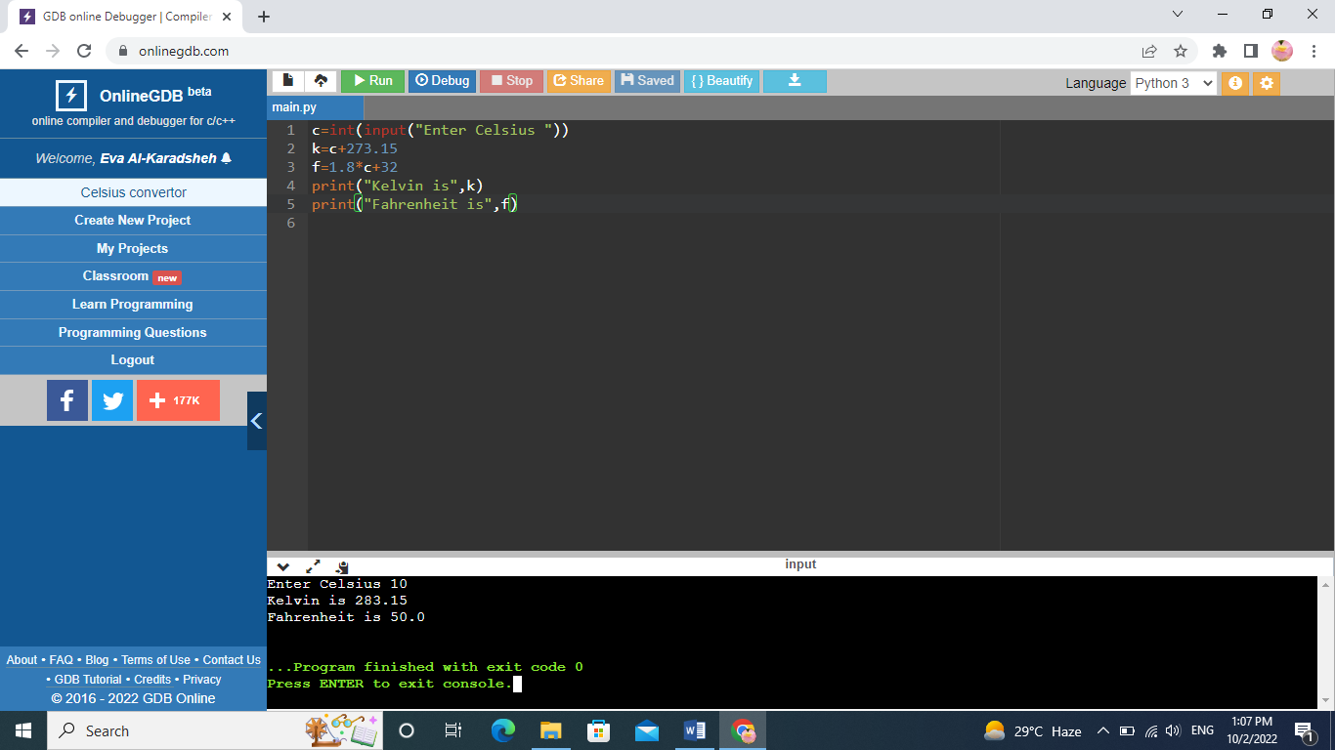

1. **Write a program to create a simple calculator (input 2 numbers and calculate the results.**

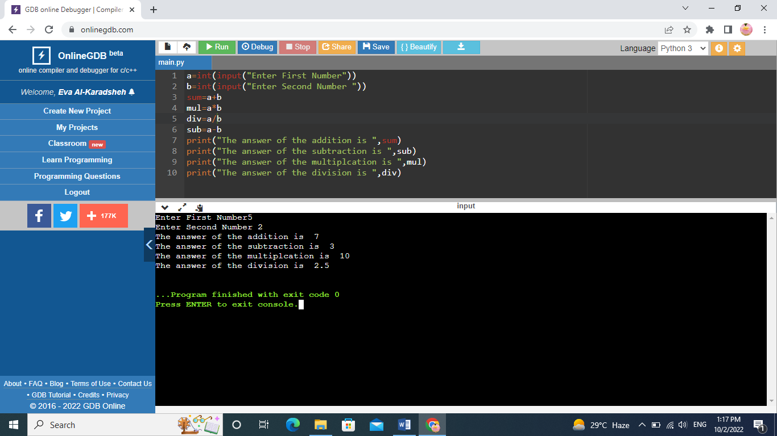

1. **Write a program to calculate the area and the perimeter of triangle**

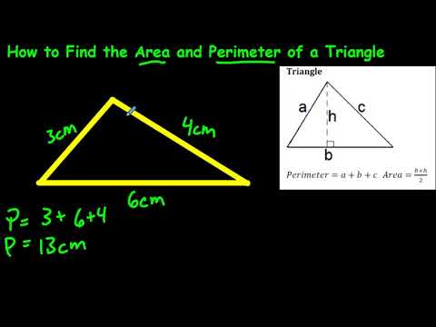

**P=a+b+c**

**Area=1/2*b*h**

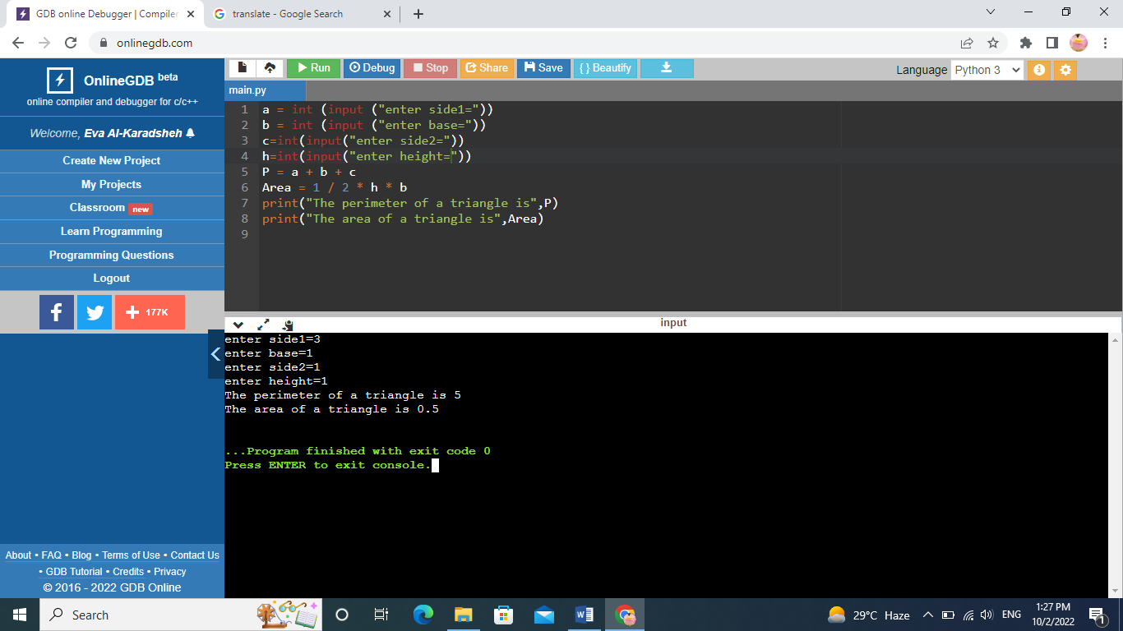

1. **Write a program to calculate the average of three numbers**

**Average=(a+b+c)/3**

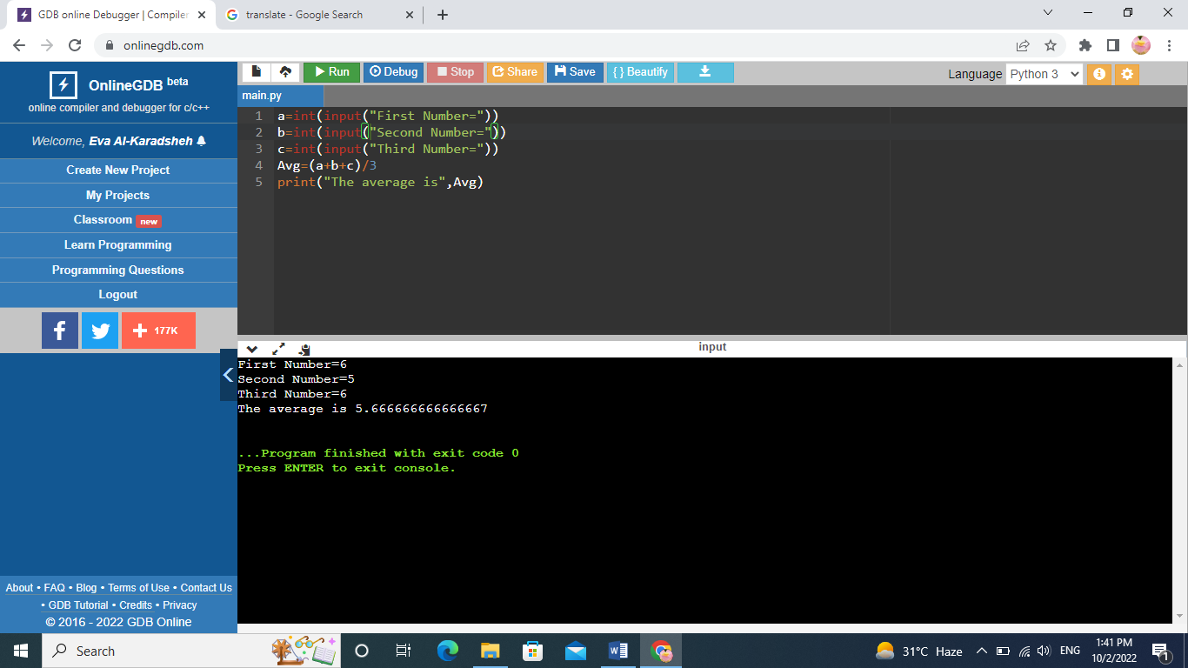

1. **Write a program to calculate the area of a circle**

**Area =3.14 *r2**

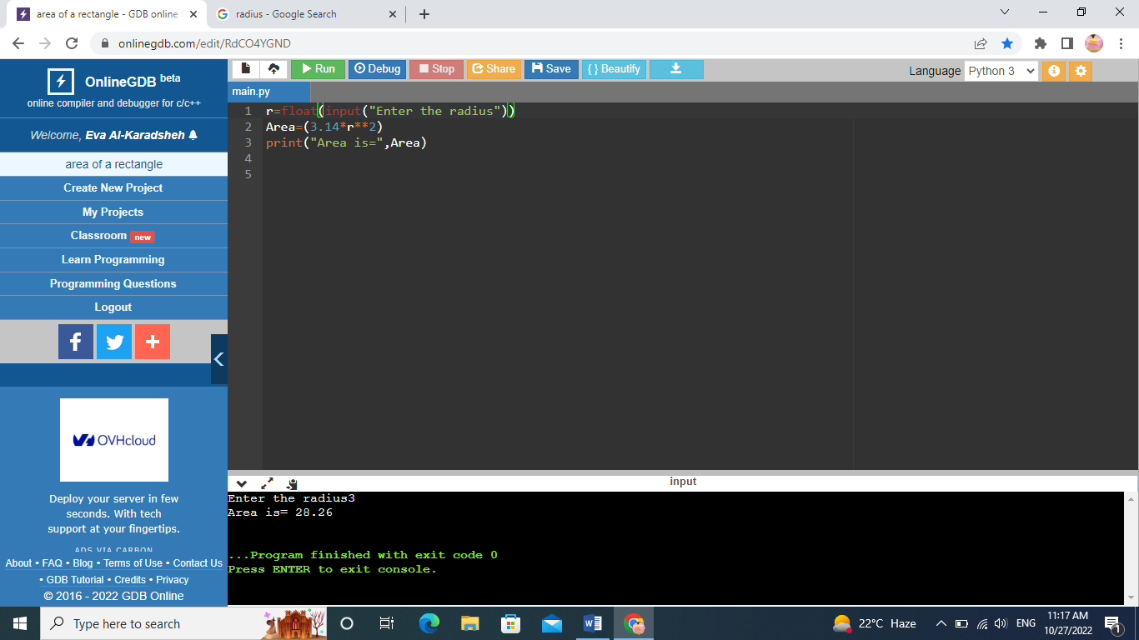

**R**2 🡺 R2**

**Example 32 🡺 3**2 = 9**

**Note: Resolve Question 2 using the indices (power) operator**

1. **Write a program that:**
   1. **Input your name.**
   2. **Print your name.**
   3. **Input your birthyear**
   4. **Calculate your age.**

