

**Our value: Self – belief and hard work will always earn you success**

**Present Continuous No. (7)**

Grade 5 (A + B)

Name: Date: / /

Objectives: To review Present Continuous tense form and use

To practise using this tense correctly.

Present Continuous Tense

|  |  |  |  |  |
| --- | --- | --- | --- | --- |
|  | Subject | | Verb to be |  |
| Affirmative | I  He / She/ It  We / You / They | | am  is  are | staying at home today. |
| Negative | I  He / She/ It  We / You / They | | am not  is not  are not | staying at home today. |
| Question | Am  Is  Are | | I  he/she/it  we/you/they | staying at home today? |
| Short answers | Yes, | I am  he/she/it is  we/you/they are | No, | I’m not.  He/she/it isn’t.  we/you/they aren’t. |

***\*\* Use the Present Continuous to talk about actions happening now, at the moment of speaking.***

We are having our pizza now so we can’t talk to you at the moment.

***\*\*Use phrases like at the moment and (right) now with the present continuous.***

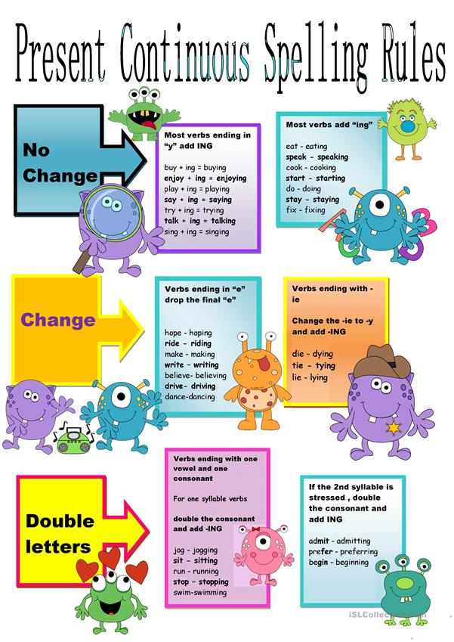

***Practice***

*1. Write sentences using present continuous tense.

1. George / shout

George is shouting.

2. Sarah / not sleep

Sarah is not sleeping.

3. He / dig up flowers

He is digging up flowers.

4. They / not write

They are not writing.

5. They / jog?

Are they jogging?

*2. Write the –ing form of these verbs.

1. Dig digging 7. Study studying

2. Make making 8. Swim swimming

3. Plan planning 9. Use using

4. Read reading 10. Wait waiting

5. Ride riding 11. Write writing

6. Sit sitting 12. Carry carrying

*3. Use the correct form of verb to be to complete each sentence.

|  |  |
| --- | --- |
| https://agendaweb.org/exercises/verbs/imaxes/present-continuous-I.jpg | I **am reading** a book. |
| https://agendaweb.org/exercises/verbs/imaxes/present-continuous-you-1.gif | You **are playing** football. |
| https://agendaweb.org/exercises/verbs/imaxes/present-continuous-he.gif | He **is** sleeping. |
| https://agendaweb.org/exercises/verbs/imaxes/present-continuous-she.gif | She **is** dancing. |
| https://agendaweb.org/exercises/verbs/imaxes/present-continuous-it.jpg | It **is** eating bamboo. |
| https://agendaweb.org/exercises/verbs/imaxes/present-continuous-we.gif | We **are** running. |
| https://agendaweb.org/exercises/verbs/imaxes/present-continuous-you-2.jpg | You **are** talking. |
| https://agendaweb.org/exercises/verbs/imaxes/present-continuous-they.jpg | They **are** walking. |
| https://agendaweb.org/exercises/verbs/imaxes/present-continuous-sister.gif | My sister **is** riding her bike. |
| https://agendaweb.org/exercises/verbs/imaxes/present-continuous-birds.gif | The birds **are** flying. |

*4. Choose the correct answer.

  
I _____ football.

|  |  |
| --- | --- |
|  | am playing |
|  | is playing |
|  | are playing |

  
He ____ video games.

|  |  |
| --- | --- |
|  | am playing |
|  | is playing |
|  | are playing |

  
It ____ golf.

|  |  |
| --- | --- |
|  | am playing |
|  | is playing |
|  | are playing |

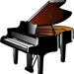  
You ____ the piano.

|  |  |
| --- | --- |
|  | am playing |
|  | is playing |
|  | are playing |
|  |  |

  
You _____ tennis.

|  |  |
| --- | --- |
|  | am playing |
|  | is playing |
|  | are playing |

  
She ____ rugby.

|  |  |
| --- | --- |
|  | am playing |
|  | is playing |
|  | are playing |

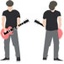  
We ____ the guitar.

|  |  |
| --- | --- |
|  | am playing |
|  | is playing |
|  | are playing |

  
They ____ basketball.

|  |  |
| --- | --- |
|  | am playing |
|  | is playing |
|  | are playing |

***Make Positive, negative, questions as in the example.***

Top of Form

|  |  |  |
| --- | --- | --- |
| drink / this man | | |
| https://agendaweb.org/exercises/verbs/imaxes/present-continuous-w-drink.jpg | https://agendaweb.org/exercises/verbs/imaxes/yes.gif | This man is drinking tea. |
| https://agendaweb.org/exercises/verbs/imaxes/no.gif | This man isn't drinking water. |
| https://agendaweb.org/exercises/verbs/imaxes/question.jpg | Is this man drinking wine? |
| have / I | | |
| https://agendaweb.org/exercises/verbs/imaxes/present-continuous-w-have.jpg | https://agendaweb.org/exercises/verbs/imaxes/yes.gif | **I am having** breakfast. |
| https://agendaweb.org/exercises/verbs/imaxes/no.gif | **I am not having** milk. |
| https://agendaweb.org/exercises/verbs/imaxes/question.jpg | **Am I having** cakes? |
| run / you | | |
| https://agendaweb.org/exercises/verbs/imaxes/present-continuous-w-run.jpg | https://agendaweb.org/exercises/verbs/imaxes/yes.gif | **You are running** alone. |
| https://agendaweb.org/exercises/verbs/imaxes/no.gif | **You are not running** fast. |
| https://agendaweb.org/exercises/verbs/imaxes/question.jpg | **Are you running** in the park? |
| fly / butterflies | | |
| https://agendaweb.org/exercises/verbs/imaxes/present-continuous-w-fly.jpg | https://agendaweb.org/exercises/verbs/imaxes/yes.gif | The butterflies **are flying**. |
| https://agendaweb.org/exercises/verbs/imaxes/no.gif | The butterflies **are not flying** high. |
| https://agendaweb.org/exercises/verbs/imaxes/question.jpg | **Are the butterflies flying** low? |
| look / we | | |
| https://agendaweb.org/exercises/verbs/imaxes/present-continuous-w-look.jpg | https://agendaweb.org/exercises/verbs/imaxes/yes.gif | **We are looking** for a shirt. |
| https://agendaweb.org/exercises/verbs/imaxes/no.gif | **We are not looking** for a hat. |
| https://agendaweb.org/exercises/verbs/imaxes/question.jpg | **Are we looking** for a tie? |
| rain / it | | |
| https://agendaweb.org/exercises/verbs/imaxes/present-continuous-w-rain.jpg | https://agendaweb.org/exercises/verbs/imaxes/yes.gif | **It is raining** in London. |
| https://agendaweb.org/exercises/verbs/imaxes/no.gif | **It is not raining** in Madrid. |
| https://agendaweb.org/exercises/verbs/imaxes/question.jpg | **Is it raining in** Paris? |

Bottom of Form

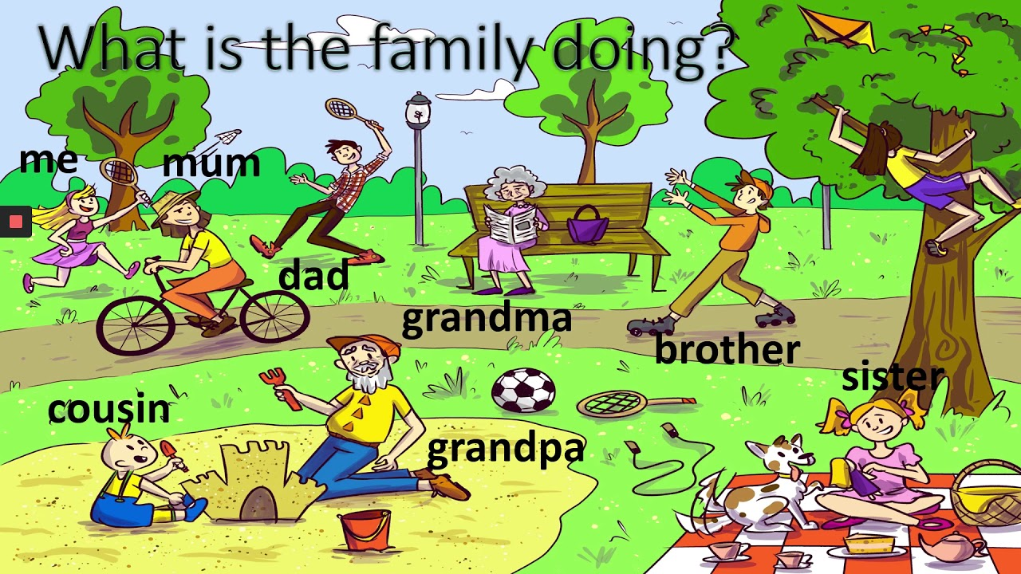

Teacher: Mirna Nawaf Al-Sahawneh.