

**Python - Study Sheet**

**Name: …………………. 7th Grade / Section: _____**

**Date: …………………. 1st Semester 2022/ 2023**

**Program**

Program is a set of stored instructions. When the computer reads the instructions it carries out the actions.

**Python is a programming Language**

Python is a text-based programming Language, the commands in Python are text.

**The Python Shell**

When you start Python, a window opens. This is called the Python Shell. You can enter Python commands one at a time into the Python Shell.

When you have typed a command, press the “Enter” key. Python will carry out the command.

**What is a variable?8**

* ****A variable is a location in memory in which you can temporarily store a value (text or numbers).

Variable = value

**Examples**

Number1 = 5 (Numeric variable)

St_name= ”Farah” (String(text) variable)

**Data Types**

The computer can save different types of data:

* **String data**

String data can include any keyboard characters.

Some strings are made of digits. They look like numbers, but they are not number values.

String data cannot be used in calculations.

Name = “Dana”

National_num = “0125866458”

* **Numeric data**

Includes numeric data ex- integer data

You can convert any variable to integer using the int – function.

Examples:

A=25

A= int(A)

**Rules of naming variables in Python**

A variable name must:

* be one word only – no spaces
* use only letters, numbers and the underscore character
* Start with a letter.

Example

|  |  |  |
| --- | --- | --- |
| **Common Mistakes** | | **Correct ones** |
| Number 1 = 6 | Space is not allowed | Number1 = 6 |
| 1Num = 8 | Should Start with a letter – not a number | Num_1 = 8 |
| Emp name = Lana | Space is not allowed  And  **“ “** must be used for **text** | Emp_Name = **“**Lana**”** |

**Python-Program #1**

Write a python program to add and print the total of two numbers.

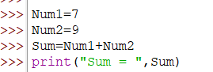

Inputs: Num1, Num2

Process: Sum=Num1+Num2

Output: Sum = 16

***Note: The command print must be in small letters***

**Python-Program #2**

Write a python program to calculate and print the average of three numbers.

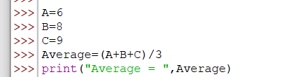

Inputs: A, B, C

Process: Average=(A+B+C)/3

Output: Average = 7.66

**Get Input**

In this part the Python program asks the user to input values for variables.

To get user input in Python we use the command **input**.

Examples:

The user must input his name and the computer will save it in the variable name

* name = input (“what is your name? “)

String variable

The user must input a number and the computer will save it in the variable length as a number.

* length = int (input (“input length”)

Numeric variable

**int – it’s an abbreviation of integer which convert the text into a number.**

**Python-Program #3**

Write a python program to input the length and width of a rectangle and then calculate and print the area of the rectangle.

L – Length / W – Width / A – Area A = L*W

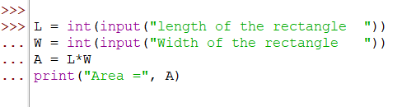

Inputs: L, W

Process: Area = L * W

Output: print Area

**Error messages**

Programmers sometimes make mistakes. A simple typing error can stop your program working. Text color can help you to find errors before you run the program.

But sometimes errors remain when you run the program. That is OK. Python will find the mistake. It will stop the program and show you an error message.

**Python’s error message will help you to work out what the error is.**

* print(hello)
* Print(“Smart”)
* A= Int(A)