

**Our value: Self – belief and hard work will always earn you success**

**Present Simple No (6)**

Grade 5 (A + B)

Name: Date: / /

Objectives: To review simple present tense form and use.

To practise using this tense correctly.

Simple Present Tense

|  |  |  |  |
| --- | --- | --- | --- |
|  | Subject | Main Verb |  |
| Affirmative | I/We/ You/ They  He/ She/ It | go  goes | to bed early. |
| Negative | I/We/ You/ They  He/ She/ It | don’t go  doesn’t go | to bed early. |
| Question | Do | I/you/ we/ they go | to bed early? |
| Does | he/ she/ it go | to bed early? |
| Positive Short Answer | Yes, I/ we/ you/ they do.  Yes, he/ she/ it does. | | |
| Negative Short Answer | No, I/ we/ you/ they don’t.  No, he/ she/ it doesn’t. | | |

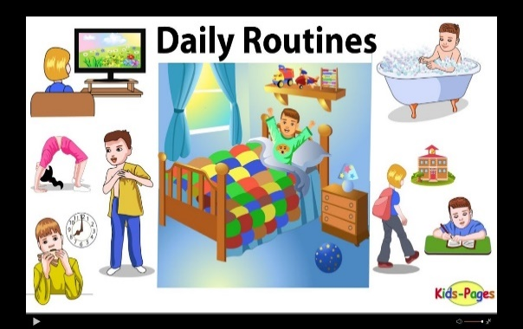**\*\* Use the Present Simple for:**

1. **Daily routine:**

I go to school every day.

Every morning, he wakes up, washes his face and brushes his teeth.

1. 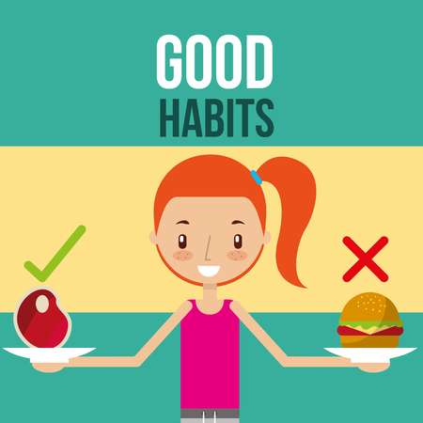**Habits: Use adverbs of frequency: (always, usually, sometimes, often, hardly ever, never)**

I always go to the park on Sundays.

I often go to the cinema.

He doesn’t usually like going to bed early.

* They are used before main verbs but after verb to be .

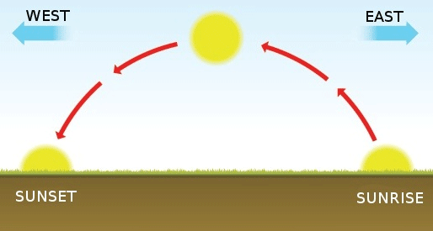He **always** goes to school.

He is **always** late.

1. **Facts:**

The sun rises from the east.

**Spelling Rules

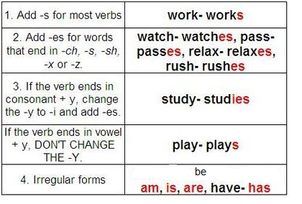

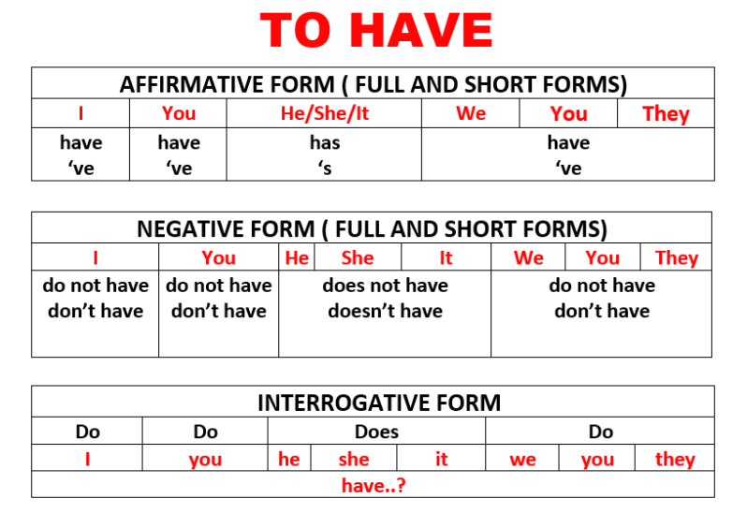

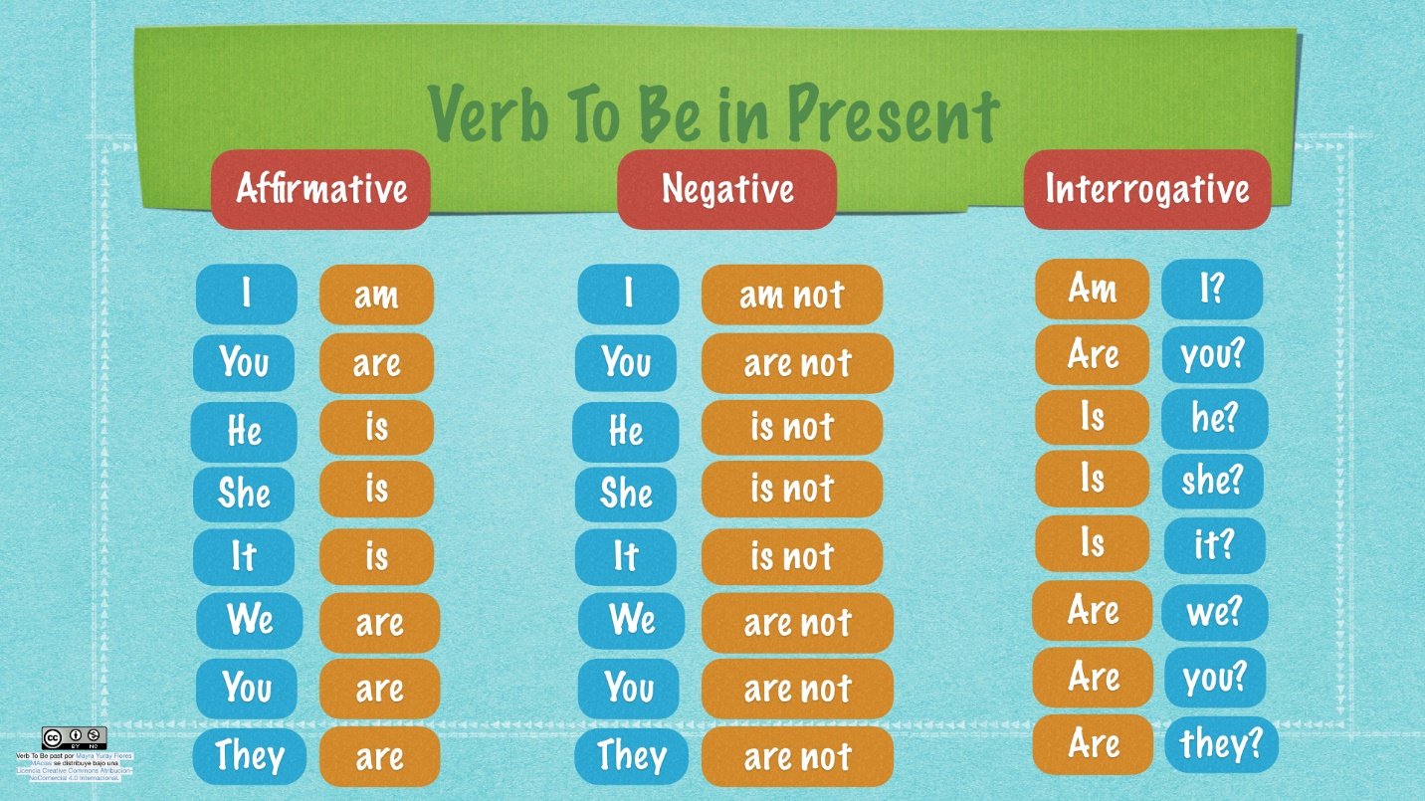

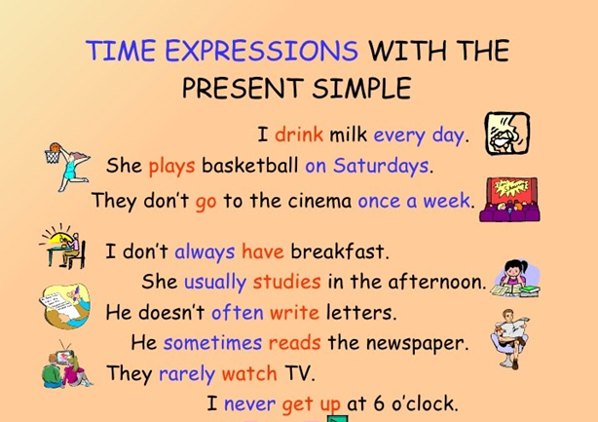

***Practice***

*1. Complete the sentences with the correct form of the verbs in the box:

Clean - have - help - play – speak - wash - watch - is

1. My mother cleans our house on Fridays.
2. The teacher speaks in English in class.
3. Jake washes his hair every morning.
4. John watches DVDs on his laptop computer.
5. Sarah helps her little sister with her homework.
6. My brothers play football every evening.
7. They have dangerous jobs.
8. She is a teacher.

*2. Change the following sentences to negative:

1. She likes apples. She doesn’t like apples.

2. He listens to CDs. he doesn’t listen to CDs.

3. Jonathan and Emma work on their computer. Jonathan and Emma (They) don’t work on their computer.

4. My friend and I talk on the phone. My friend and I (We) don’t talk on the phone.

5. Sam sings in his car. Sam doesn’t sing in his car.

*3. Change the following sentences to questions:

1. You work every day. Do you work every day?

2. She likes her work. Does she like her work?

3. Your parents watch TV every night. Do your parents watch TV every night?

4. I talk in my sleep. Do I talk in my sleep? /// Do you talk in your sleep?

5. The sharks eat every day. Do the sharks eat every day?

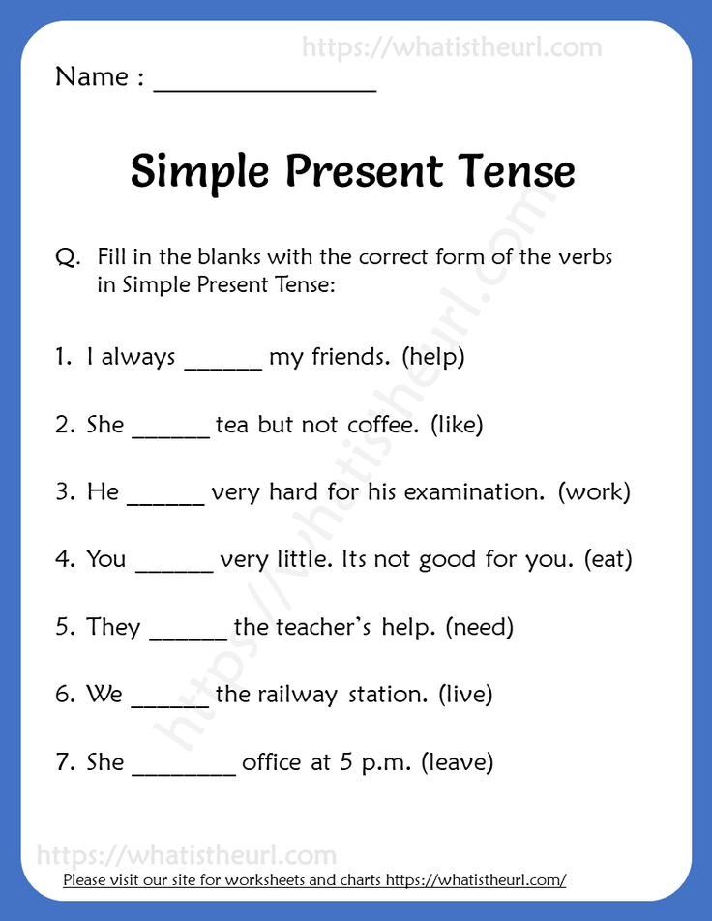

leaves

live

need

eat

likes

works

help

**5. Order the words to make sentences

1. week. /every / plays / tennis / She

She plays tennis every week.

2. Sundays / work / don’t / on/ I

I don’t work on Sundays.

3. work / doesn't/ evening /Sally/ the/ in

Sally doesn’t work in the evening.

Teacher: Mirna Nawaf Al- Sahawneh.

Coordinator’s Signature: ------------------