

Practice Paper Unit ( 5 )

The breakfast quest

Grade (4)

Name: Date: / /2022

|  |
| --- |
| **Objectives:**  1. To identify the meaning of the new words.  2. To identify the synonym of the new words.  3. To use the new words in meaningful sentences. |

|  |  |  |
| --- | --- | --- |
| **Verbs** | **Meaning** | **Synonym** |
| Gather | To bring different things together into one place.  **Example**:  I **gather** two brown eggs and one chicken from the farm. | Bring together / collect |
| Introduce | To present something or someone to another person.  **Example:**  Let me introduce myself, I’m Peter. | Present . |

|  |  |  |
| --- | --- | --- |
| Peel | To remove the skin off fruits or vegetables .  **Example**:  My sister was able to **peel** an apple when she was 7 years old. | Remove |
| Coax | To get  **Example**:  He wants to **coax** the ingredients onto a steamship. | Get |
| Hop | To jump  **Example:**  I **hop** on my bike and ride it across the town. | Jump |
| Roll | To turn over.  **Example:**  Dogs usually **roll** on the green field in the park. | Turn over |
| Explain | To make things clear.  **Example:**  I need to **explain** what happened to him. | Clear |
| Spill | To fall from a container.  **Example**:  Don't pour too much, it might **spill** over. | To fall |

|  |  |  |
| --- | --- | --- |
| **Nouns** | **Meaning** | **Synonym** |
| Ingredients | The food that is needed to prepare something.  **Example**:  What ingredients do you need to make pancakes? | Material |
| Bark | The hard surface of a tree.  **Example:**  We think that **bark** could be used as a paper. | Outside of a tree. |
| Plantation | A large farm used for growing plants.  **Example:**  Let me take you to my friend’s plantation. | Large farm |
| Steamship | A large ship powered by steam.  **Example:**  The steamship is coming towards the port. | Large ship |
| Coop | A cage for small animals**.**  **Example:**  We went to see the chicken’s coop with the farmer yesterday. | Cage |
| Pail | Bucket  **Example:** How many pails of water do you need? | bucket |
| Wheat | Grain  **Example**: Most bread is made from wheat. | Grain |

|  |  |  |
| --- | --- | --- |
| **Adjective** | **Meaning** | **Synonym** |
| Smooth | Soft  **Example:**  I gathered two smooth eggs. | Soft |
| Nervous | Not calm.  **Example:**  I get very nervous before a big race. | Not calm |
| Sly | Not to be trusted.  **Example:**  Her sly smile told me that it was all a joke. | Tricky |
| Enormous | Very big  **Example:**  We found an enormous, sleepy cow in the field. | Very big. |
| Magnificent | Wonderful  **Example:**  You've all done a **magnificent** job. | wonderful |

**Q1) Order the words to make meaningful sentences.**

1. making – I’m – special-today- a- breakfast.

**I’m making a special breakfast today .**

1. The – best- I –know- butter- from- comes-Denmark.

**The best butter I know comes from Denmark.**

**Q2) Match each word with its synonym.**

**1.Nervous a. jump**

**2. magnificent b. grain**

**3. wheat. c. to fall**

**4. spill d. wonderful**

**5. hop e. not calm**

**f. tricky**

|  |
| --- |
| 1.---e-- 2.----d----3.---b ---- 4.-----c---5.-----a--- |

**Q3) Write the correct word under each picture.**

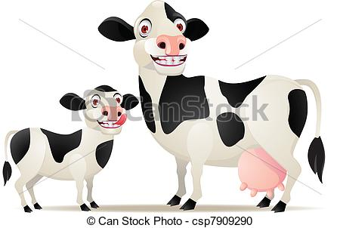

1. 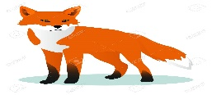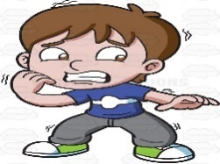2. 2. 3.

Not calm/ nervous Enormous/ very big Sly

1. 5. 6.

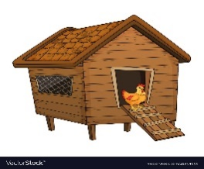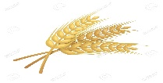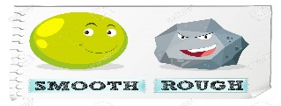

smooth Wheat / grain coop / cage

**Q3) Complete the sentences using the words in the box.**

|  |
| --- |
| enormous , smooth , slyly , spoil , explain , nervous |

1. He was very **nervous** before the show.
2. He smiles **slyly.**
3. He has an **enormous** cow.
4. Can you **explain** what does this word means?
5. Some kind of food will **spoil** soon.

Teacher: Raneem Haddad.

Coordinator’s Signature:___________