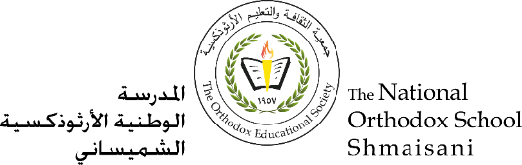

**The Primary Stage of Grades (4-5)**

**School Year 2022 – 2023**

**Name** : ___________ **Subject** : Comprehension Practice key

**Date : / / Class : Grade 4 CP (All Sections )**

**_____________________________________________________________**

**Objective/s :** To read a text and answer comprehension questions.

-**Read the following passage then answer the questions**

**HUMMINGBIRDS**

1. Why are they called hummingbirds?

They make a buzzing noise when they fly.

1. How do hummingbirds eat?

They use their tongues for eating. They flick their tongues in and out of their mouths while inside of flowers. They lap up nectar.

1. How do hummingbirds help flowers?

Hummingbirds help pollen get from one flower to the next. This helps flowers make more seeds.

1. According to the text, what does the Bee hummingbird use to make a nest?

They use cobwebs and bits of bark to make their nests.

5- Which statement about Bee hummingbirds is **not true**.

a. Bee hummingbird eggs are smaller than peas.

b. Bee hummingbirds weigh less than a penny.

c. Bee hummingbirds have built nests on clothespins.

d. Bee hummingbirds do not grow larger than bees.

6- Why does the hummingbird have to eat so often? Refer to the text to support your answer.

Hummingbirds move fast. It takes lots of energy to move as fast as they do. This means that they need to eat a lot of food.

7- Write two facts you learned about hummingbirds.

Students’ answers

8- The underlined word “**hover”** means:

Stay in one spot in the middle of the air

9- The underlined word “**nectar”** means:

A sweet liquid inside of some flowers.

10- Find a word in the fourth paragraph that means “**very small**”: _____tiny_____

11- Tick (√) two statements that are true about the text:

1. It is written in the first person

√

1. It is written in the third person

√

1. It uses the present tense
2. It uses the past tense