**The National Orthodox School / Shmaisani**

**Subject: Biology Quiz**

**Name:**

**Date:** **Grade 9 IB**

Question 1 :

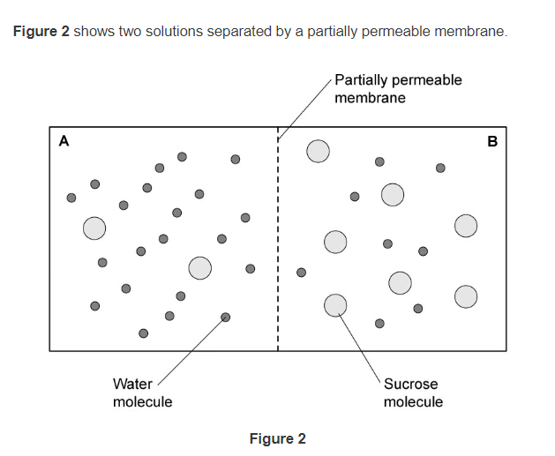

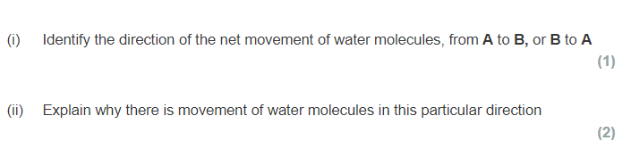

**Solution A has a high concentration of water , solution B has a low concentration of water , water moves by osmosis from a highly concentrated solution (with water )to a lower concentrated solution (with water) through a partially permeable membrane.**

