

**Our value: Self – belief and hard work will always earn you success**

**Present Simple No (6)**

Grade 5 (A + B)

Name: Date: / /

Objectives: To review simple present tense form and use.

To practise using this tense correctly.

Simple Present Tense

|  |  |  |  |
| --- | --- | --- | --- |
|  | Subject | Main Verb |  |
| Affirmative | I/We/ You/ They  He/ She/ It | go  goes | to bed early. |
| Negative | I/We/ You/ They  He/ She/ It | don’t go  doesn’t go | to bed early. |
| Question | Do | I/you/ we/ they go | to bed early? |
| Does | he/ she/ it go | to bed early? |
| Positive Short Answer | Yes, I/ we/ you/ they do.  Yes, he/ she/ it does. | | |
| Negative Short Answer | No, I/ we/ you/ they don’t.  No, he/ she/ it doesn’t. | | |

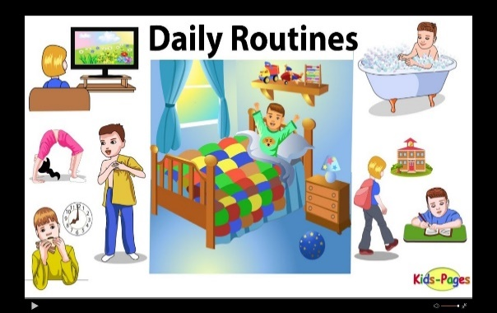**\*\* Use the Present Simple for:**

1. **Daily routine:**

I go to school every day.

Every morning, he wakes up, washes his face and brushes his teeth.

1. 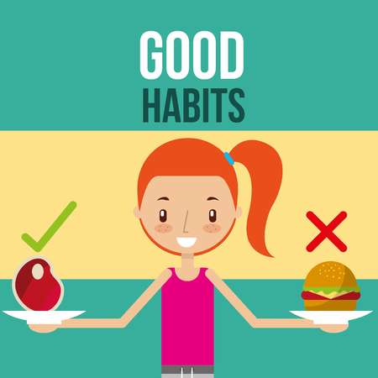**Habits: Use adverbs of frequency: (always, usually, sometimes, often, hardly ever, never)**

I always go to the park on Sundays.

I often go to the cinema.

He doesn’t usually like going to bed early.

* They are used before main verbs but after verb to be .

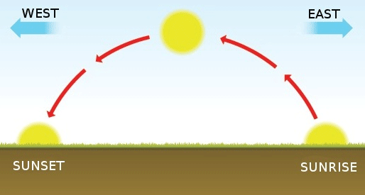He **always** goes to school.

He is **always** late.

1. **Facts:**

The sun rises from the east.

**Spelling Rules

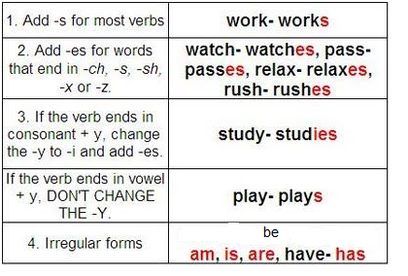

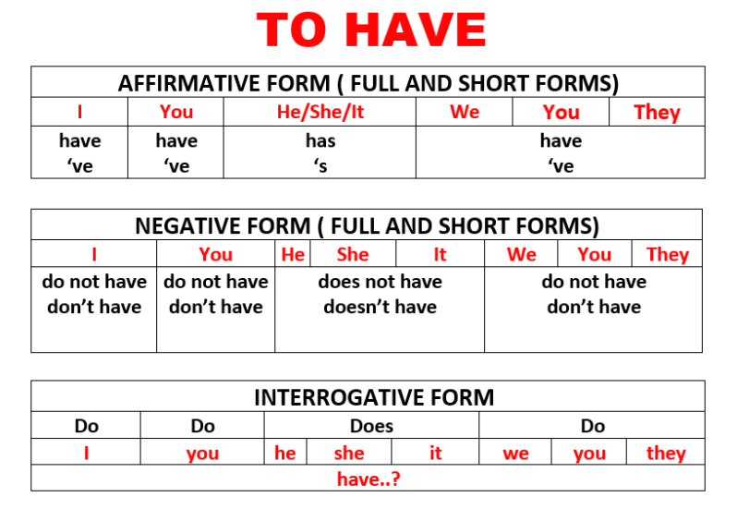

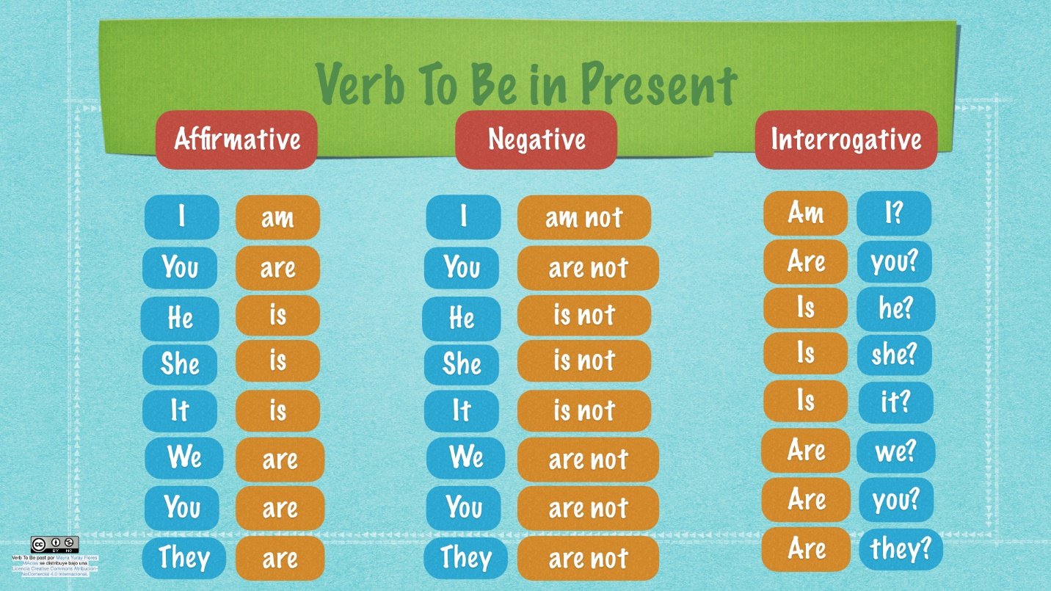

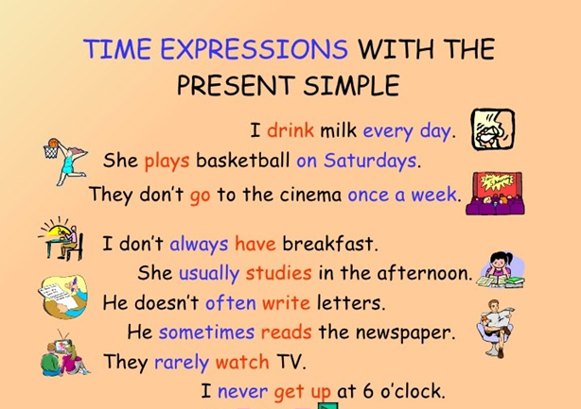

***Practice***

*1. Complete the sentences with the correct form of the verbs in the box:

Clean - have - help - play – speak - wash - watch - is

1. My mother ------------ our house on Fridays.
2. The teacher ---------------- in English in class.
3. Jake --------------- his hair every morning.
4. John ------------- DVDs on his laptop computer.
5. Sarah ---------------- her little sister with her homework.
6. My brothers --------------- football every evening.
7. They --------------- dangerous jobs.
8. She ----------- a teacher.

*2. Change the following sentences to negative:

1. She likes apples.

-----------------------------------------------------------

2. He listens to CDs.

----------------------------------------------------------

3. Jonathan and Emma work on their computer.

----------------------------------------------------------

4. My friend and I talk on the phone.

----------------------------------------------------------

5. Sam sings in his car.

----------------------------------------------------------

*3. Change the following sentences to questions:

1. You work every day.

---------------------------------------------------------

2. She likes her work.

---------------------------------------------------------

3. Your parents watch TV every night.

---------------------------------------------------------

4. I talk in my sleep.

----------------------------------------------------------

5. The sharks eat every day.

----------------------------------------------------------

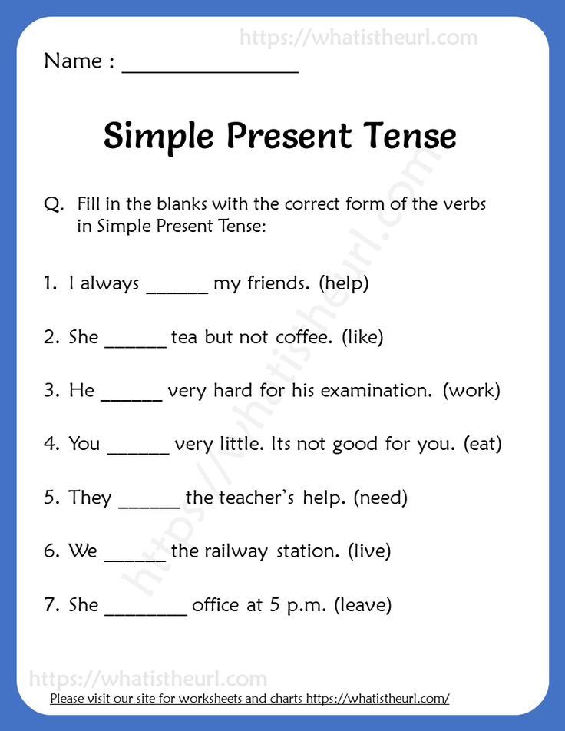

**5. Order the words to make sentences.

1. week every. / plays / tennis / She

------------------------------------------------------------

2 Sundays / work / don’t / on/ I

----------------------------------------------------------------

3 work / doesn't/ evening /Sally/ the/ in

----------------------------------------------------------------

Teacher: Mirna Nawaf Al- Sahawneh.

Coordinator’s Signature: ------------------