

**Reported Speech**

**Grade9 ( A + B )**

**Name: Date : /10 /2022**

**Objectives: To learn how to reported Statements and Commands.**

**To practise reporting statements and commands .**

## When we report someone’s words we can do it in two ways. We can use direct speech with quotation marks (*“I work in a bank”*), or we can use reported speech (*He said he worked in a bank*.) In reported speech the tenses, word-order and pronouns may be different from those in the original sentence.

## Reported statements Present simple and present continuous tenses

* **Direct speech**:*“I* ***travel*** *a lot in my job.”(****present )***
* **Reported speech**:*He said that he* ***travelled*** *a lot in his job.****(past*** *)*
* **Direct speech**:*“The baby’s sleeping.”****(present continuous)***
* **Reported speech**:*She told me that the baby was sleeping****.(past continuous )***

**Past simple and past continuous tenses**

* **Direct speech**:*“We* ***lived*** *in China for 5 years.”****(simple past)***
* **Reported speech**:*She told me that they* ***had lived*** *in China for 5 years****.(past perfect)***

.

* **Direct speech**:*“I* ***was walking*** *down the road when I* ***saw*** *the accident.”****(past******continuous )***
* **Reported speech**:*He told me that* ***he’d been walking*** *down the road when* ***he’d seen*** *the accident****.(past perfect continuous )***

**Perfect tenses**

* **Direct speech**:*“They* ***have always******been*** *very kind to me”.****(present perfect)***
* **Reported speech**:*She said that* ***they had always been*** *very kind to her.****(past******perfect)***
* **Direct speech**:*“They* ***had already eaten*** *when I arrived”(****past perfect*** *)*
* **Reported speech**:*He said that* ***they had already eaten*** *when he’d arrived.(****past perfect )***

## Reported Commands

There is **no backshift of tenses with commands** in Reported Speech.

### Form

* affirmative commands → **to** + **infinitive**
* negative commands → **not** + **to** + **infinitive**

#### 1. Affirmative commands

* Direct Speech → Dad: “Do your homework.”
* Reported Speech → Dad **told** me **to** **do** my homework.

#### 2. Negative commands

* Direct Speech → Teacher: “Do**n't** talk to your friend.”
* Reported Speech → The teacher **told** me **not** **to** **talk** to my friend.

**Modals in reported speech**

* When there is a modal verb in the original statement, suggestion, etc., this sometimes changes when we report what was said.

|  |  |
| --- | --- |
| **Modal verb in original** | **Modal verb in report** |
| could, would, should, might, ought to | could, would, should, might, ought to |
| will, can, may | would, could, might |
| shall | should |
| must(necessary)  must(conclude)  mustn’t | must or had to  had to  mustn’t |

# CHANGING TIME AND PLACE REFERENCES

Time and place must often change when going from direct to reported speech.

| **Phrase in direct speech** | **Equivalent in reported speech** |
| --- | --- |
| **today** | **that day** |
| "I saw him **today,**" she said. | She said that she had seen him **that**  **day**. |
| **yesterday** | **the day before** |
| "I saw him **yesterday,**" she said. | She said that she had seen him **the day before**. |
| **The day before yesterday** | **two days before** |
| "I met her**the day before yesterday,**" he said. | He said that he had met her **two days before**. |
| **Tomorrow** | **the next/following day** |
| "I'll see you **tomorrow,**" he said | He said that he would see me **the next day**. |
| **The day after tomorrow** | **in two days time/ two days later** |
| "We'll come **the day after tomorrow,**" they said. | They said that they would come **in two days time/**  **two days later**. |
| **Next week/month/year** | **the following week/month/year** |
| "I have an appointment **next week,**" she said. | She said that she had an appointment **the following**  **week**. |
| **Last week/month/year** | **the previous/week/month/year** |
| "I was on holiday **last week,**" he told us. | He told us that he had been on holiday **the previous**  **week**. |
| **Ago** | **Before** |
| " He saw her **a week ago,**” he said. | He said that he had seen her **a week before**. |
| **this (for time)** | **That** |
| "I'm getting a new car **this week,**" she said. | She said that she was getting a new car **that week**. |
| **this/that (adjectives)** | **The** |
| "Do you like **this shirt**?" he asked.  ‘I will meet you this week ,’he said . | He asked if I liked **the shirt**.  He said that he would meet me that week . |
| **Here** | **There** |
| He said, "I live **here.**" | He told me he lived **there**. |

## *****RULES FOR THE CHANGE OF PRONOUN IN INDIRECT SPEECH*****

* 1. First person pronoun in reported speech i.e. I, we, me, us, mine, or our, is changed according to the pronoun of reporting verb if pronoun in reporting verb is third person pronoun i.e. he, she, it, they, him, his, her, them or their.

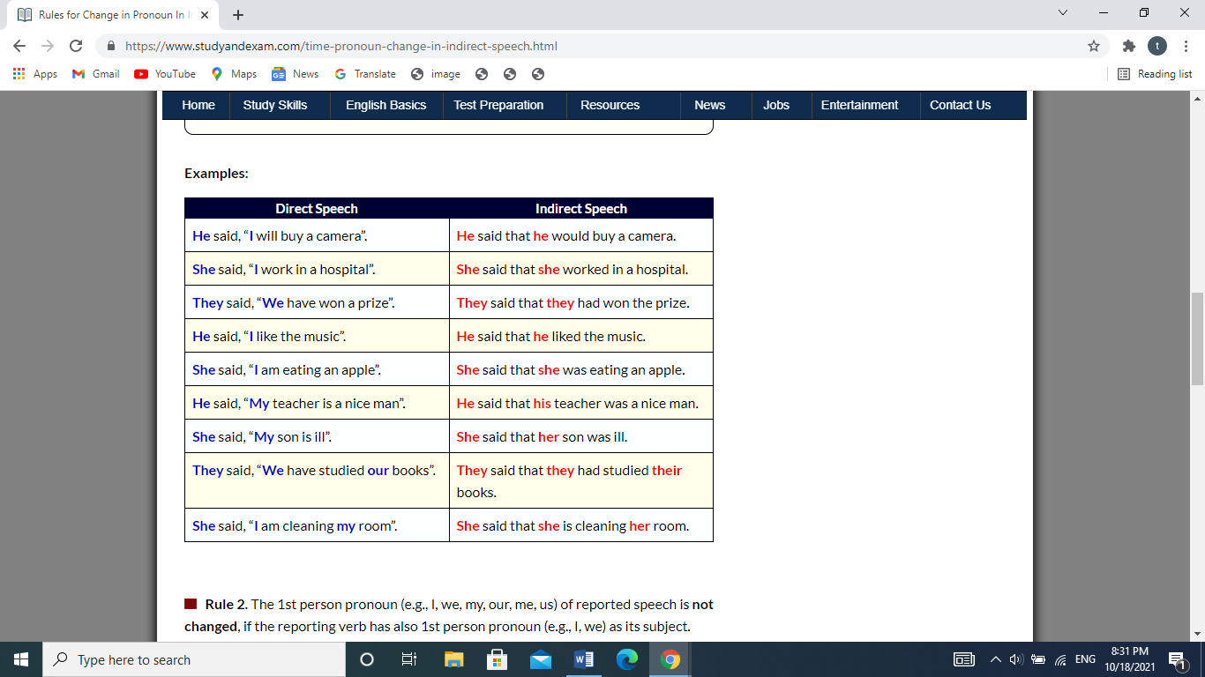

         

* 1. First person pronoun in reported speech i.e. I, we, me, us, mine, or our, is not changed if the pronoun (Subject) of reporting is also first person pronoun i.e. I or we.

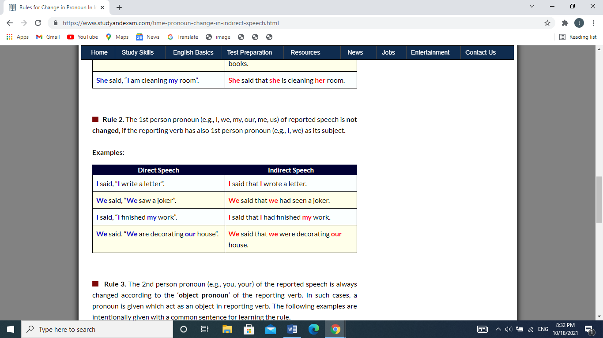

3. Second person pronoun in reported speech i.e. you, yours is changed according to the person of object of reporting verb.

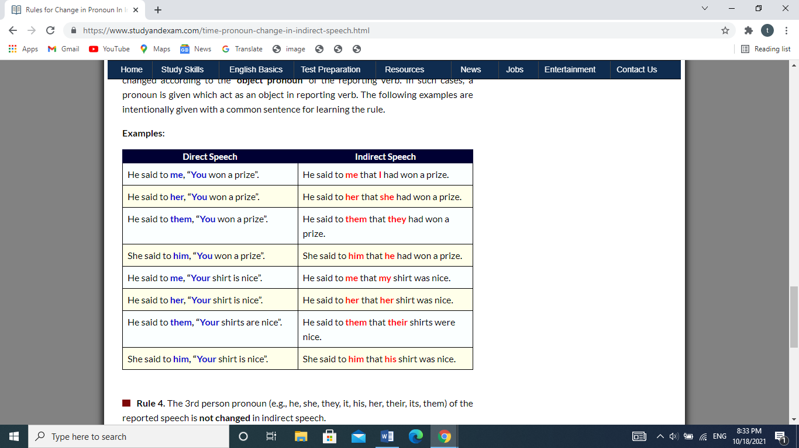

4-Third person pronoun in reported speech i.e. he, she, it, they, him, his, her, them or their, is not changed in indirect speech.

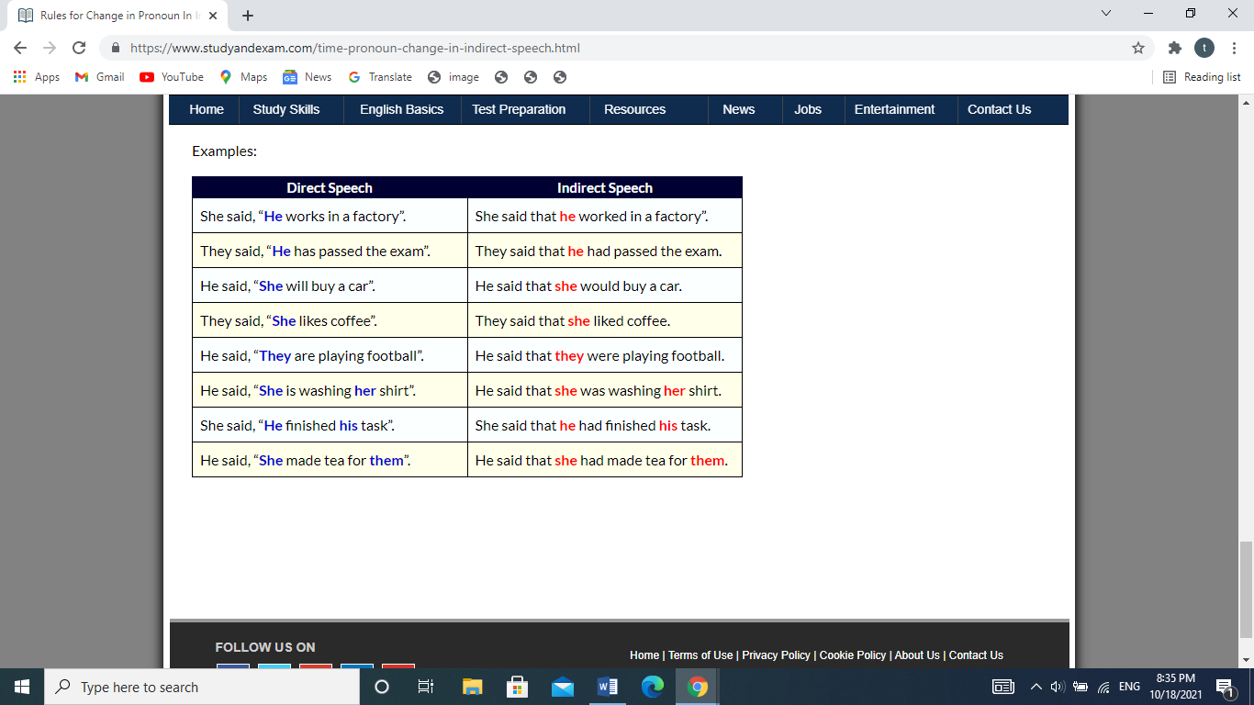

.

**Exercises**

**Report these statements:**

1. John said, "Mandy is at home."  
   John said (that) ……………………………………………………….
2. Susan said,"I'm watching TV now."  
   Susan said to me (that) …………………………………………………….
3. Simon said, "David was ill."  
   Simon said (that) …………………………………………………………..
4. Peggy said, "The girls helped in the house two days ago."  
   Peggy said (that) ………………………………………………………..
5. Richard said , "I am going to ride a skateboard."  
   Richard said (that)……………………………………………………
6. Stephen and Claire said , "We have cleaned the windows."  
   Stephen and Claire said (that )…………………………………………
7. Charles remarked , "I didn't have time to do my homework yesterday."  
   Charles remarked (that)…………………………………………………..
8. Mrs Jones said , "My mother will be 50 years old tomorrow."  
   Mrs Jones told me (that )………………………………………………….
9. Jean said , "The boss must sign the letter."  
   Jean said (that) ……………………………………………….

**Report these commands**

1. Karen: "Don't play football in the garden!"  
   Karen told me ………………………………………………….……..
2. Teacher: "Don't forget your homework!"  
   The teacher reminded us ……………………………………….……
3. Mike: "Don't shout at Peter!"

Mike told Sam ………………………………………………….…….

1. Andrew: "Clean your blue bike!"  
    Andrew told me …………………………………………………….
2. Jessica: "Write a text message!"  
    Jessica told Ray ………………………………………………………...
3. Nelly: "Help Peter's sister!"  
    Nelly told me …………………………………………………………..

Taroub Massarweh Coordinator Signature--------------

Ghazi Abu AlSha’ar