Get moving!



**A: A growing problem**



In many countries, an increasing number of young people and adults are overweight or even obese. One reason for this is the growing popularity of fast food, which didn’t use to be as common as it is now.

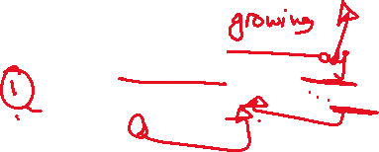

(1) Another big factor is lack of exercise. People would often walk to school or work, but these days many more of us drive. Modern technology has also played its part; we spend more and more time focusing on computer screens. Before the Internet was invented, nobody had dreamt of online shopping, but now we can buy almost anything without leaving the sofa.

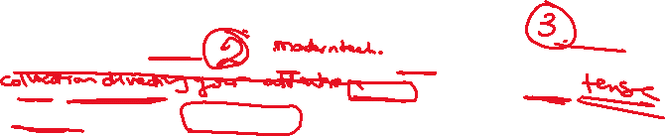

**B: Time to listen**

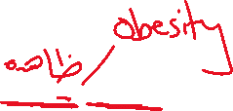

Health experts have been warning about this trend for years, and their advice is clear. Adults should aim to exercise for at least two and a half hours every week; for children and teenagers the target should be at least an hour a day. This might not sound very much. However, recent research shows that less than 50% of the British population manages this. (2) School children are less physically active than they used to be. Girls in particular often dislike PE. This can lead to serious health problems.

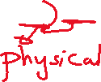

**C: It’s good for you!**

Experts recommend a mixture of activities. These should include moderate exercise, such as fast walking, and more strenuous exercise, like running. (3) They also advise exercise that strengthens the muscles, for example sit ups. The more muscle we build, the more calories we burn, and the fitter we become. In addition, exercise is a great way to cope with stress. In a recent study, patients who had been suffering from depression reported a great improvement after increased physical activity.

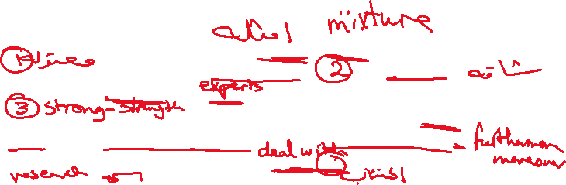

**D: Useful Tips**

Of course, this raises a question: how can I manage to fit in all this extra exercise? The best way is to build it into our daily lives so that it becomes a routine. (4) It doesn’t have to take much extra time. You could get off the bus one stop earlier than usual, or stand up when you’re on the phone! Most importantly, we should find a sport that we enjoy doing. That way, we will all become fitter, healthier and happier.

