Vocabulary | Grammar
1 Match the phrases in the table with | 3 Complete the sentences with the correct
the correct meanings. One word is not | form of the phrases in the box. Two
needed. The fi rst one is done for you. | phrases are needed twice. The first one is
acupuncture homoeopathy ailment | done for you.
acupuncture homoeopathy ailment | be used to use to
arthritis immunization  malaria allergies migraine | be used to use to


1 a serious illness that is
malaria
spread by mosquitoes

2 a disease that causes pain and swelling in joints
arthritis
ailment
3 an illness or disease which is not very serious

4 giving a drug to protect against illness
immunisation
migraine

5 an extremely bad headache

6 a form of complementary medicine which uses thin needles
acupuncture

7 conditions that make you ill when you eat, touch or breathe a particular thing
allergies

2 Complete the sentences with words from exercise 1. The first one is done for you.

1 My grandfather has arthritis in his fingers, so he sometimes finds it difficult to write.

2 | Allergy | to nuts and milk are
 | becoming more common.

3 Many serious diseases can be prevented

 | By | Immunization |  |  | , which helps the
 | body to build antibodies.
4 Headaches and colds are common
 | Ailme | nt |  | s, especially in winter.
5 If you have a
 |  |  | migraine |  |  | , the best

thing to do is take some medicine and rest somewhere quiet.
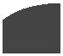

3 Complete the sentences with the correct form of the phrases in the box. Two phrases are needed twice. The first one is done for you.
Be used to , used to
not be used to used to
1 We needed warm clothes when we went to London. We weren’t used to the cold weather.

2 My grandparents didn’t use to

send emails when they were my age.
. 3 Rashed __used to go swimming every morning but now he doesn’t.

4 We always go to the market across the street, so we are used to eating fresh vegetables.

5 Please slow down. I am not used to walking so fast!

6 When you were younger, did you use to play in the park?

- Choose the correct form of the verbs below. The first one is done for you.

1 I used to / am used to go shopping in the local supermarket, but it closed two years ago, so now I have to drive into town to shop.

2 There didn’t use to / wasn’t used to be so much pollution, but these days it is a global problem.

3 I think television used to / is used to be better than it is now. Most of the programmes these days are just reality TV.

4 Most Jordanians are used to / used to the hot weather that /which we have in

summer.
5 There was used to / used to be a lot more wild animals in the past, but they are becoming rare nowadays.

6 Salma has been practising the oud really hard and she is now used to / now used to playing it.

- Complete the sentences with the correct form of the verbs in brackets. The first one is done for you.

1 When I was a student, I used to work (work) very hard. I used to get up (get up) very early and study alone before my lectures, attend lectures all day, and then come home to study some more!

2 Are you used to living (live) in Jordan yet? You’ve only been here for two months.

3 When I was a child, my grandmother used to make(make) cakes for us all

the time, and I liked helping her a lot.
4 My grandfather retired a month ago. He isn’t used to having (have) nothing to do all day. He says he needs a project to

concentrate on.

5 I just got glasses this week, and I’m not used to wearing
(wear)them yet, so I’m

still having difficulty.

Vocabulary

- Complete the sentences with the words in the box.

viable alien conventional sceptical complementary

1 I don’t really believe that story – I’m very skeptical.

2 Doctors often treat infections with antibiotics; that is the conventional
approach.
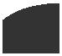
3 Medicines that are not the normal, modern conventional traditionally accepted treatments are known as . complementary

4 Another way of saying that something

could be successful is to say it is

viable.

5 If something seems very strange, we

sometimes say it is alien .

- Sentences 1–4 contain incorrect information. Correct them, using the phrases in the box. One phrase is not needed. The fi rst one is done for you.

conventional medicine / produce antibodies

children and teenagers better and healthier lifestyle choices
suffer from health problems relax / get some exercise

1 A good way to cope with stress is to work extra hard.

No, it isn’t. You should try to relax and get some exercise.

2 Complementary medicine can be used to immunise people.

No, it can’t. You can immunise yourself using conventional medicine because it doesn’t produce the necessary antibodies

3 Optimistic people make bad lifestyle choices.

No, they don’t. They make better and healthier life choices.
4 Seeing red has positive effects on your health.

No, it doesn’t. You often suffer from health problems if you get angry.

12



Reading

- Read the article and match the paragraphs with the correct headings. One heading is not needed.

1 Time to listen

2 Useful tips

3 Don’t leave it too late!

4 A growing problem

5 It’s good for you!

Get moving!
A A growing problem

In many countries, an increasing number of young people and adults are overweight or even obese. One reason for this is the

- growing popularity of fast food, which didn’t use to be as common as it is now.

(1) Another big factor is lack of exercise. People would often walk to school or work, but these days many more
of us drive. Modern technology has also

- played its part; we spend more and more time focusing on computer screens. Before the Internet was invented, nobody had dreamt of online shopping, but now we can buy almost anything without leaving

15 the sofa.

B Time to listen

Health experts have been warning about this trend for years, and their advice is clear. Adults should aim to exercise for at

- least two and a half hours every week; for children and teenagers the target should be
at least an hour a day. This might not sound very much. However, recent research shows that less than 50% of the British population manages this. School children are less physically active than they used to be. Girls in particular often dislike PE. This can lead to serious health problems.

C It’s good for you!

Experts recommend a mixture of activities.

- These should include moderate exercise, such as fast walking, and more strenuous exercise, like running. (3) ___c_____ The

more muscle we build, the more calories we burn, and the fitter we become. In
³⁵ addition, exercise is a great way to cope with stress. In a recent study, patients who had been suffering from depression reported a great improvement after increased physical activity.
- D Useful Tips

Of course, this raises a question: how can I manage to fit in all this extra exercise? The best way is to build it into our daily

lives so that it becomes a routine.

- (4) ____e____ You could get off the bus one stop earlier than usual, or stand up when you’re on the phone! Most importantly,

we should find a sport that we enjoy doing. That way, we will all become fitter,
50 healthier and happier.

- Read the article again and complete it with the missing sentences. One sentence is not needed.

a School child are less physically active than they used to be.

b Another big factor is lack of exercise.

c They also advise exercise that strengthens the muscles, for example sit-ups.
d On the other hand, it can be fun.

e It doesn’t have to take much extra time.

10 Answer the following questions.

1 According to the article, what are the main reasons for higher rates of obesity?
- The growing popularity of fast food; 2. increasing inactivity (preferring to drive rather than walk, and
3. shopping online)
2 What is the minimum amount of exercise recommended for someone in your age group? (teenagers)
At least an hour’s exercise every day,

3 Do most British people get enough exercise? Which sentence in the article tells you this?
No, they don’t: “However, recent research……. this."

13

4 Guess the meaning of the highlighted word in paragraph C. Then check in a dictionary.

Strenuous-means a lot of effort.
5 The author suggests some ways of including exercise in our normal lives. Give two examples from the article.

1.Getting off the bus stop earlier than usual; 2. standing up when you are on the phone.

Writing

11 Read the article on page 13 again, then answer the questions in note form.

1 Paragraphs A and B: In your opinion, is this true of Jordan? What about you, your family and friends? Give examples from your own experience to explain your answers.
Yes, what is mentioned in paragraph A and B is true of Jordan. There are many people who are overweight because of lack of exercising and sitting for long hours using their computers. For me, I try to do exercises regularly to keep fit and healthy. Some of my friends and members of my family are overweight or even obese.

2 Paragraphs C and D: Think of some simple ways you and other people you know could increase your physical activity. Write two or three ideas.
Walking, running, swimming, working in the garden, cleaning the house and the car, playing some games such as table tennis.

12 Now write a two-paragraph report to answer the questions. Use your notes from exercise 11. Are you, your family and your friends active enough? How could you increase your physical activity?
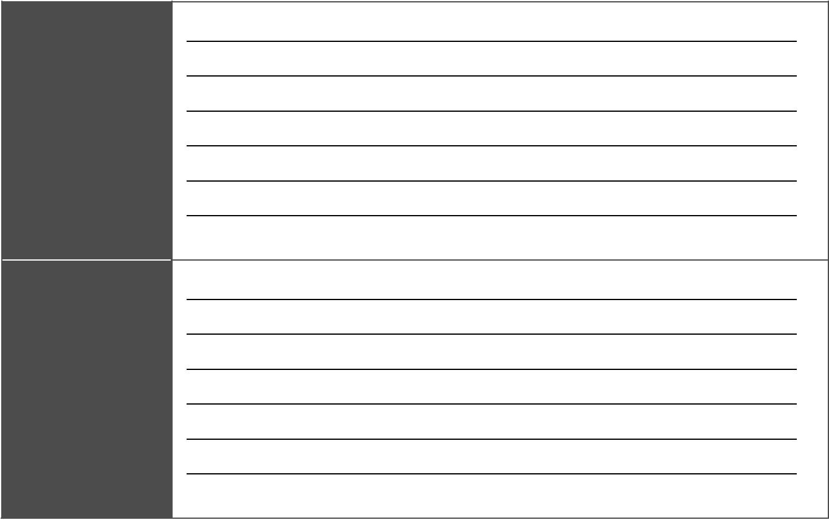
Paragraph 1

Say what the situation is at the moment, both generally and personally.

Paragraph 2

Explain how you, your family and your friends could increase your physical activity.

14

Module 2 Health
 | n | i | t | 3 | M | e | d | i | c | a | l
U

a

d

v a
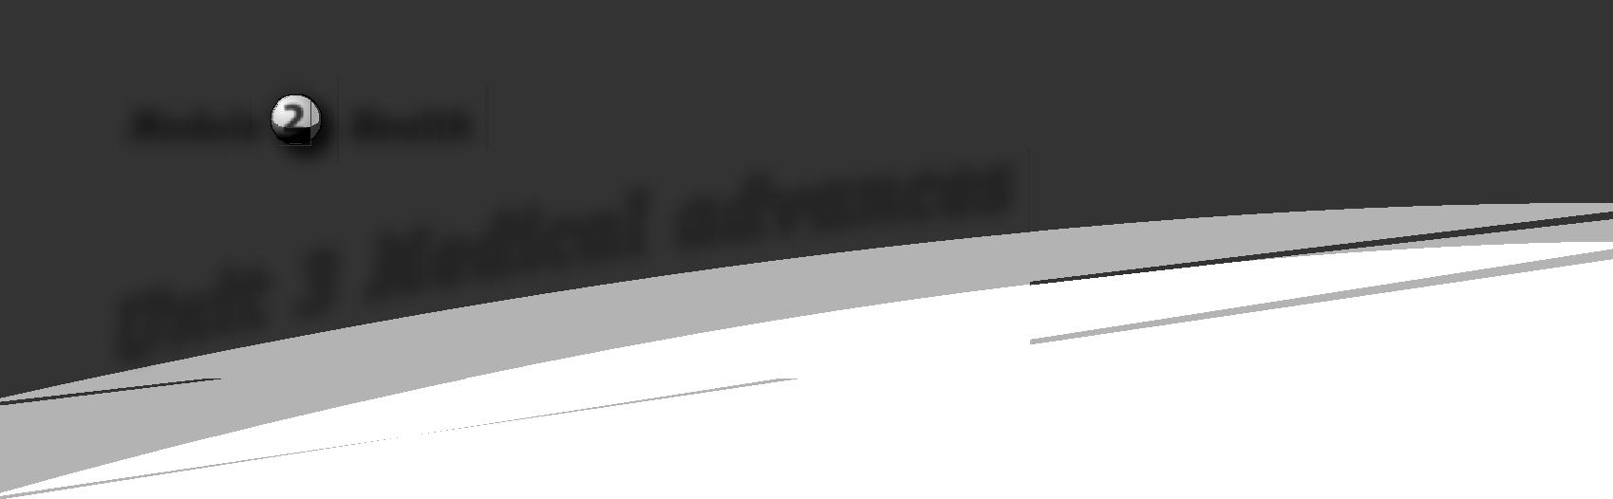
n

c

e

s

Vocabulary

- Make pairs of words with similar meanings and match them with the correct defi nitions. The fi rst one is done for you.

apparatus artificial equipment fund prosthetic sponsor
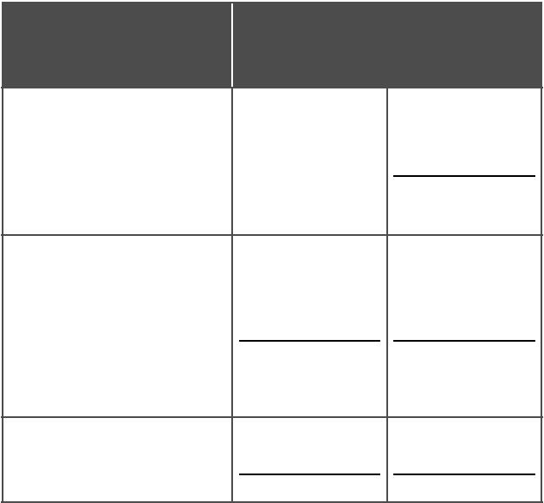
Words with similar
Definitions
meanings

1 describes an
object that is
artifi cial
manufactured by humans

2 tools or machines that have a particular purpose

3 to pay for

- Choose the correct verb to complete the collocations. Then, write two sentences of your own, using two collocations of your choice. The fi rst one is done for you.

1 catch / take someone’s attention

2 get / catch an idea

3 take / get an interest in something/ somebody

4 spend / do time doing something

5 make / attend a course

- Use the words in the box to complete the sentences. One word is not needed. The fi rst one is done for you.

helmet inspire monitor reputation risk seat belt self-confidence tiny waterproof

1 You can wear your watch when you go

swimming if it’s waterproof.

2 It’s amazing how huge trees grow from seeds.

3 The Olympic Games often

young people to take up a sport.

4 Please hurry up. Let’s not

missing the bus.

5 You must always wear a

in a car, whether you’re the driver or a passenger.

6 When my grandfather had a heart

attack, the doctors attached a special

to his chest.

7 It’s important to encourage young people

and help them develop |  |  |  | .
8 Petra has a |  |  | as a fascinating
place to visit.

15



Grammar

- There is one mistake in the verb tenses in each of the four conversations below. Underline the mistake and rewrite the verb in the correct tense.

1 A: What do you think you will be doing in two years’ time?

    - I think I will be living in Karak, and I will study Geography.

2 A: Don’t phone me at seven. I’ll have dinner with my family.

B: OK, I’ll phone at nine.

3 A: What time will you get here tomorrow?

- At about three, I think. I’ll be texting you the exact time later.

4 A: Please be quiet when you come home tonight. The baby will sleep.

B: Don’t worry. I won’t forget.


Vocabulary

- Replace the words and phrases in bold with words from the box. One word is not needed.

a coma dementia medical trials pills symptoms

1 Doctors look at the signs of illness before they decide how to treat the patient.

2 Before doctors prescribe drugs to patients, scientists perform special tests to make sure the drugs are safe.

3 After Ali’s accident, he lay in an unconscious state for two weeks.

16

4 My grandfather has to take a lot of medicine – he takes six different tablets every day.


Speaking

- Read the following sentences, then talk about yourself. Use hope, plan and intend.

  - I intend to study Medicine at university. Then I hope to work in hospital near my home town.

  - I hope to be an engineer one day. I’m planning to get some work experience before I go to university.

  - I hope to do well in my exams this year. Then I intend to go to university and study Archaeology.

  - I plan to go abroad when I leave school. I intend to improve my English. Then I hope to return to Jordan and get a good job.
Grammar

- Complete the text with the correct form of the verbs in the box. The fi rst one is done for you.

going to + do going to + miss

going to + take | will + have
will + stay | will + tell

Rami has broken his leg. It (1) ’s going to take a long time to get better. He

(2) |  |  | in hospital for
at least two weeks, and he
(3) |  |  |  | his leg in
plaster for much longer. Rami
(4) |  |  |  | a lot of lessons
at school, but he (5)

some work while he’s in hospital, and he also hopes his friends

(6) |  | him about the
lessons he has missed.


Reading

- In your opinion, in what ways would a prosthetic hand improve someone’s life? What problems might it cause?

- Read the article below and choose the best title.

A Accident victim invents hand that can feel B Accident victim gets amazing new hand C Accident victim tests first artifi cial limb

Scientists have successfully invented a prosthetic hand with a sense of touch. It is an exciting new invention, which they plan to develop. It is possible that, in the

- not-too-distant future, similar artificial arms and legs will have taken the place of today’s prosthetic limbs.

Dennis Sorensen, a 39-year-old from Denmark, was the fi rst person to try out the

- new invention. After losing his left hand in an accident, he had been using a standard prosthetic hand for nine years. The new hand, which was developed by Swiss and Italian scientists, was a huge improvement.

- With it, Sorensen could not only pick up

and manipulate objects, but he could also feel them. ‘When I held an object, I could feel if it was soft or hard, round or square,’ he explained. He said that the sensations

- were almost the same as the ones he felt with his other hand.

Unfortunately, Sorensen was only taking part in trials, and the equipment is not

ready for general use yet. He was only

- allowed to wear it for a month, for safety reasons. So now he has his old artificial hand back. However, he hopes that soon he will be wearing the new type of hand again. He is looking forward to the time

- when similar artifi cial limbs are available for the thousands of people who need them. He will have helped to transform their lives.
10 Read the article again and answer the questions.

1 Who invented the new prosthetic hand? What is special about it?

2 Why does Dennis Sorensen need a prosthetic hand?

3 Which hand is he wearing now? Why?

4 Who do the bold pronouns ‘I’ refer to in line 17?

5 Find a word that is the opposite of ‘natural’in the fi rst and third paragraphs.

Grammar

11 Complete the sentences in the Future Perfect or the Future Continuous. The fi rst one is done for you.

1 Next month, we / live / in this house for a year. Let’s celebrate!

Next month, we will have lived in this house for a year. Let’s celebrate!

2 Next Monday, I / work / in my new job.

3 you / do / all your homework by eight o’clock?

4 It’s three o’clock now, so Miriam’s flight / arrive / at Queen Alia International Airport.

5 you / meet us / at the library this afternoon?

6 You can borrow this book tomorrow. I / fi nish / it by then.

17



Writing

12 Read the predictions and tick the ones you agree with. Then rewrite the ones you disagree with, using the phrases in bold and your own predictions.

1 Before long, all prosthetics will be bionic.

Before long,

2 By the end of this decade, doctors will have discovered how to cure colds and flu.

By

3 By the time I am fifty, the average life expectancy will be 100.

4 In thirty years’ time, scientists will have found a cure for cancer.

5 Within fifty years, scientists will invent a device that enables blind people to see.

6 By the end of this century, there will be no diseases left.

13 Write an essay predicting medical advances by the year 2100 CE. Use some of the expressions from exercise 12. Write about 100 words.

18

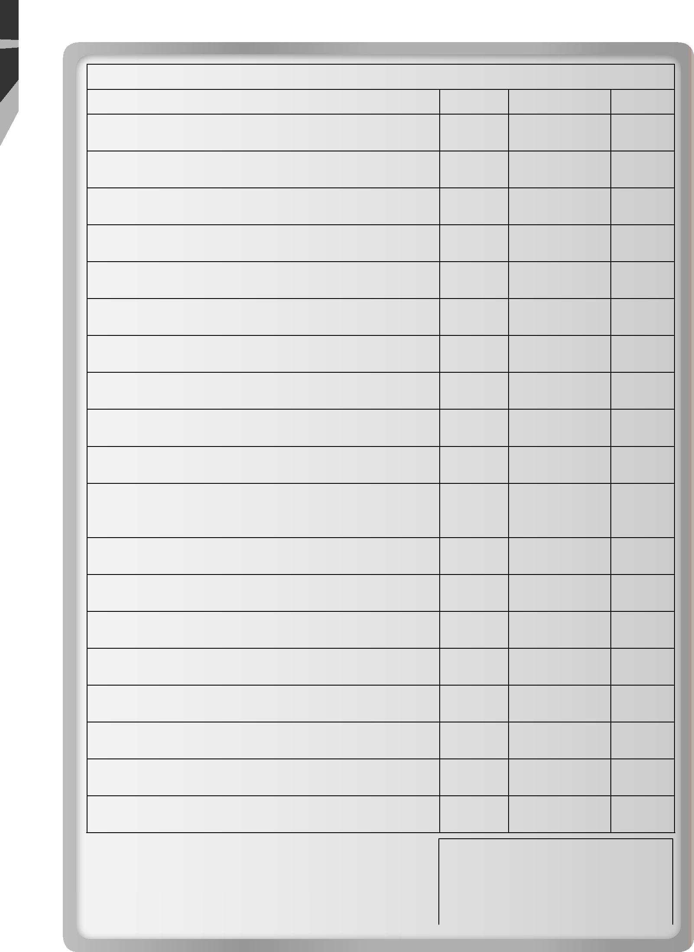
WHAT I CAN DO

Always Sometimes Rarely

- I can defi ne words related to illnesses and medical treatments.

- I can use the vocabulary related to illnesses and medical advances in sentences.

- I can rewrite sentences, using the correct vocabulary items.

- I can categorise words according to definitions and similar meanings.

- I can construct collocations and use them in sentences.

- I can distinguish between used to and be used to by completing sentences.

- I can detect incorrect verb forms in the future.

- I can complete a paragraph with the correct future verb forms.

- I can distinguish between the Future Perfect and the Future Continuous by completing sentences.

- I can talk about my intentions, hopes and plans for the future.

- I can talk about the advantages and disadvantages of the invention of a prosthetic hand, using my critical-thinking skills.

- I can match headings to different parts of an article.

- I can complete paragraphs with missing information.

- I can demonstrate my knowledge of healthy living by answering questions.

- I can skim through an article to choose a suitable title.

- I can analyse an article by answering questions.

- I can write notes and a report about healthy living in Jordan.

- I can predict developments in medicine, using time expressions for the future.

- I can write an essay about advances in medicine by the year 2100 CE.

Total number of ticks

Always | Sometimes | Rarely

19

