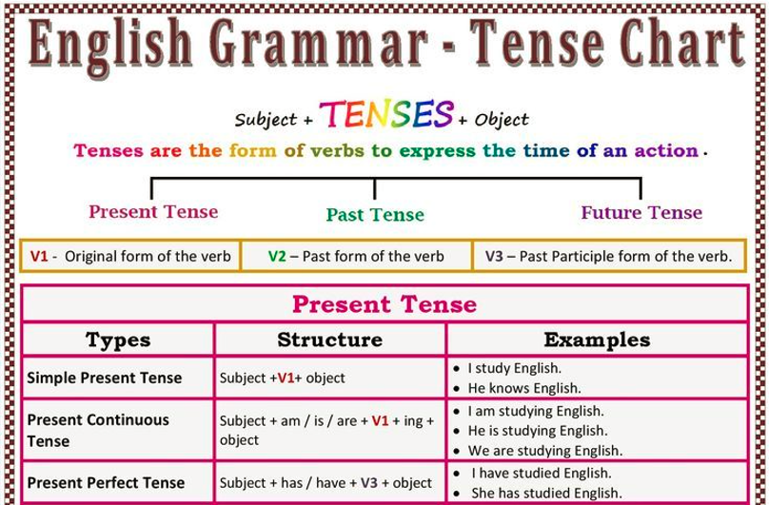

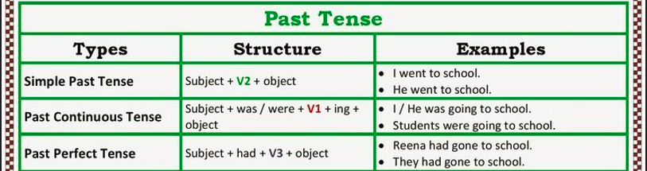

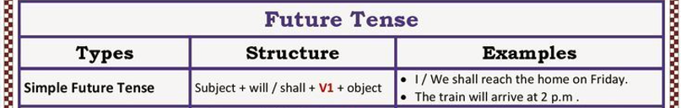

Fill in the correct form of the verb

1. I saw a great film yesterday. (see)

2. have you ever bought a new car? (you ever buy)

3. I met him last Monday. (meet)

4. The band was playing while I was writing . (play, write)

5. She bought the new car in 2005. (buy)

6. They were already in Germany when we arrived a few days ago. (already be)

7. are you planning to get married? (you plan)

8. I have had so much fun since I was a kid. (have)

9. When I got up I looked out of the window and saw that it was raining . (look, see, rain)

10. I have seen three movies so far this week. (see)

11. I flew over Loch Ness last week. – did you see the Loch Ness monster? (fly, you see)

12. I’m afraid I’m not hungry. I have already eaten . (already eat)

13. Peter was playing football in the afternoon when he got the call. (play)

14. “What were you doing between 9 and 12 yesterday morning”, the detective said. (you do)

15. He kept looking at her, wondering where he had seen her before. (see)

16. The doctor’s waiting room was full of people. Some were reading a magazine, a woman was knitting and a child was playing with a doll. Suddenly the door opened and a nurse came out. (read, knit, play, open, come)

17. Travelling has become much easier and more comfortable in the past hundred years. (become)

18. When I first came to this house , it was quite a noisy area. (be)

