

**Our value: Self – belief and hard work will always earn you success**

Present Participle Adjectives

**Name ………………… Grade (7)**

Objectives: To learn what a present participle is.

To practise using the present participle as a verb and an

adjective.

* Participles are words that originate from a verb but are used in different ways.

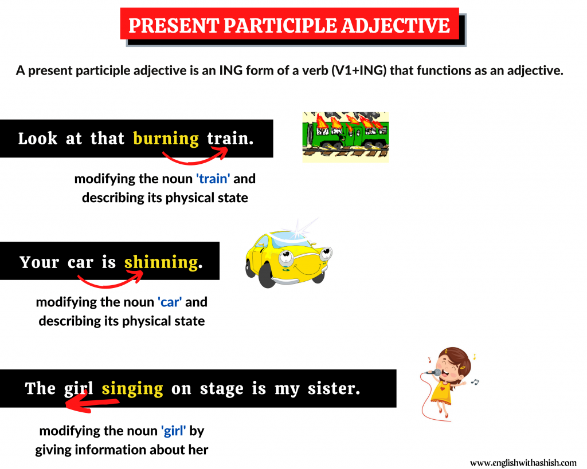

The food is burning. 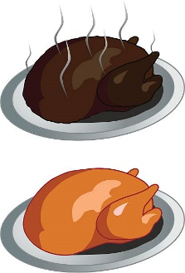

Verb tense

from (to burn)

1. Are the following present participles used as verbs or adjectives.

1. Interesting concert but we didn’t enjoy it much.

**a. Interesting is used as an adjective**

**b. Interesting is used as a verb.**

2. It was raining when I got home.

**a. Raining is an adjective**

**b. Raining** **is used as a verb.**

3. I love the noise of falling rain.

**a. Falling is used as an adjective**

**b. Falling is used as a verb.**

4. It is a pressing problem.

**a. Pressing is an adjective**

**b. Pressing is used as a verb.**

5. She was writing a letter.

**a.** **Writing is an adjective**

**b. Writing is used as a verb.**

6. The lecture was very interesting.

**a. Interesting is an adjective**

**b. Interesting is used as a verb.**

7. She is an interesting writer.

**a. Interesting is an adjective**

**b. Interesting is used as a verb.**

8. The news was exciting.

**a. Exciting is an adjective**

**b. Exciting is used as a verb.**

9. I was working on that report when she called.

**a. Working is an adjective**

**b. Working is used as a verb.**

B) Write these two sentences as one.

1. The girl ran out of the room. She was screaming.

The screaming girl ran out of the room.

1. The tourists were walking. They saw the library.

The walking tourists saw the library.

1. The pigeons were cooing. They strutted hopefully around the benches.

The cooing pigeons strutted hopefully around the benches.

1. Use the following participles in two sentences once as a verb and once as an adjective.
2. Boiling
3. Verb: The water is boiling.
4. Adjective: The boiling water is extremely hot.
5. Waiting
6. Verb: We were waiting for the bus.
7. Adjective: The waiting children were exciting to have their snack.
8. Smiling

a. Verb: The children were smiling.

b. Adjective: The smiling children were playing.

Teacher: Mirna Nawaf Al-Sahawneh.

Coordinator’s Signature: ----------------------