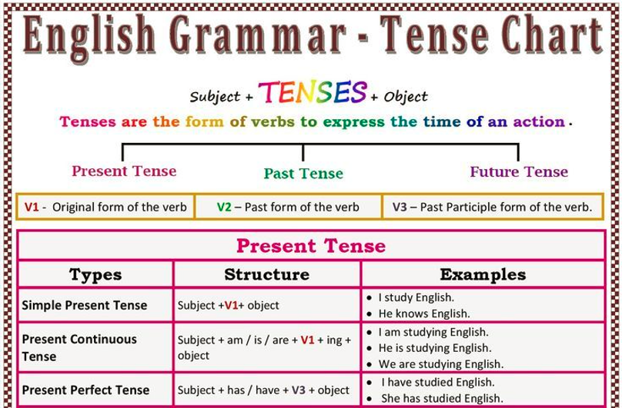

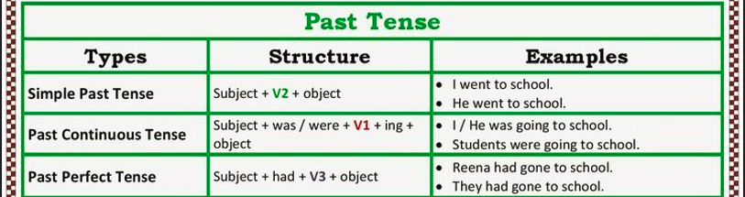

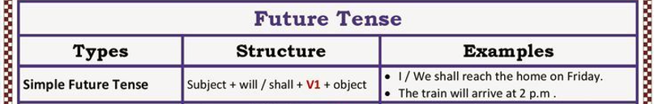

Fill in the correct form of the verb

1. I _______________ a great film yesterday. (see)

2. _____________________ a new car? (you ever buy)

3. I _______________ him last Monday. (meet)

4. The band _______________ while I _______________ . (play, write)

5. She _______________ the new car in 2005. (buy)

6. They ____________________________ in Germany when we arrived a few days ago. (already be)

7. _______________________ to get married? (you plan)

8. I _____________________ so much fun since I was a kid. (have)

9. When I got up I _____________________ out of the window and _____________________ that it _____________________ . (look, see, rain)

10. I _____________________ three movies so far this week. (see)

11. I _____________________ over Loch Ness last week. - _____________________ the Loch Ness monster? (fly, you see)

12. I’m afraid I’m not hungry. I _____________________ . (already eat)

13. Peter _____________________ football in the afternoon when he got the call. (play)

14. “What _____________________ between 9 and 12 yesterday morning”, the detective said. (you do)

15. He kept looking at her, wondering where he _____________________ her before. (see)

16. The doctor’s waiting room was full of people. Some _____________________ a magazine, a woman _____________________ and a child _____________________ with a doll. Suddenly the door _____________________ and a nurse _____________________ out. (read, knit, play, open, come)

17. Travelling _____________________ much easier and more comfortable in the past hundred years. (become)

18. When I first came to this house it _____________________ quite a noisy area. (be)

