

**Our value: Self – belief and hard work will always earn you success**

**Vocabulary _ Unit 2**

**No (5)**

**(Save Our Tigers)**

**Name………………… Grade (5)**

|  |
| --- |
| **Objectives**  **1. Identify the meaning of the new words.**  **2. Identify the synonyms of the new words.**  **3. Practice using the new words in sentences.** |

**Verbs**

|  |  |  |
| --- | --- | --- |
| **Word** | **Meaning /Synonym** | **Example** |
| Terrify | To **scare**. | Dracula might **terrify** some younger members in the audience of a horror film, but we know he is an imaginary creature. |
| Identify | To **recognize.** | She was able to **identify** her attacker. |
| Protect | To **guard** | It’s important to **protect** your skin from the harmful effects of the sun. |
| Inspire | To **influence.** | By visiting schools, the actors hope to **inspire** children to put on their own productions. |
| Fascinate | To **attract** | The sky was sparkly enough to **fascinate** her. |

**Adjectives**

|  |  |  |
| --- | --- | --- |
| **Word** | **Meaning /Synonym** | **Example** |
| Diverse | Including many different types of people or things./**various** | Work well with a multi-cultural and **diverse** work force. |
| Starving | Dying because of not having enough  food./ **hungry** | My heart ached for the **starving** homeless children. |
| Damaged | **Destroyed**. | The tiger’s teeth were **damaged**. |

**Nouns**

|  |  |  |
| --- | --- | --- |
| **Word** | **Meaning /Synonym** | **Example** |
| Foothills | A low **hill** at the base of a mountain range. | We marched 5 km across the **foothills**. |
| Tracker | A person who is trained to find animals. / **spy** | Police and **tracker** dogs were beating the woods for the lost boy. |
| Naturalist | A person who studies living  things. /**zoologist** | Sam was a keen and talented **naturalist**. |
| Injury | **Harm** or damage that is done. | He was discharged from the army following his **injury**. |
| Wound | A **cut**. | Blood was pouring from the **wound**. |
| Poaching | To **hunt** | **Poaching** on other’s land is illegal. |
| Conservation | **Keeping.** | The lake was recently designated a **conservation** area. |
| Preservation | **Maintenance**. | The picture is in an excellent state of **preservation.** |
| Population | The total number of **people or animals** living in an area. | The country has a total **population** of 65 million. |
| Reserve | A **sanctuary**. | The land is to be left undisturbed as a nature **reserve**. |

1. **Write the synonym of each of these words**:
2. Terrify scare
3. Identify recognize
4. Protect guard
5. Inspire influence / impact
6. Diverse various
7. Starving hungry
8. Fascinate attract
9. Damaged destroyed
10. Foothills hills
11. Tracker spy
12. Naturalist zoologist
13. Injury harm
14. Wound cut
15. Poaching hunt
16. Conservation keeping
17. Preservation maintenance
18. Population people or animals
19. Reserve sanctuary
20. **Write the correct word under each picture.**

|  |
| --- |
| Terrify _ Identify _ Protect _ Inspire _ Fascinate _ Damaged _ Diverse Starving _ Foothills _ Tracker_ Naturalist _ Injury _ Wound _ Poaching Conservation _ Preservation_ Population _ Reserve. |

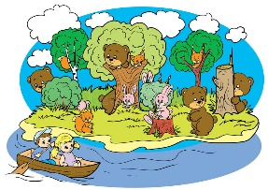  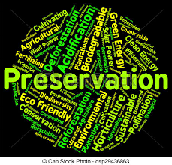

Reserve population preservation

  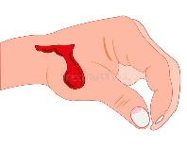 

Conservation poaching wound injury

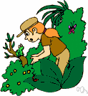  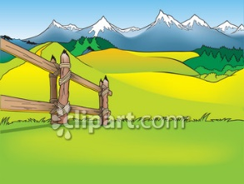  

Naturalist tracker foothills starving diverse

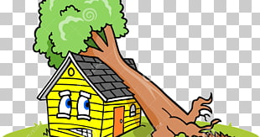   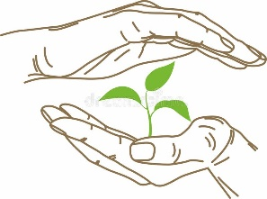

Damaged fascinate inspire protect

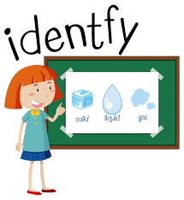 

Identify terrify

1. **Fill in the gaps with the correct words from the box.**

|  |
| --- |
| Terrify _ Identify _ Protect _ Inspire _ Fascinate _ Damaged _ Diverse_ Starving _ Foothills _ Tracker_ Naturalist _ Injury _ Wound _ Poaching Conservation _ Preservation_ Population (2) _ Reserve. |

1. The reserve covers an area of some 1140 square kilometers.
2. We broadcast the news to the local population every morning.
3. The population of the nearest big city was growing.
4. The aim of the policy is the preservation of peace.
5. There is a need for the conservation of trees, or there will soon be no forests.
6. They were poaching wild animals.
7. When the wound is healed, the pain is forgotten.
8. He suffered a serious injury that forced him to give up work.
9. My father is a naturalist. He studies living things.
10. The police used tracker dogs to find the criminal.
11. The foothills have been farmed out with tomatoes.
12. I’m absolutely starving. I missed lunch.
13. The book covers such diverse topics as snorkeling and first aid.
14. Oranges and pears are seriously damaged by insects.
15. The place continues to fascinate visitors, cloaked in its mystery.
16. We need someone who can inspire the team.
17. Are you doing enough to protect the environment?
18. Passengers were asked to identify their own suitcases before they were put on the plane.
19. The aim of the terrorists is to terrify people!
20. **Find the synonyms of the following words in the crossword and write them down.**

|  |  |  |  |  |  |  |  |  |  |  |  |
| --- | --- | --- | --- | --- | --- | --- | --- | --- | --- | --- | --- |
| v | e | c | s | c | a | r | e | g | f | i | n |
| a | w | g | u | a | r | d | p | e | a | r | y |
| a | t | t | r | a | c | t | u | l | b | n | m |
| s | d | e | s | t | r | o | y | o | n | a | d |
| g | h | u | n | g | r | y | p | y | o | r | h |
| r | a | w | c | i | n | j | u | r | y | e | n |
| e | c | g | a | h | u | n | t | r | v | e | c |
| t | p | e | o | p | l | e | t | i | o | n | v |

1. Terrify ----------- 2. Protect --------------
2. Fascinate ------------- 4. Damage ----------------
3. Starving ------------- 6. Wound ----------------
4. Poaching -------------- 8. Population --------------

Teacher: Mirna Nawaf Al-Sahawneh.

Coordinator’s Signature: --------------------------

Teacher: Mirna Nawaf Al-Sahawneh.