

**Our value: Self – belief and hard work will always earn you success**

**Vocabulary _ Unit 2 No. (5)**

**(Overcoming Earth’s Obstacles)**

**Name ………………… Grade (6)**

|  |
| --- |
| **Objectives**  **1. Identify the meaning of the new words.**  **2. Identify the synonyms of the new words.**  **3. Practice using the new words in sentences.** |

**Verbs**

|  |  |  |
| --- | --- | --- |
| **Word** | **Synonym** | **Meaning** |
| Overcome | Defeat | To succeed in dealing with a problem.  Example: My friend overcame her fear of skydiving. |
| Support | Bear / Help | To bear all or part of the weight.  Example: My sister supported me during my grief. |
| Link | Join | To connect or join.  Example: The river links the two seas. |

**Adjectives**

|  |  |  |
| --- | --- | --- |
| **Word** | **Synonym** | **Meaning** |
| Varied | Different | Having many types or kinds.  Example: This is an interesting varied album. |
| Problematic | Difficult | Difficult to solve or to decide on.  Example: They found themselves in a problematic situation. |
| Suspended | Hanging | Hanging without support from below.  Example: The suspended bridge took two years to be built. |

**Nouns**

|  |  |  |
| --- | --- | --- |
| **Word** | **Synonym** | **Meaning** |
| Obstacle | Block | Something that blocks one’s way.  Example: I faced an obstacle in the French language lesson. |
| Situation | Case | A set of circumstances.  Example: The situation could have been more dangerous. |
| Beam | Bar | A long, strong piece of wood or metal used to support a building or a bridge.  Example: The load on this beam is more than it will bear. |
| Span | Distance | The space that something covers.  Example: The book covers the entire span of Arab history. |
| Cable | Wire | A thick wire used for construction.  Example: The screens are connected by a cable. |
| Explosives | bombs | A substance which can cause damage to the surroundings.  Example: They kept the explosives in secured containers. |
| Waterway | Channel | A water channel or river.  Example: They camped near the waterway. |

1. **Write the synonym of each of these words**:
2. varied different
3. problematic difficult
4. overcome defeat
5. obstacle block
6. Situation case
7. beam bar
8. span distance
9. Suspended hanging
10. cable wire
11. support help
12. explosives bombs
13. link join
14. waterway channel
15. **Write the correct word under each picture.**

|  |
| --- |
| link_ explosives_ support_ cable_ suspended _waterway _ obstacle varied _ problematic _ beams |

 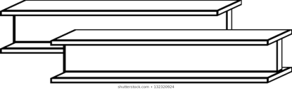 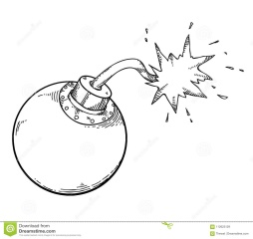 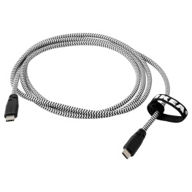

Link beams explosives cable

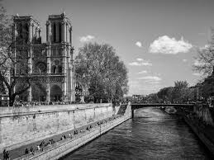 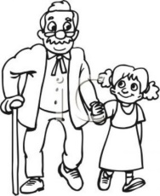 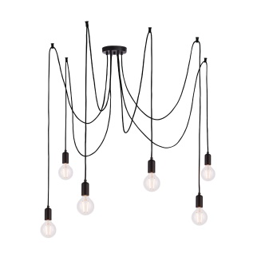 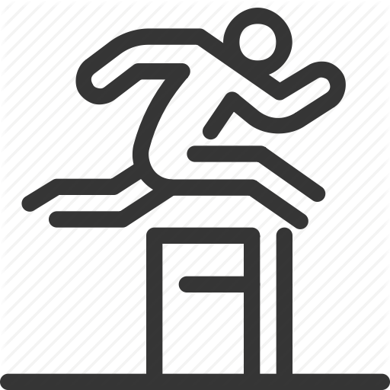

waterway support suspended obstacle

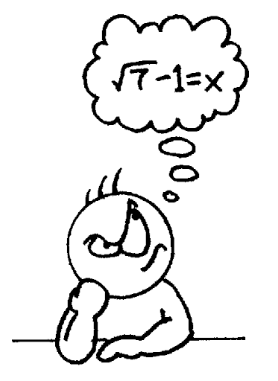 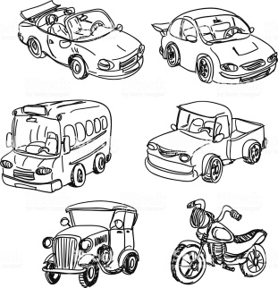

problematic varied

1. **Fill in the gaps with the correct words from the box.**

|  |
| --- |
| link_ explosives_ support_ cable_ suspended _waterway _span _ obstacle_ varied _ problematic _ beam _ situation _ overcome |

1. Her diet is varied with vegetables and fruits.
2. Getting everyone there on time might be problematic.
3. We did our best to overcome our difficulties.
4. The greatest obstacle to success is laziness.
5. My mom was in a bad situation when she forgot her keys.
6. He is walking on a beam of wood.
7. The map covers the whole span of the country.
8. He swam across the waterway to reach the island.
9. The new bridge will link the island to the mainland.

10.Natural gas is a kind of explosives.

11. She worked to support her children.

12.A cable can carry the signal to the computer.

13.The balloons are suspended from the ceiling.

1. **Find the synonyms of the following words in the crossword and write them down.**

|  |  |  |  |  |  |  |  |  |  |  |  |  |  |  |  |
| --- | --- | --- | --- | --- | --- | --- | --- | --- | --- | --- | --- | --- | --- | --- | --- |
| q | r | e | e | x | p | l | o | s | i | v | e | g | h | j | s |
| s | p | r | o | b | l | e | m | a | t | i | c | g | j | i | u |
| d | f | h | j | l | j | t | v | b | n | d | e | t | d | s | s |
| l | i | n | k | r | t | v | w | a | t | e | r | w | a | y | p |
| q | w | e | r | r | t | a | j | i | o | p | l | s | k | j | e |
| o | y | m | b | v | b | r | t | b | e | a | m | i | f | g | n |
| v | y | u | r | t | q | i | s | w | e | d | x | t | c | d | d |
| e | c | a | b | l | e | e | q | z | z | a | q | u | w | d | e |
| r | a | e | s | r | d | d | t | h | b | s | p | a | n | j | d |
| c | m | s | u | p | p | o | r | t | l | o | u | t | t | k | h |
| o | q | w | e | d | f | g | y | u | i | o | p | i | k | d | v |
| m | r | f | o | b | s | t | a | c | l | e | j | o | p | i | y |
| e | c | v | f | g | j | m | l | z | x | d | f | n | y | i | o |

hanging suspended wire cable

bear support join link

distance span case situation

bar beam block obstacle

various varied difficult problematic

defeat overcome channel waterway

Teacher: Mirna Nawaf Al-Sahawneh.

Coordinator’s Signature: -----------------------