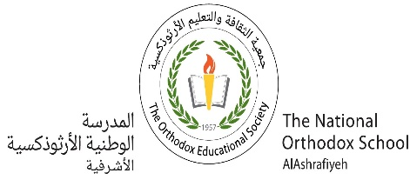The National Orthodox School

**Value*: You always gain by giving love..***

Science Worksheet #2

Grade: 4(A+B) Date: / /2022

Name:

A Balanced Diet

|  |  |  |
| --- | --- | --- |
| **Type of Food nutrient** | **Function** | **sources** |
| Carbohydrates | Give us energy | Rice/sweets/bread |
| Proteins | Build the body | Meat/ lentil |
| Vitamins & Minerals | Keep the body healthy | Apple/carrot/appricot  mango |
| Fats and Oils | Give us energy | Nuts/ milk /olive oil |
| Fibre | Helps the intestines to work properly. | Vegetables/grains |
| Water | prevents the body from becoming dry | ---- |

Carbohydrates/ Proteins/ Fats and oils/ Vitamins and minerals// fibre/ water