Are happier people healthier – and, if so, why?



It’s normal to feel a bit blue from time to time. However, studies show that negative emotions can harm the body.



Anger can also have harmful effects on health. When you see red, your blood pressure is raised and you can suffer from headaches, sleep problems and digestive problems. However, what about positive feelings and attitudes? Until recently, scientists had not investigated whether there is a link between positive feelings and good health.

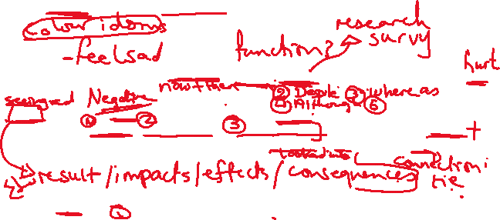

Then, in a study that had followed more than 6,000 men and women aged 25 to 74 for 20 years, researchers found that positivity reduced the risk of heart disease. Other factors influencing health included a supportive network of family and friends, and an optimistic outlook on life.



The research showed that children who were more able to stay focused on a task, and who had a more positive attitude to life at age seven, were usually in better health 30 years later.



The study has been controversial. Some health professionals believe that bad lifestyle choices, such as smoking or lack of exercise, are the reason for heart disease and other illnesses, and not an individual’s attitude. The researchers, while agreeing, raise the question: why are people making bad lifestyle decisions? Do more optimistic people make better and healthier lifestyle choices?



The researchers appreciate that not everyone’s personal circumstances and environment make it possible to live without worry. However, they believe that if we teach children to develop positive thinking, and to ‘bounce back’ after a setback, these qualities will improve their overall health in the future.

