

Learning never exhausts the mind.

**Worksheet (1) Grade 2**

**Name : ____________ Date : 10/10/2022**

**______________________________________________**

**Q1 ) Name five things that living things can do .**

**1.______________ 2.______________**

**3.______________ 4.______________**

**5.______________**

**Q2) Write ( Yes ) or (No) .**

1. Animals and plants are non-living things. (_______)
2. Living things can live without air. (_________)
3. Animals eat many kinds of food. (___________)
4. Some animals eat both plants and animals. (______)
5. Fish have gills to breathe. (__________)
6. All living things only eat plants. (___________)
7. The plants make their own food. (___________)
8. A frog hops on land with its fins. (__________)

**Q3) Complete the table using the words from the box.**

|  |
| --- |
| **cat/ dog /tiger /rabbit/cow/ bear / human/ lion shark/ sheep** |

|  |  |  |
| --- | --- | --- |
| **Animals that eat only plants** | **Animals that eat only other animals** | **Animals that eat both plants and animals** |
|  |  |  |

**Q4) Match the baby to its parent.**

1. ***Seed Cat***
2. ***Puppy Kangaroo***
3. ***Tadpole Dog***
4. ***Kitten Plant***
5. ***Joey Frog***

**Q5) Circle the correct answer .**

1. A fish swims in water with its tail and **------**
2. **wings b) fins**
3. We take air through our nose and **---------**
4. **mouth b) ear**
5. The living things need food to **---------**
6. **fly b) grow**
7. A frog hops on land with its ---------
8. **legs b) body**
9. The humans walk, run and jump with their **------**
10. **wings b) legs**
11. A plant takes air through ---------- in its leaves**.**
12. **small holes b) mouth**

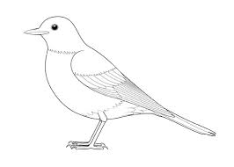**Q6) Color the pictures then write the name of these animals.**

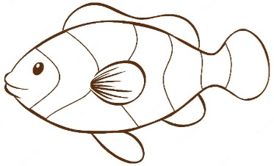

**______________ _______________**

**Teacher : Raneem Haddad**