
Learning never exhausts the mind.
Worksheet (10)
Grade 2(A+B)
Name: ------------ Date: 6 / 10 /2022
_________________________________________________ Objective: To join two nouns to make compound words .
Compound words are two words put together to make a new word.
Butter + fly =butterfly
Basket + ball =basketball

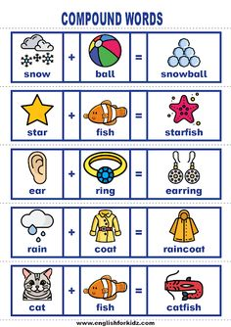

- Join two words to make one compound word.
- foot + ball =football
- rain + bow =rainbow
- bed +room = bedroom
- lady +bird =ladybird
5.snow + man =snowman
- Write the second word of the compound word.
- homework
- bathroom
- starfish

T.Taghreed Alnimri Coordinator’s Signature:

