

## Let us forgive each other – only then we will

## live in peace

**Grammar Worksheet** (2)

Adjectives end in -ed and -ing

Grade ( 3 )

Name: Date: / /2022

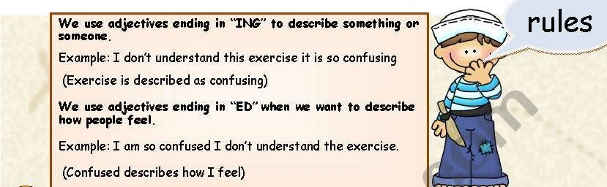

|  |
| --- |
| **Objectives:**  1.To differentiate between adjectives ending in -ed and -ing.  2.To practice using the adjectives ending in -ed and -ing **.** |

**Examples**:

1. You look really **tired** . Why don’t you go to bed ?

( describes what he feels)

1. His exam results were really **disappointing** .

( describes the results (thing ) )

1. I was really **surprised** that I won the competition.
2. This book is **boring** I don’t like it. If I read it I get **bored.**

**Q1) Circle the correct adjective according to the sentence.**

1. Holidays are **exciting / excited** .
2. The festival was **amazed/ amazing.**
3. I was **interested / interesting** in this book .
4. Flying is **frightening / frightened** .
5. Sweeping the floor is **tired / tiring.**
6. The last lesson was **bored / boring** .

**Q2) Order the words to make correct sentences .**

1. I / interested / in / am / soccer / game.

**I ama interested in soccer game.**

1. The / wasn’t / festival / exciting .

**The festival wasn’t exciting.**

**Q3) Complete the sentences with the correct form of the adjectives .**

1. **My English class is so interesting.( interest)**
2. **Rainy days make me feel depressed .(depress)**
3. **My teacher is annoyed by the students because they are annoying (annoy )**
4. **I was shocked when I heard the news.(shock)**
5. **Grammar is confusing .(confuse)**

**Q4) Write 2 sentences about something you like ( use adjectives with –ed , -ing) .**

**1.I am interested in paintings.**

**2. The movie was boring**

Teacher : Raneem Haddad

Coordinator’s Signature : _________________.