

**The Primary Stage of Grades (4-5)**

**School Year 2022 - 2023**

**Name**: ___________ **Subject**: **English Language**

**Writing Worksheet#2**

**Date: / / Class: Grade 4 CP (All Sections)**

**_____________________________________________________________**

**Objective/s: Write an ending to the story.**

**Magdi**

Magdi looked out of the window and saw clear blue skies. "Yes!" he shouted. "It's a beautiful day! I can go fishing."

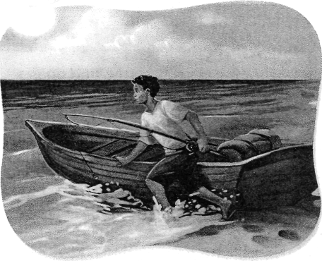"Hi, Dad! Bye, Dad! It's a beautiful day! See you later!" shouted Magdi. He was so excited that he was speaking very, very fast. He rushed out of the house with his fishing rod.

"What did he say?" asked his sister.

"He said that it was a beautiful day for fishing," chuckled Magdi's dad with a big smile on his face. "He's always happy when he goes fishing."

Magdi raced to the beach and untied his little red fishing boat. Maybe today I'll catch a fish for dinner! he thought. He waded out into the warm blue water, pushing the boat until it floated. Then he jumped into it and paddled toward some rocks.

Magdi looked over the side of the boat and saw a lion fish. He knew that lion fish were very dangerous; they could sting you. Magdi sat and watched quietly as it dove under the boat and disappeared under a rock. Next, he saw a parrot fish, with its shiny blue, purple, and green scales, gliding through the water. Parrot fish are tasty, he thought. Maybe today I'll catch a parrot fish. Magdi put a piece of bread on the hook of his fishing rod and threw the fishing line into the water. Then he threw more bread into the water to attract the fish. Suddenly, hundreds of fish swam up to the boat.

There were bright yellow fish, black-and-white fish that looked like zebras, fish with long noses, and big, fat puffer fish. Magdi knew all their names. He beamed with delight. Maybe I won't catch any fish today, he thought. They're beautiful! Maybe today I'll just watch them. Magdi pulled his paddles into the boat, turned onto his stomach to watch the fish, and fell asleep in the warm sun. Magdi woke up feeling chilly. Looking up, he saw black skies. Big waves were shaking his little red fishing boat, and it was drifting out to sea.

Two of Magdi's friends, Malik and Ali, were playing on the beach. "Hey, Magdi! Magdi!" they shouted. "Come back! There's a storm!" Their words floated across the water, carried by the wind.

"What did you say?" Magdi yelled.

"We said that there was a storm!" shouted Malik and Ali. "Come back!"

**Write an ending (not more than two paragraphs) to the story you have read telling:**

1. How was the sea when the storm started?
2. Who helped Magdi? And how?
3. Was he hurt?
4. How did he feel in the end?

**Make sure to:**

* Use similes and metaphors.
* Use at least five words from the following:

**roared, rolling, spread, lashing, curling, exploding, pounding, shaking, tumbling, battering, vast, fearsome, awestruck, din, marvelously, extraordinarily.**

* Use a variety of sentences (simple and /compound).
* Add possible dialogues.

**Planning**

Spend up to **5 minutes** making notes in the box.

|  |  |
| --- | --- |
| How was the sea when the storm started?  ______________________________________  ______________________________________  ______________________________________  ______________________________________  ______________________________________  ______________________________________ ______________________________________ ______________________________________ | Who helped Magdi? And how?  _______________________________  _______________________________  ­­­_______________________________  _______________________________  _______________________________  _______________________________  _______________________________  _______________________________ |
| Was he hurt?  ______________________________________  ______________________________________ ______________________________________ ______________________________________  ______________________________________ | How did he feel in the end?  _______________________________ _______________________________ _______________________________  _______________________________  _______________________________ |

____________________________________________________________________________________________________________________________________________________________________________________________________________________________________________________________________________________________________________________________________________________________________________________________________________________________________________________________________________________________________________________________________________________________________________________________________________________________________________________________________________________________________________________________________________________________________________________________________________________________________________________________________________________________________________________________________________________________________________________________________________________________________________________________________________________________________________________________________________________________________________________________________________________________________________________________________________________________________________________________________________________________________________________________________________________________________________________________________________________________________________________________________________________________________________________________________________________________________________________________________________________________________________________________________________________________________________________________________________________________________________________________________________________________________________________________________________________________________________________________________________________________________________________________________________________________________________________________________________________________________________________________________________________________________________________________________________________________

|  |  |
| --- | --- |
| **My Writing Checklist** | **√** |
| Did I punctuate the sentences correctly? |  |
| Did I include similes and metaphors? |  |
| Did I use words from the vocabulary I learnt? |  |
| Did I use simple and compound sentences? |  |
| Did I add dialogue? |  |

|  |  |
| --- | --- |
| Content and audience | /3 |
| Text structure | /2 |
| Sentence structure | /3 |
| Vocabulary | /3 |
| Spelling | /2 |
| punctuation | /2 |
| Total | /15 |