**Complementary medicine: is it really a solution?**



Most doctors used to be sceptical about the validity of homoeopathy, acupuncture and other forms of complementary medicine. If patients wanted to receive this kind of non-conventional treatment, they used to have to consult a private practitioner who was likely not to have a medical degree. However, in recent years, the perception of this type of treatment has changed. These days, many family doctors study complementary medicine alongside conventional treatments, and many complementary medicine consultants also have medical degrees.

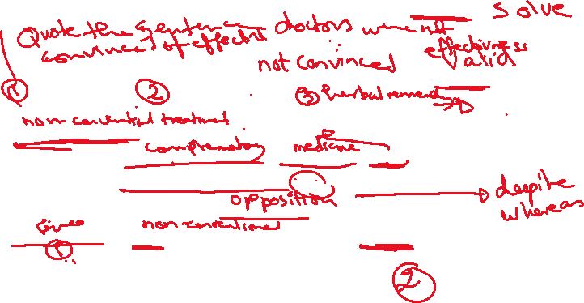

Whereas critics used to say that there was no scientific evidence that non-conventional treatments actually worked, now it is more common for medical experts to recognise that conventional medicine may not always be the only way to treat an ailment.



At a surgery in London, 70 per cent of patients who were offered the choice between a herbal or a conventional medicine for common complaints such as insomnia, arthritis and migraines chose the herbal remedy. Fifty per cent of patients then said that the treatment helped. One doctor said, "I now consider homoeopathy to be a viable option for many different conditions, including anxiety, depression and certain allergies. It provides another option when conventional medicine does not address the problem adequately."

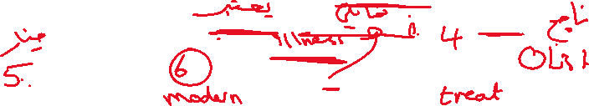

However, complementary medicine cannot be used for all medical treatments. It can never substitute for immunisations as it will not produce the antibodies needed to protect against childhood diseases. It also cannot be used to protect against malaria.

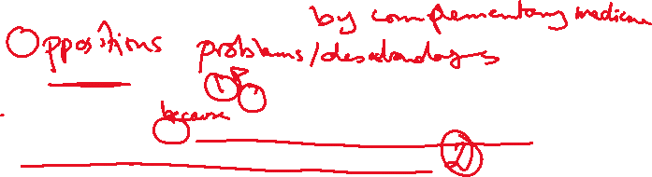

One doctor said, "I will always turn to conventional medical treatment first to ensure that no underlying condition is missed. However, the idea of complementary treatments is no longer an alien concept. In my opinion, it should work alongside modern and not against it.

