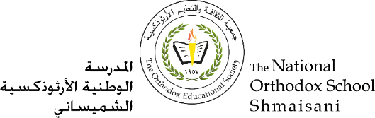

**The Primary Stage of Grades (4-5)**

**School Year 2022- 2023**

**Name** : ___________ **Subject** : English Language

Vocabulary sheet#1

**Date : / / Class : Grade 5CP(All Sections)**

**_____________________________________________________________**

**Objective/s:**

* Understand and learn the meaning of new vocabulary words.
* Use the new vocabulary words in meaningful sentences.

Unit One: **Young heroes**. (Fiction)

|  |  |  |
| --- | --- | --- |
| **Word** | **Meaning** | **Synonym** |
| Courage | Behave bravely. | **Bravery** |
| Billowing | Moving up and down in wind or water. | **Rise and fall** |
| Sow | Plant, for example, by scattering seeds in soil. | **Plant** |
| Reap | Gather in a crop or harvest. | **Gather** |
| Transfixed | Focused very closely on something. | **Mesmerized** |
| Stubborn | Fixed in opinion or behavior. | **Headstrong** |
| Suspicious | Not trusting | **Doubtful, skeptical** |
| Forsaken | Nothing there. | **Abandoned, deserted** |
| Scoop | Pick up something in a quick, smooth movement. | **Pick up.** |
| Seize | Took hold of something suddenly and strongly. | **Grab, snatch** |

1. **Use the following words in meaningful sentences:**

|  |  |  |  |
| --- | --- | --- | --- |
| **Courage** | **reap** | **sow** | **transfixed** |

1. **The boy had enough courage to touch the snake.**
2. **You will soon reap the benefits of your hard work.**
3. **The farmers will sow the corn in spring.**
4. **She stood transfixed in front of the beauty of the scene.**
5. **Write the synonyms of the following words:**
6. Billowing: **rise and fall.**
7. Stubborn: **headstrong**
8. Suspicious: **doubtful, skeptical.**
9. **Fill in the blanks with the correct vocabulary:**
10. He**seized** hold of the door handle before it shut from the wind.
11. They were moving into a neighborhood that had been a **forsaken** stretch of abandoned buildings.
12. Cassie **scooped** sand to make a pillow and put her hat over her face