 Simple Past Tense Worksheet No. (3)

**Our value: A loving heart is the truest wisdom.**

Grade 5 (A + B)

Name: Date: / /

Objectives: To review simple past.

To practise forming and using this tense in sentences.

Simple Past Tense

|  |  |  |
| --- | --- | --- |
| Positive | Negative | Question |
| I **played / ran** in the park. | I **didn’t play / run** in the park. | **Did** I **play / run** in the park? |
| He **played / ran** in the park. | He **didn’t play / run** in the park. | **Did** he **play / run** in the park? |
| She **played / ran** in the park. | She **didn’t play / run** in the park. | **Did** she **play / run** in the park? |
| It **played / ran** in the park. | It **didn’t play / run** in the park. | **Did** it **play / run** in the park? |
| We **played / ran** in the park. | We **didn’t play / run** in the park. | **Did** we **play / run** in the park? |
| You **played / ran** in the park. | You **didn’t play / run** in the park. | **Did** you **play / run** in the park? |
| They **played / ran** in the park. | They **didn’t play / run** in the park. | **Did** they **play / run** in the park? |

**Uses:**

**1. We use the Past Simple to talk about actions and situations in the past. The actions and situations are finished.

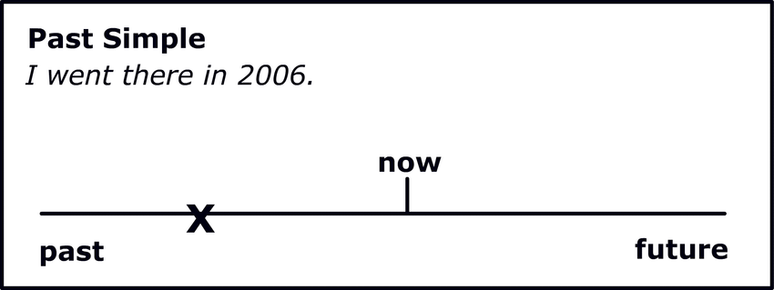

-My hair was black when I was a girl, but it’s brown now.

**2. Actions that happened one after the other in the past (like in a story) Sequencing

-I **went** into the disco and I **saw** my favourite girl, then I **asked** her to dance,.........

**\*\*Regular verbs (positive):**

We form the past tense of most regular verbs by adding –ed to the verb.

Work + ed = worked

Watch + ed = watched

Listen + ed = listened

***Note the spelling rules:***

1. ***Add –d to verbs that end in –e***

Live + d = lived

Change + d = changed.

1. ***With verbs that end in consonant + y: change ‘’y’’ into ‘’i’’ and add –ed***

Stu**dy** Stud**ied**

Car**ry** Carr**ied**

***If the verb ends in a vowel (a, e, i, o, u) + ‘’y’’, add –ed***

St**ay** Stayed

Pl**ay** Played

1. ***With verbs of one syllable that end in vowel+ consonant, double the consonant and add –ed,***

Plan Planned

Jog Jogged

**\*\*Regular Verbs (negative):**

**Subject + did+ not + base form of the verb**

Ancient people did not use compasses. (Correct)

Ancient people did not used compasses. (Wrong)

**\*\*Regular Verbs (questions):**

***-Wh questions***

Wh –word + did+ subject + infinitive verb

When did you finish work yesterday?

Who did John talk to yesterday?

***-Yes / No questions***

Did + subject+ infinitive verb

Did you study at university?

Yes, I did. No, I didn’t.

**\*\*Irregular verbs:**

Many common verbs in English have an irregular past form; they do not end in –ed in the past.

Have Had

Do Did

Go Went

Make Made

Irregular verbs form both negative and questions with did + the infinitive verb like the regular verbs.

*He gave his mother some flowers last week.

-Negative: He didn’t give his mother some flowers last week.

-Question: Did he give his mother some flowers last week?

*They went to Australia on holiday last year.

-Negative: They didn’t go to Australia on holiday last year.

-Question: Did they go to Australia on holiday last year?

**Key words

*Yesterday* / *Last week*, *Last* night, *Last* weekend / *Two days ago /*

On Saturday / Lately / Once upon a time / Long ago / 2 weeks ago.

***Practice***

*1. Complete the sentences with the correct form of the past tense:

1. My grandmother and grandfather lived (**live)** in the last century.

2. My uncle worked **(work)** in a factory.

3. My brother stayed **(stay)** at home.

4. He studied **(study)** at the University of Jordan.

5. He thought **(think)** that people had **(have)** problems with their weight because they ate **(eat)** the wrong things.

*2. Change the following sentences to questions:

1. Albert Einstein understood Math.

Did Albert Einstein understand math?

What did Albert Einstein understand?

2. Charles Darwin came from France.

Did Charles Darwin come from France?

Where did Charles Darwin come from?

1. Mozart played the piano.

Did Mozart play the piano?

What did Mozart play?

4. The ancient Romans spoke Latin.

Did the ancient Romans speak Latin?

What did the ancient Romans speak?

*3. Change the following verbs into past:

1. Plan: Planned 6. Stop: Stopped

2. Bin: Binned 7. Rot: Rotted

3. Dub: Dubbed 8. Knit: Knitted

4. Rub: Rubbed 9. Kidnap: Kidnapped

5. Slip: Slipped 10. Worship: Worshipped

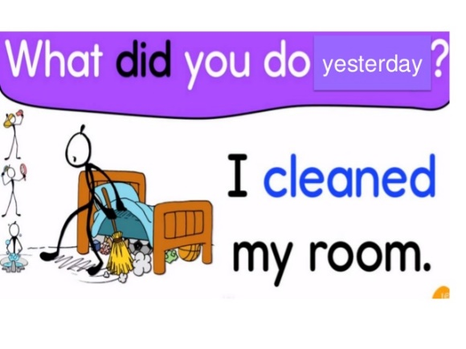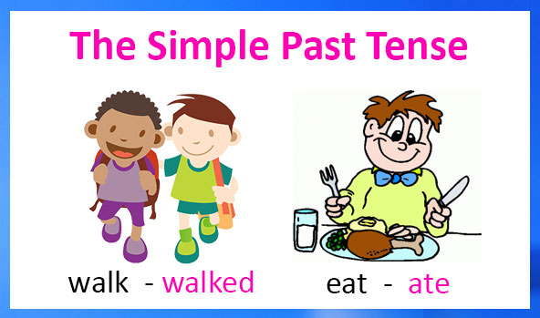

Coordinator’s Signature: _______________

Teacher: Mirna Nawaf Al-Sahawneh.

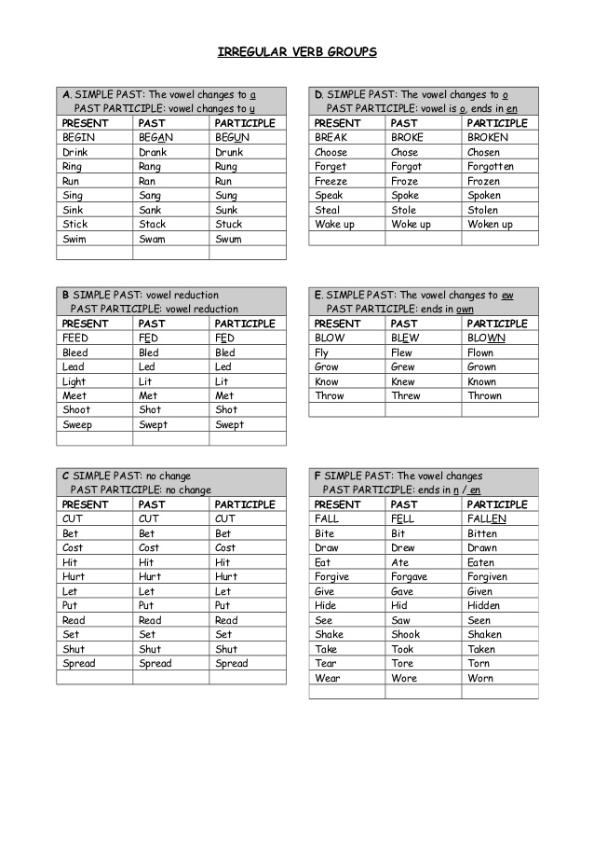

Teacher: Mirna Nawaf Al-Sahawneh

Extra:

Change the following sentences to negative:

1. She met her friends at school.

She didn’t meet her friends at school.

2. We knew the answers.

We didn’t know the answers.

3. We had dinner at a restaurant yesterday.

We didn’t have dinner at a restaurant yesterday.

4.My mom made a delicious cake.

My mom didn’t make a delicious cake.

5.I carried the heavy bag myself.

I didn’t carry the heavy bag myself.