
Worksheet ( 8 )
Tolerance is the power of life.
Grade 2
Name: ------------ Date: 1 / 10 /2022
________________________________________________ Objectives: To use subjective and objective pronouns.

A pronoun is a word that takes the place of a noun.
*Sally saw Ramez yesterday.
She saw him yesterday.
*Ramez saw Sally yesterday.
He saw her yesterday.
***Subjective pronouns come before the verb.
***Objective pronouns come after the verb.

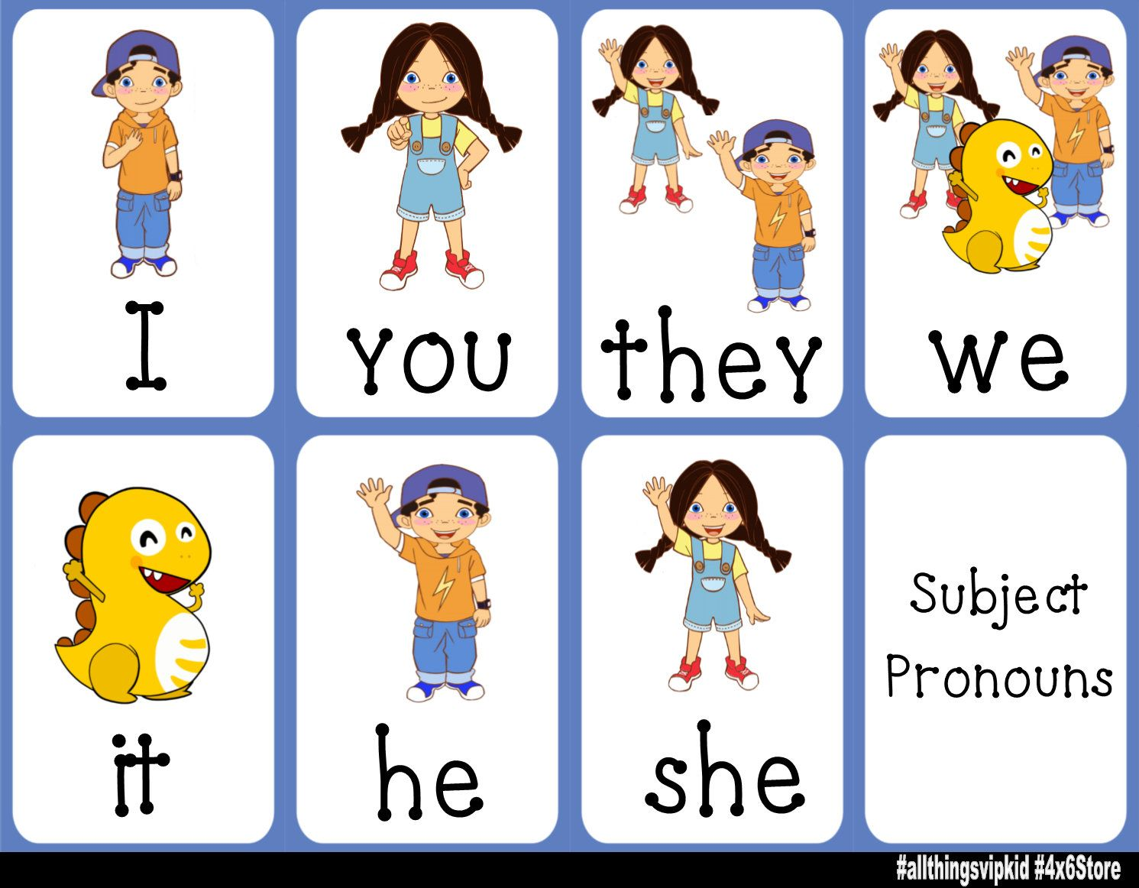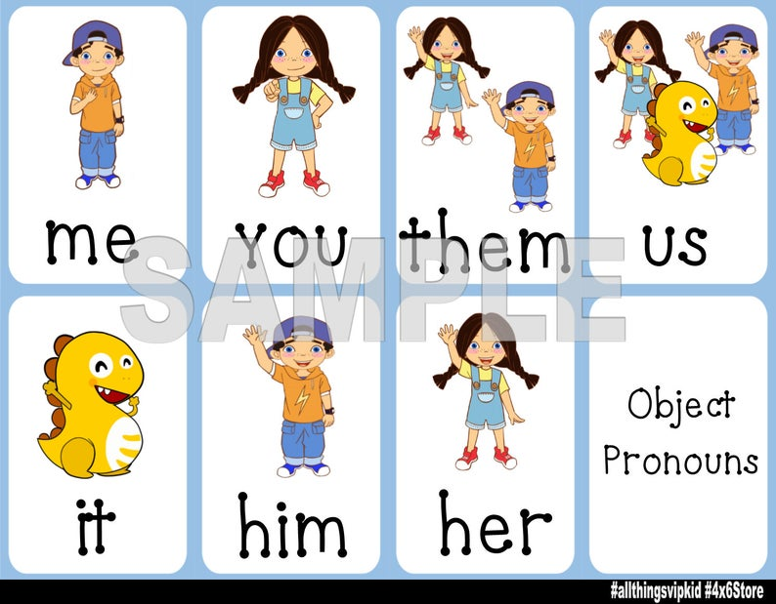

Subjective pronoun | Objective pronoun
I | me
You | you
He | him
She | her
It | it
We | us
They | them

- Use one of the words in the box to replace the words given.
She He They You We It I

Words | Pronouns
Rana and I | We
My brother | He
My mother | She
Zaid and Yazeed | They
frogs | They
boys | They
MY Dad | He
Hashem | He

2-Circle the correct answer.
1-He is dancing. Look at __________.
her him me
2-We don’t know the road. Please help ______.
They her us
3- My sister is singing. Listen to________.
her me them
4- I am playing football. Would you please play with____?
her him me

T.Taghreed Alnimri Coordinator’s Signature:

