
Worksheet (7)
Tolerance is the power of life.
Grade 2 (A+B)
Name: Date: 28 / 9/2022 ______________________________________________
Objective: To identify and use subject pronouns.
*A pronoun is a word that takes the place of a noun.
*Subject pronouns are those pronouns that perform the action in a sentence.

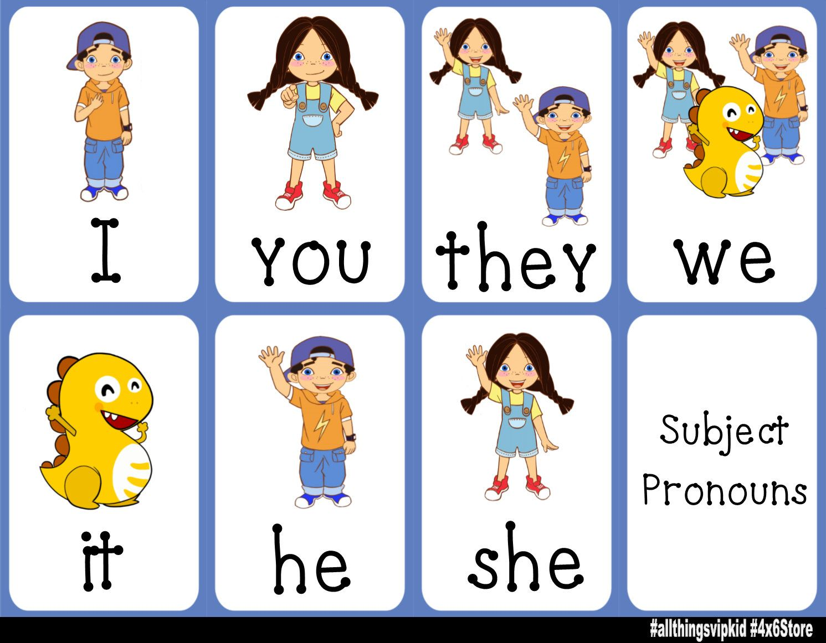


11)Circle the subject pronouns in each sentence.
1. You are funny!
2.She is reading a story.
3.We are late again!
4.It is a small bag.
5.They are in grade two.
6.He is writing new words.

2)Use one of the words in the box to replace the words given.
She He They You We It I

Words | Subject Pronouns
My father | He
My sister | She
Masa and Julia | They
A dog | It
Children | They
Chairs | They
Ward | He
Jehad and I | We
Amphibians | They
3) Use the following subject pronouns in sentences of your own.
He: He is my dad.
She: She is my sister.
I: I am seven years old.

T.Taghreed Alnimri Coordinator’s Signature:

