
Worksheet (6)
Tolerance is the power of life.
Grade 1
Name: Date: 27 /9/2022
Objectives: To identify the meaning of new words.
To practise using the new words in sentences.
Study the words below:
Word | Meaning
family | 
father | 
mother | 
brother | 
sister | 
grandmother | 
grandfather | 
friends | 
big | 
small | 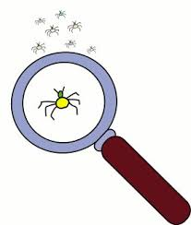

2) Circle the correct word:

mother –friend– grandfather
mother - father- brother
grandmother -family - friends

3)Fill in the blanks with the correct word:
big grandmother friends sister

- Karam and Tia are friends.
- My grandmother makes delicious food.
- The correct spelling of the word sister is s-i-s-t-e-r.
- Our house is very big .
T.Taghreed Alnimri Coordinator’s Signature:

