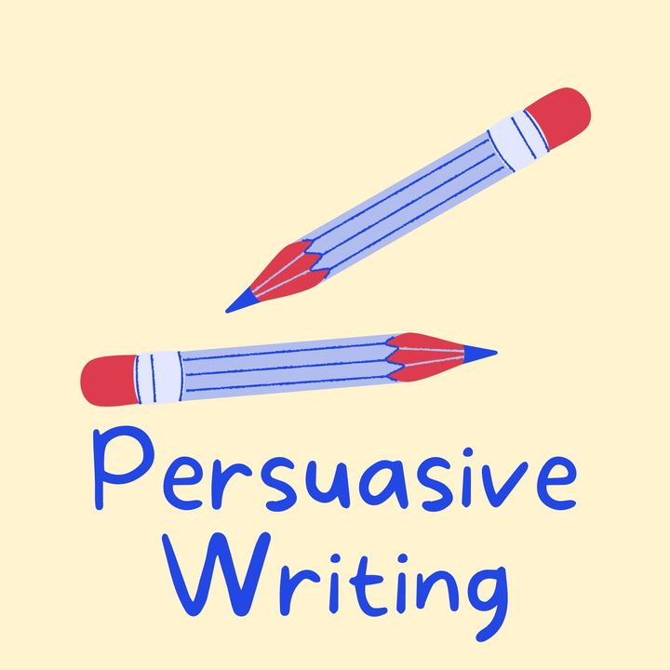

**Writing Checklist**

Did you include….?

|  |  |
| --- | --- |
| an opening sentence that hooks the reader and explains why you are writing in the introduction paragraph |  |
| body paragraphs that explain a point each and evidence to support it |  |
| emotive language, such as ‘Everyone would be ecstatic if…’ |  |
| persuasive phrases from the persuasive phrases word mat |  |
| rhetorical questions, such as ‘Are we supposed to just sit back…? |  |
| exaggeration, such as ‘It would be a tragedy if…’ |  |
| flattery, such as ‘I’m sure that you have noticed…’ |  |
| a conclusion that summarizes that main point and reinforces the opinion |  |
| ‘Yours faithfully’ if you don’t know the recipient or ‘Yours sincerely’ if you do know the recipient |  |
| simple, compound and complex sentences |  |
| 180-250 words |  |