|  |
| --- |
| **Grammar Worksheet/Unit 1/ Family Ties** |
| **Name:** |
| **Grade: 7 ( A )** |

**Simple present:** We use the simple present form of the verb to talk about habits and repeated situations, permanent situations, scientific facts and future actions based on timetables and schedules.

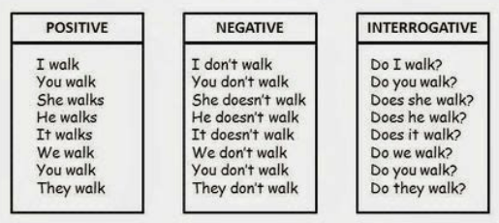Explore the following examples:

**Present continuous:** We use the present continuous form to talk about actions happening now, temporary situations, future plans, annoying habits, and changing and developing situations in the present.

Explore the following examples:

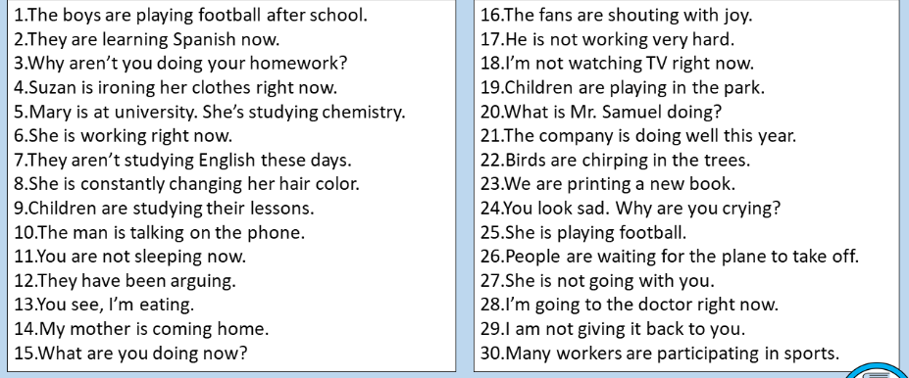

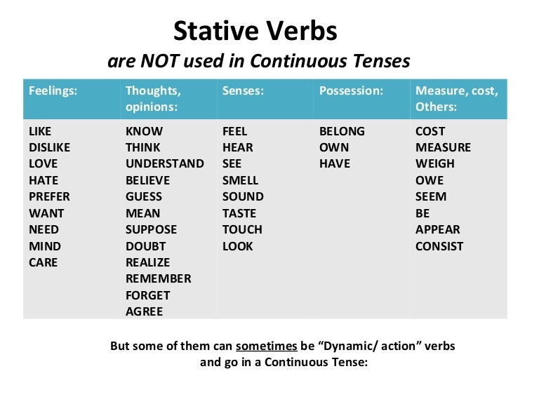Stative verbs:

**Circle the correct answer:**

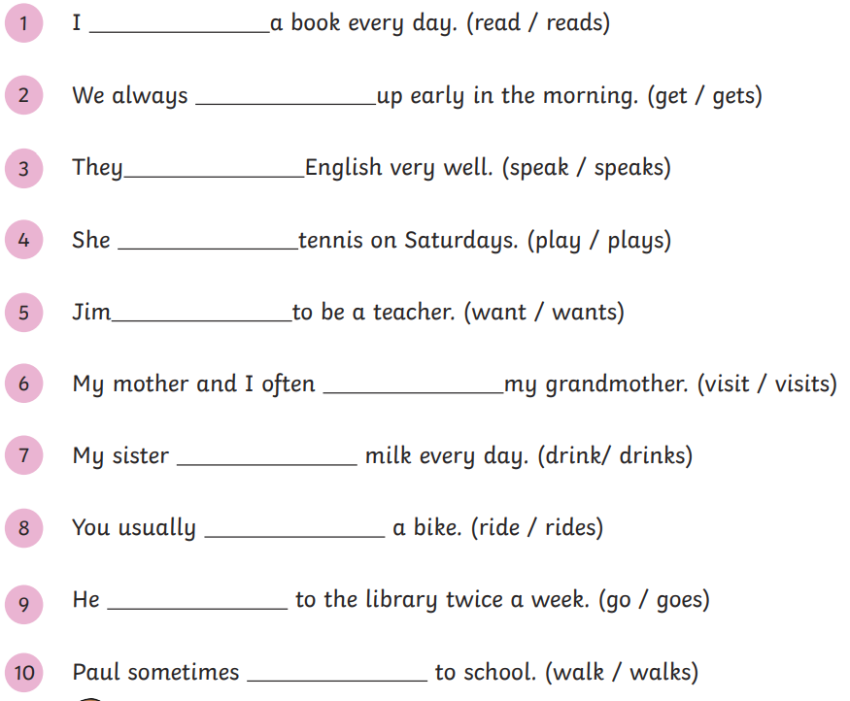

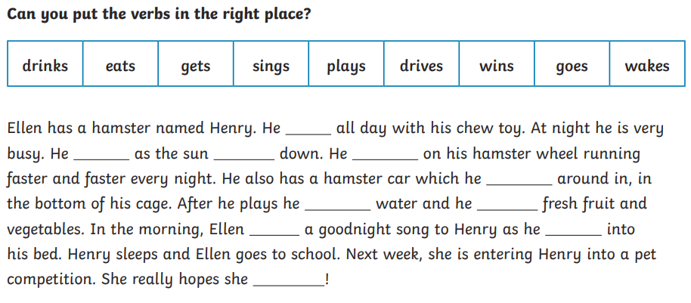

**Use the present continuous form of the verb to fill the blanks:**

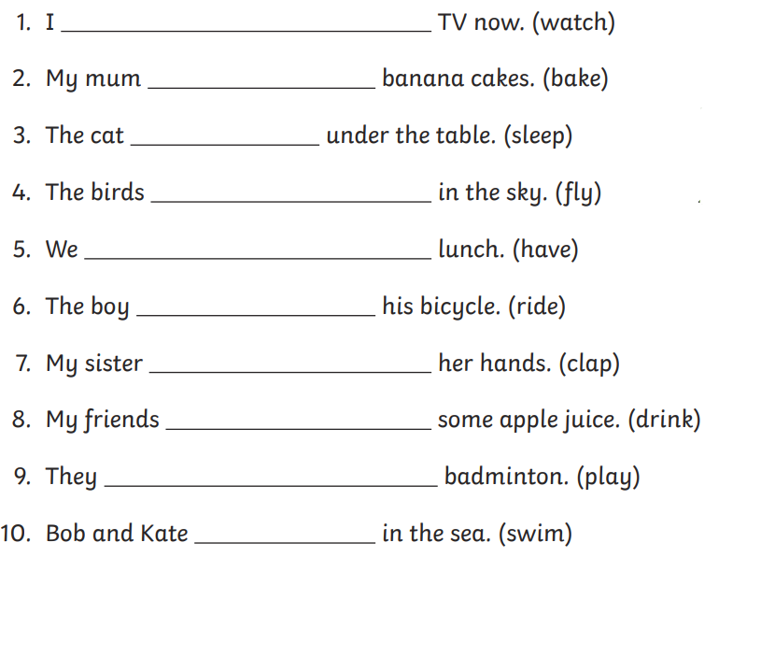

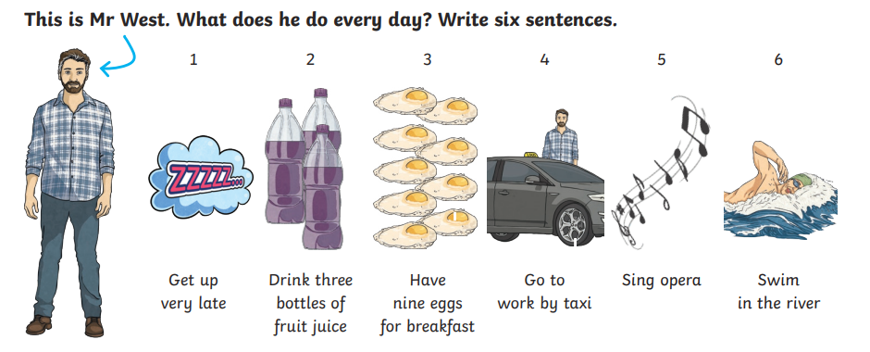

1. _____________________________________________________________________
2. _____________________________________________________________________
3. _____________________________________________________________________
4. _____________________________________________________________________
5. _____________________________________________________________________
6. _____________________________________________________________________