 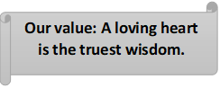

**Grammar Worksheet ( Revision) Grade 7**

**Worksheet No. (5)**

**Name ………………… Date: / /**

**Objectives: To revise the present continuous tense.**

**To practice forming and using the present continuous tense.**

**\*\*Form:**

| **Affirmative** | **Negative** | **Interrogative** |
| --- | --- | --- |
| **I** am going | I am not going | Am I going? |
| **You** are going | You aren't going. | Are you going? |
| **He, she, it**is going | He, she, it isn't going | Is he, she, it going? |
| **We** are going | We aren't going | Are we going? |
| **You** are going | You aren't going | Are you going? |
| **They** are going | They aren't going | Are they going? |

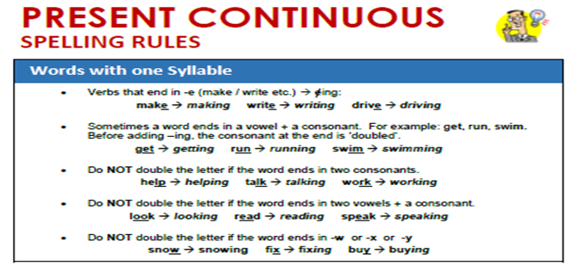

***Verbs end in (ie) change the (ie) into (y) then add (ing)

Die dying

**Present Continuous Uses**

**USE 1: Now**

present continuous now

Use the present continuous with [normal verbs](https://www.englishpage.com/verbpage/types.html) to express the idea that something is happening now, at this very moment. It can also be used to show that something is not happening now.

Examples:

* You **are learning** English now.
* You **are not swimming** now.

**USE 2: Actions that are temporary (around the time of speaking)**

present continuous longer duration

* I **am studying** to become a doctor.
* I **am reading** the book *Tom Sawyer.*
* I **am not reading** any books right now.
* **Are** you **working** on any special projects at work?

### USE 3: Near Future

present continuous near future

Sometimes, speakers use the present continuous to indicate that something will or will not happen in the near future.

Examples:

* I **am meeting** some friends after work.
* I **am not going** to the party tonight.
* **Is** he **visiting** his parents next weekend?
* **Isn't** he **coming** with us tonight?

**\*A) Complete the following sentences using Present Continuous Tense. (Capitalize when needed)**

1. My son________________ (**talk**) on the phone right now.

2. ___________ ___________________ ________________ (**you** / **sleep**)?

3. Jason ____________________________ (**do**) his homework at the moment.

4. Tom ___________________(**work**) on a project nowadays.

5. My kids _______________________ (**play**) in the garden now.

6. Some people ______________________ (**wait**) to talk to you.

7. My wife ________________________ (**not/** **cook**) today.

8. _________________________________ (**Lucas** / **study**) for his exam right now?

9. ____________________________________ (**Ryan** / **play**) the piano now?

10. Lea and I ___________________________________ (**paint**) the fences today.

11. Andrea ________________________________________ (**help**) me at present.

12. My children _________________________________________ (**not/** **listen**) to the radio now.

13. Selena __________________________________(**not/** **drink**) tea now.

14. I ___________________________________(**vacuum**) the carpet right now.

15. My father ______________________________________ (**watch**) TV now.

16. What ______________________________________ (**she** / **eat**) right now?

17. _______________________________________________(**your** **dog** / **hide**) from me?

18. What book ________________________________________ (**you** / **read**) nowadays?

19. Thomas ______________________________________________ (**drive**) me home now.

20. I ___________________________________________(**wash**) my face at the moment.

*B) Complete the sentences with the words between brackets using simple present or present continuous. Write the use under each sentence.

1.Look! She_____________ **(run)** because she's late for her lesson.

__________________________________________

2.Our teacher always__________ **(give)** us lots of homework.

___________________________________________

3.We never_______________ **(go)** to the cinema.

__________________________________________

4.What time_______________ **(you / meet)** Pete tomorrow?

__________________________________________

5.I_____________ **(not work)** today. I'm on holiday.

__________________________________________

6.Pete ________________ **(make)** a project these days.

__________________________________________

7.Andrew _____________ (not use) his computer at the moment.

__________________________________________

8.___________________ **(Tony / live)** near the park?

______________________________________

9.Earth _____________ around. **(move)**

______________________________________

10.The football match ___________ at 6:00 p.m. **(begin)**

______________________________________

Coordinator’s Signature: ______________________