** Vocabulary _ Unit 1**

Value: A loving heart is the truest wisdom.

**(The Earthworm and the Spider)**

**Name ………………… Grade (6)**

|  |
| --- |
| **Objectives**  **1. Identify the meaning of new words.**  **2. Identify the synonyms of the words.**  **3. Practice using the new words in sentences.** |

**Verbs**

|  |  |  |
| --- | --- | --- |
| **Word** | **Synonym** | **Meaning** |
| Wriggle | Twist | To turn with quick writhing movement.  Example: He was able to escape because he wriggled through the tunnel. |
| Insist | Say firmly | To say something forcefully.  Example: My neighbor insisted to have me for dinner in his house. |
| Admire | Love | To love and appreciate.  Example: I admire my parent’s patience. |
| Labor | Work hard | Example: We labored all day in the field. |
| Discourage | Persuade against | To persuade someone against an action.  Example: His reaction discouraged me. |
| Depart | Leave | To leave from one place to another.  Example: The train will depart from platform 9. |
| Fade | Disappear | To disappear slowly.  Example: Old soldiers never die, they just fade away. |
| Shone | Beam | Gave out or reflected light.  Example: The lamp in the window shone away for hours. |

**Adjectives**

|  |  |  |
| --- | --- | --- |
| **Word** | **Synonym** | **Meaning** |
| Isolated | Far away | Far away from other places, buildings or people.  Example: He was isolated from all the other prisoners. |
| Hazardous | Dangerous | Dangerous.  Example: Talking to strangers is hazardous. |
| Skeptical | Doubting | Having doubts or reservations.  Example: The patient was skeptical about the result of his checkup. |
| Suspicious | Unsure | Unsure.  Example: They were suspicious about the strange man so they called the police. |
| Exquisite | Very beautiful | Example: I found exquisite jewelry in the store. |
| Unseen | Hidden | That cannot be seen.  Example: I managed to slip out the room unseen. |

**Nouns**

|  |  |  |
| --- | --- | --- |
| **Word** | **Synonym** | **Meaning** |
| Strand | Shoreline / thread | The shore of a large river.  Example: I found a shell on the strand. |
| Sapphire | A precious stone | A precious stone typically blue.  Example: Sapphire is expensive because it’s hard to find. |
| Herds | Flock | Large number of animals that live and eat together.  Example: The reindeer herds are slowly dying off. |
| Base | Bottom / support | A starting point from which something develops or is made.  Example: The statue has a solid concrete base. |

**Adverbs**

|  |  |  |
| --- | --- | --- |
| **Word** | **Synonym** | **Meaning** |
| Gratefully | Thankfully | In a way that shows thanks to someone.  Example: All donations will be gratefully received. |

1. **Write the synonym of each of these words**:
2. isolated far away
3. Hazardous dangerous
4. Wriggle twist
5. Skeptical doubting
6. Insist say firmly
7. Admire love
8. Labor work hard
9. Strand shoreline/thread
10. Discourage persuade against
11. Sapphire precious stone
12. Suspicious unsure
13. Exquisite very beautiful
14. Depart leave
15. Herds flock

15.Fade disappear

16.Unseen hidden

17.Base bottom/support

18. Shone beam

19. Gratefully thankfully

1. **Write the correct word under each picture.**

|  |
| --- |
| Isolated _ Hazardous _ Wriggle _ Skeptical _ Admire _ Labor _ Strand  Discourage _ Depart _ Suspicious _ Sapphire _Herds _Fade _ Unseen _ Base_ Shone_ Gratefully |

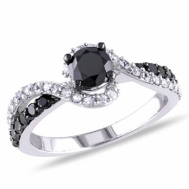   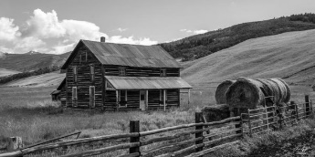

Sapphire suspicious depart isolated

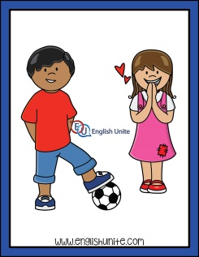 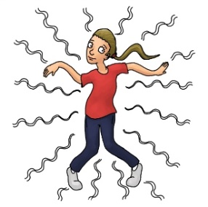  

Admire wriggle skeptical hazardous

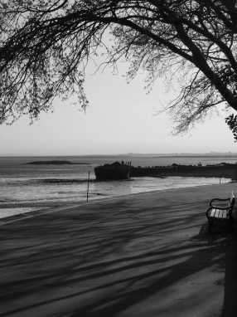 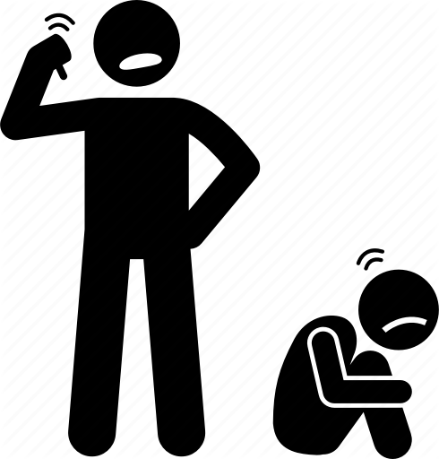 

strand Discourage labor

  

Gratefully shone base unseen

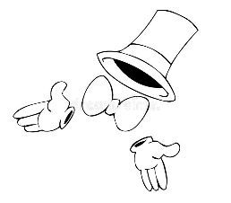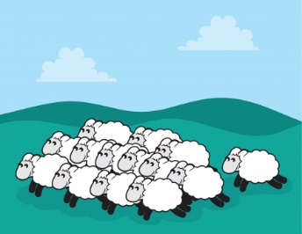

Fade herds

1. **Fill in the gaps with the correct words from the box.**

|  |
| --- |
| Isolated _ Hazardous _ Wriggle _ Skeptical _ Admire _ Labor _ Discourage _ Strand _  Depart _ Suspicious _ Sapphire_ insist _ exquisite |

1. The manager forced the worker to labor really hard.
2. He is a kind man. We all admire him.
3. Stay and have lunch. I insist!
4. They were skeptical about how much the house cost.
5. The snake wriggle to get out of the mud.
6. Garden tools can be hazardous if you use them carelessly.
7. The castle is isolated from the other buildings.
8. Flights for Amman depart from terminal 3.
9. Her wedding dress was exquisite.

10.The boat was sailing towards the strand of the river.

11. Don’t discourage her! She’s doing her best.

12.She had the sapphire set on a gold ring.

13.I’m suspicious about my little brother’s friend.

1. **Find the synonyms of the following words in the crossword and write them down.**

|  |  |  |  |  |  |  |  |  |  |  |  |  |  |  |  |
| --- | --- | --- | --- | --- | --- | --- | --- | --- | --- | --- | --- | --- | --- | --- | --- |
| s | u | s | p | i | c | i | o | u | s | r | s | u | i | o | s |
| q | s | d | i | c | s | f | s | r | i | c | u | o | u | s | t |
| c | a | e | s | t | a | r | e | h | b | n | e | d | l | e | r |
| s | p | p | o | i | s | k | e | p | t | i | c | a | l | x | a |
| t | p | a | l | t | h | a | z | a | r | d | o | u | s | q | n |
| r | h | r | a | p | f | p | d | s | h | a | i | e | c | u | d |
| e | i | t | t | o | c | o | p | x | i | f | c | k | e | i | e |
| a | r | h | e | b | p | p | j | o | k | e | a | x | z | s | n |
| d | e | i | d | r | s | w | r | i | g | g | l | e | e | i | t |
| m | s | r | i | p | r | s | f | g | l | a | b | o | r | t | u |
| i | e | e | t | y | d | i | s | c | o | u | r | a | g | e | m |
| r | o | t | v | h | e | a | d | g | q | p | d | h | u | h | g |
| e | q | u | d | o | h | f | m | i | n | s | i | s | t | x | z |

Far away_________ Dangerous ___________ Twist____________ Doubting_________

Say firmly ________ Adore __________

Work hard ________ Shoreline ________

Unsure _________ Beautiful _________ Leave __________ Persuade against__________

A precious -stone __________

Coordinator’s Signature: _________________

Teacher: Mirna Nawaf AL-Sahawneh.