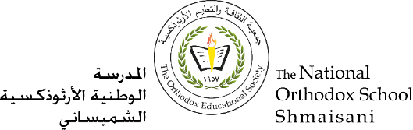ه

**The Primary Stage of Grades (4-5)**

**School Year 2022 - 2023**

**The name of The Father, The Son and The Holy Spirit. Amen**

**Worksheet N.(2)**

**Name**: ___________ **Subject**: **The four evangelists**

**Date: / / Class: Grade four**

**Golden verse: ‘I am not ashamed of the gospel, because it is the power of God for the salvation of everyone who believes’**

**(Romans( 1: 16)**

1-What are the parts of the Holy Bible?

The Old Testament.

The New Testament.

2-What is the meaning of Gospel?

The Good News.

3-What are The New Testament sections?

The four Gospels.

The acts of the Apostles.

The Letters.

The Revelation.



4-In which language was The Gospel written?

The Gospel was written in Aramaic and Greek languages.

5-Who wrote The Acts of the Apostles Book?

|  |  |
| --- | --- |
| Evangelist’s name | His work |
| Mathew | He was as a tax collector |
| Mark | He was an evangelist |
| Luke | He was a doctor and a painter. |
| John | He a fisherman |

Luke the Evangelist.

**Good Luck**