Read and write the words.
1
hazardous depart isolated sapphire exquisite labor

1 This is a precious stone that is often blue. _______________
2 This is something you do when you work hard. _______________
3 This word describes something elegant and lovely. _______________
4 This means you leave a place. _______________
5 This means something is very dangerous for your health. _______________
6 You feel like this if you are kept apart from others. _______________
Look and write full sentences using the future continuous. Then match.
2
1 She / study / English / Saturday
_______________________________________________________

2 They / travel to Peru / next Saturday
_______________________________________________________

3 The train / crossing the bridge / this afternoon
_______________________________________________________

4 Charles / climbing a mountain / Sunday
_______________________________________________________

5 We / running a race / spring
_______________________________________________________

6 He / living in France / summer
_______________________________________________________

7 They / coming to lunch / next week
_______________________________________________________
C
B
A

 | 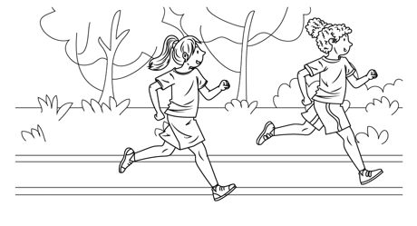  E |  | 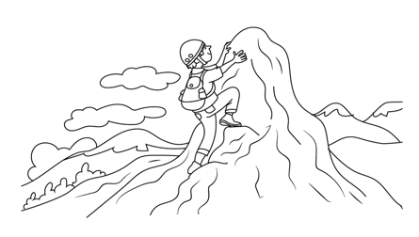 |  | 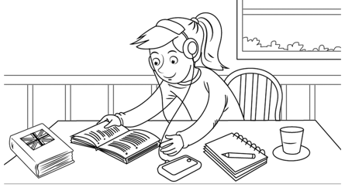
 | 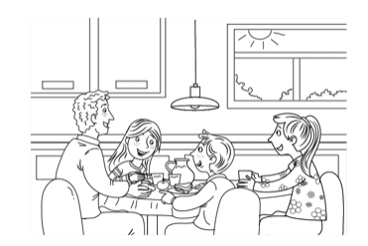  D | 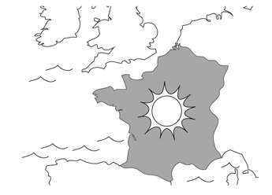  F |  | 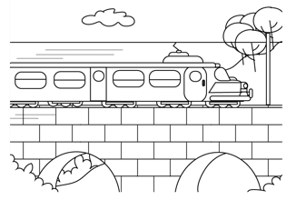  G |  | 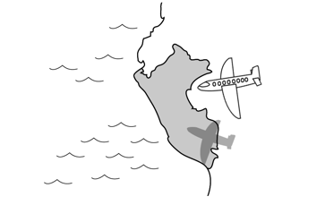

Read and answer the questions with full sentences.
3
The Sydney Harbour Bridge
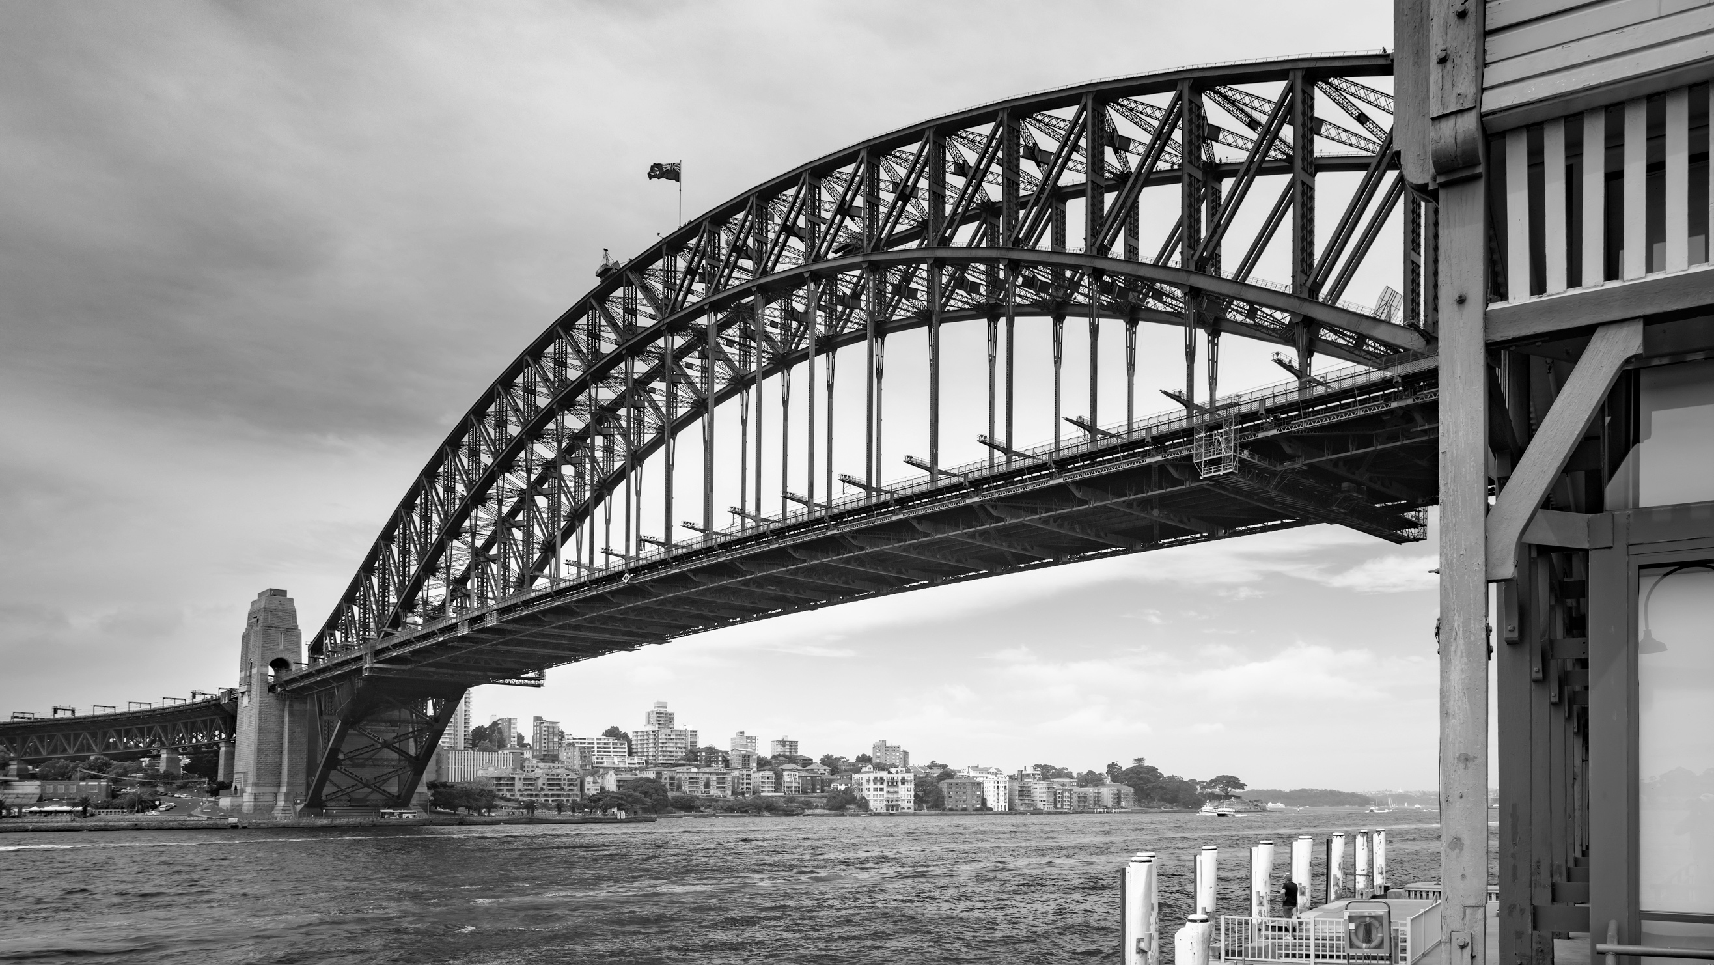
The Sydney Harbour Bridge is one of the most famous sights in Australia and millions of visitors take photos of it every year. Here are some facts about the Sydney Harbour Bridge that you may not know!
- It is sometimes called the Coat Hanger. Can you guess why?
- It has eight lanes for cars, two train lines, a footway, and a cycle path.
That is a wide bridge!
- Why is the bridge painted a boring gray? Because when it came time to paint it, gray was the only color they could find in enough quantity.
- It took 1,400 men to build the bridge over eight years.
- More than 1,600 cars cross it every day.
- It moves! The arch of the bridge can rise or fall by up to 18 centimeters due to heating and cooling.
1 What is the author’s purpose?
_____________________________________________________________________
2 How do you know?
_____________________________________________________________________
3 What do you think is the most interesting fact? Why?
_____________________________________________________________________
4 Summarize the text in 25 words or less.
_____________________________________________________________________
_____________________________________________________________________
Write about a bridge or tunnel that you find interesting.
4
_________________________________________________________________
_________________________________________________________________
_________________________________________________________________
_________________________________________________________________
_________________________________________________________________
_________________________________________________________________

