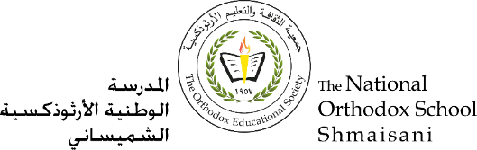

**The Primary Stage of Grades (4-5)**

**School Year 2021 - 2022**

**Name** : \_\_\_\_\_\_\_\_\_\_\_ **Subject** : English Language

Writing Fiction Studysheet

**Date : / / Class : Grade 4 CP (All Sections)**

**\_\_\_\_\_\_\_\_\_\_\_\_\_\_\_\_\_\_\_\_\_\_\_\_\_\_\_\_\_\_\_\_\_\_\_\_\_\_\_\_\_\_\_\_\_\_\_\_\_\_\_\_\_\_\_\_\_\_\_\_\_**

**Objective/s: identify the main elements of a story**

* **Identify the features of adventure stories, science fiction stories and fantasy stories.**

All books are either non-fiction or fiction. Fiction books are ones that have been made up. Perhaps some of their elements are based on hints of truth, but they have been fabricated into a new story.

**Elements of a Short Story**

|  |  |
| --- | --- |
| **Story Element** | **Definition** |
| C:\Users\user\AppData\Local\Microsoft\Windows\INetCache\IE\5MYLKWYF\3d-Earth-Globe[1].pngC:\Users\user\AppData\Local\Microsoft\Windows\INetCache\IE\4EE4CUEM\sands-of-time[1].png Setting | Setting includes both time and place!    1. Time – day, month, year, time of day, season    2. Place – state, country, area, building, surroundings |
| Characters  C:\Users\user\AppData\Local\Microsoft\Windows\INetCache\IE\QFP0LWES\secondhand_youth_characters_by_t_drom[1].jpgC:\Users\user\AppData\Local\Microsoft\Windows\INetCache\IE\X911Y1CY\famous-cartoon-character-road-runner[1].jpg | The characters are the people (or animals, monsters, robots, and so on) who appear in the story. |
| Plot    C:\Users\user\AppData\Local\Microsoft\Windows\INetCache\IE\X911Y1CY\1383412929[1].png The sequence of events that happen in a story; all the action that takes place…  beginning, middle, end | Introduction – introductory information that provides setting, introduces characters, and other facts necessary to understand the story.    Rising Action – events that occur before the climax (problem occurs)      Climax – the highest point of suspense/action; the point of the story where all of the actions change (towards the end of the story); turning point    Falling Action – events that occur after the climax; leads to the conclusion of the story    Resolution – point at which main conflict is resolved |
| Point of View    C:\Users\user\AppData\Local\Microsoft\Windows\INetCache\IE\5MYLKWYF\johnny-automatic-man-using-binoculars-2[1].png | The way a story is told...   * 1st person – the narrator is a character in the story and is telling it from his/her point of view - uses the pronouns I, we, me, or us      * 3rd person – the narrator is not a character in the story - he/she tells only what he sees or hears; like a movie camera - some are able to see into the minds of characters and reveal the thoughts of a character, also known as an outside observer/narrator - uses the pronouns he, she, they, them |

Stories can be divided into many different types, called “genres”. Some of these genres covered in unit one are:

1. **An Adventure story:**  A story in which the characters go somewhere or do something that could be exciting or dangerous.

**Key Features**

* The main character is a hero or heroine who is setting out on a journey to face a challenge.
* There are good and nasty characters.
* The setting changes, moving from place to place as we follow the hero/ heroine through his or her journey. It underlines the sense of danger and obstacles to be overcome.
* The story can be realistic or a fantasy.

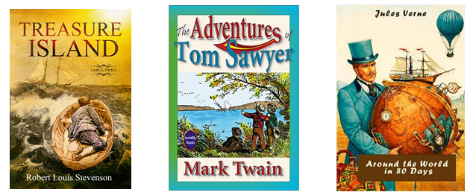Examples: Treasure Island, the Adventure of Tom Sawyer, Around the world in eighty days.

1. **Science Fiction** Science fiction stories are often set in the future or on another planet.

**Key Features**

* The setting is usually out of this world ( moon, spaceship, galaxy )
* They include possibilities like time travel, new technologies, alien worlds, virtual reality.
* They make the characters do exciting things and allow us to escape from our day – to day.
* Characters may include aliens and robots.

Examples: The War of the Worlds, A Space Odyssey, Star Wars.

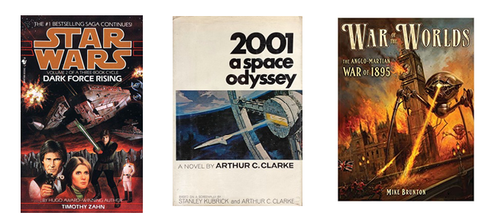

1. **Fantasy**: Fantasy stories are a product of the imagination involving magic and adventure.

**Key Features**

* They often include unusual or magical settings such as other worlds.
* Strange characters with magical powers, such as made-up creatures or animals that can talk.
* Impossible actions and outcomes.

Examples: Alice in Wonderland, Charlie and the Chocolate factory, Harry Potter.

