

**Our value: A loving heart is the truest wisdom.**

Simple Past Tense Worksheet No. (3)

Grade 5 (A + B)

Name: Date: / /

Objectives: To review simple past.

To practise forming and using this tense in sentences.

Simple Past Tense

|  |  |  |
| --- | --- | --- |
| Positive | Negative | Question |
| I **played / ran** in the park. | I **didn’t play / run** in the park. | **Did** I **play / run** in the park? |
| He **played / ran** in the park. | He **didn’t play / run** in the park. | **Did** he **play / run** in the park? |
| She **played / ran** in the park. | She **didn’t play / run** in the park. | **Did** she **play / run** in the park? |
| It **played / ran** in the park. | It **didn’t play / run** in the park. | **Did** it **play / run** in the park? |
| We **played / ran** in the park. | We **didn’t play / run** in the park. | **Did** we **play / run** in the park? |
| You **played / ran** in the park. | You **didn’t play / run** in the park. | **Did** you **play / run** in the park? |
| They **played / ran** in the park. | They **didn’t play / run** in the park. | **Did** they **play / run** in the park? |

**Uses:**

**1. We use the Past Simple to talk about actions and situations in the past. The actions and situations are finished.

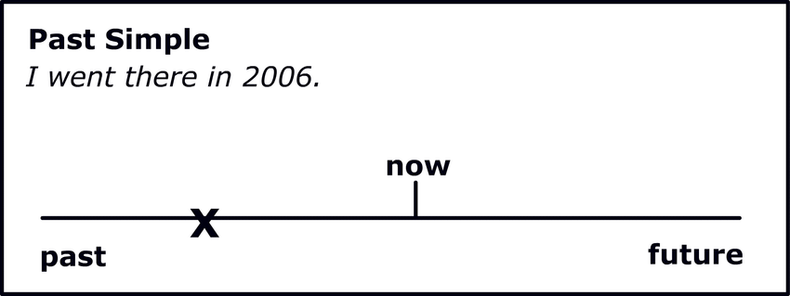

-My hair was black when I was a girl, but it’s brown now.

**2. Actinos which happened one after the other in the past (like in a story) Sequencing

-I **went** into the disco and I **saw** my favourite girl, then I **asked** her to dance,.........

**\*\*Regular verbs (positive):**

We form the past tense of most regular verbs by adding –ed to the verb.

Work + ed = worked

Watch + ed = watched

Listen + ed = listened

***Note the spelling rules:***

1. ***Add –d to verbs that end in –e***

Live + d = lived

Change + d = changed.

1. ***With verbs that end in consonant + y: change ‘’y’’ into ‘’i’’ and add –ed***

Stu**dy** Stud**ied**

Car**ry** Carr**ied**

***If the verb ends in a vowel (a, e, i, o, u) + ‘’y’’, add –ed***

St**ay** Stayed

Pl**ay** Played

1. ***With verbs of one syllable that end in vowel+ consonant, double the consonant and add –ed,***

Plan Planned

Jog Jogged

**\*\*Regular Verbs (negative):**

**Subject + did+ not + base form of the verb**

Ancient people did not use compasses. (Correct)

Ancient people did not used compasses. (Wrong)

**\*\*Regular Verbs (questions):**

***-Wh questions***

Wh –word + did+ subject + infinitive verb

When did you finish work yesterday?

Who did John talk to yesterday?

***-Yes / No questions***

Did + subject+ infinitive verb

Did you study at university?

Yes, I did. No, I didn’t.

**\*\*Irregular verbs:**

Many common verbs in English have an irregular past form; they do not end in –ed in the past.

Have Had

Do Did

Go Went

Make Made

Irregular verbs form both negative and questions with did + the infinitive verb like the regular verbs.

*He gave his mother some flowers last week.

-Negative: He **didn’t give** his mother some flowers last week.

-Question: **Did** he **give** his mother some flowers last week?

*They went to Australia on holiday last year.

-Negative: They **didn’t go** to Australia on holiday last year.

-Question: **Did** they **go** to Australia on holiday last year?

**Key words

*Yesterday* / *Last week*, *Last* night, *Last* weekend / *Two days ago /*

On Saturday / Lately / Once upon a time / Long ago / 2 weeks ago.

***Practice***

*1. Complete the sentences with the correct form of the past tense:

1. My grandmother and grandfather -------- (**live)** in the last century.

2. My uncle ------------- **(work)** in a factory in 1999.

3. My brother -------------- **(stay)** at home last night .

4. He -------------- **(study)** at the University of Jordan.

5. He ----------- **(think)** that people -------------- **(have)** problems with their weight because they ------------ **(eat)** the wrong things.

*2. Change the following sentences to questions:

1. Albert Einstein understood Math.

------------------------------------------

2. Charles Darwin came from France.

------------------------------------------

1. Mozart played the piano.

------------------------------------------

1. The ancient Romans spoke Latin.

--------------------------------------------

*5. Change the following verbs into past:

1. Plan: 6. Stop:

2. Bin: 7. Rot:

3. Dub: 8. Knit:

4. Rub: 9. Kidnap:

5. Slip: 10. Worship:

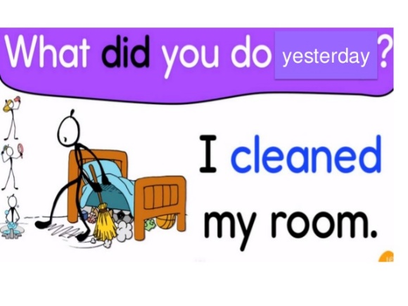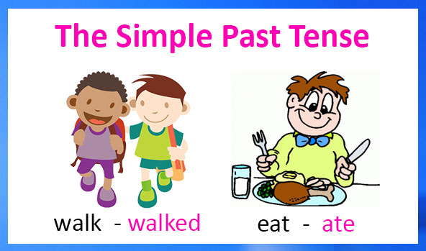

Coordinator’s Signature: _______________

Teacher: Mirna Nawaf Al-Sahawneh.

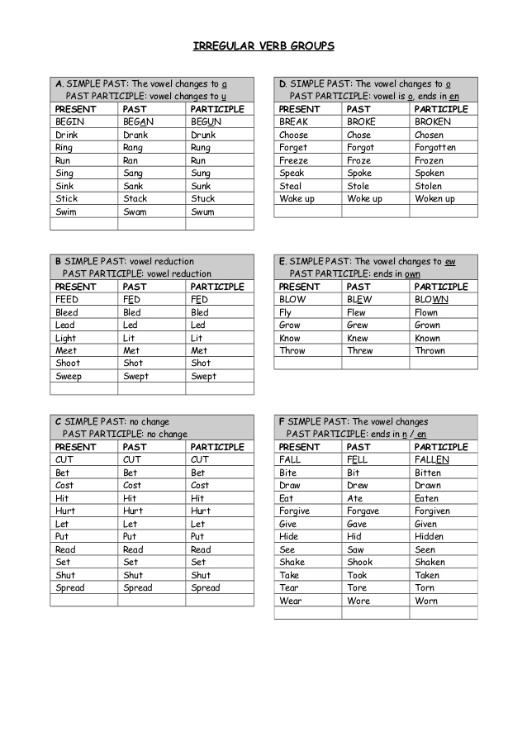

Change the following sentences to negative:

Extra:

Change the following sentences to negative:

1. She met her friends at school.

-------------------------------------------------------

2. We knew the answers.

-------------------------------------------------------

3. We had dinner at a restaurant yesterday.

---------------------------------------------------------

4.My mom made a delicious cake.

----------------------------------------------------------

5.I carried the heavy bag myself.

-----------------------------------------------------------