 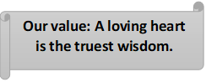

**Present Simple** Worksheet No.(3)

Name: _______________ Grade 6

Date: / /

Objectives: To review the present simple tense.

To practise using the present simple tense.

------------------------------------------------------------------------------------------------------------

|  |
| --- |
| ***Negative*** |
| He **doesn’t talk** |
| She **doesn’t talk** |
| It **doesn’t talk** |
| I **don’t talk** |
| You **don’t talk** |
| We **don’t talk** |
| They **don’t talk** |

Form: subject + verb

|  |
| --- |
| ***Affirmative*** |
| He **talks** |
| She **talks** |
| It **talks** |
| I **talk** |
| You **talk** |
| We **talk** |
| They **talk** |

|  |
| --- |
| ***Interrogative*** |
| **Does** he **talk**? |
| **Does** she **talk**? |
| **Does** it **talk**? |
| **Do** I **talk**? |
| **Do** you **talk**? |
| **Do** we **talk**? |
| **Do** they **talk**? |

|  |
| --- |
| ***Short answers*** |
| Yes, he **does**. / No, he **doesn’t**. |
| Yes, she **does**. / No, she **doesn’t**. |
| Yes, it **does**. / No, it **doesn’t**. |
| Yes, I **do**. / No, I **don’t**. |
| Yes, you **do**. / No, you **don’t**. |
| Yes, we **do**. / No, we **don’t**. |
| Yes, they **do**. / No, they **don’t**. |

**spelling (3rd person singular affirmative)**

* Most verbs take –s in the third person singular.

I work

He work**s**

* Verbs ending in –ss, - sh , -ch , -x or –o take –es .

I mi**ss** I wa**sh** I wat**ch**

He miss**es** He wash**es** He watch**es**

I fi**x** I g**o**

He fix**es** He go**es**

* Verbs ending in consonant + y drop they –y and take –ies.

I cr**y**

He cr**ies**

* But verbs ending in vowels +y take –s.

I pl**ay**

He play**s**

**Uses**

We use the present simple for:

1. Permanent states.

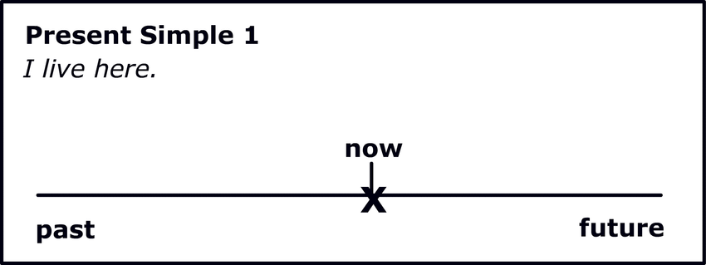

He **lives** in London.

Tom **works** for a construction company.

1. Daily routine.

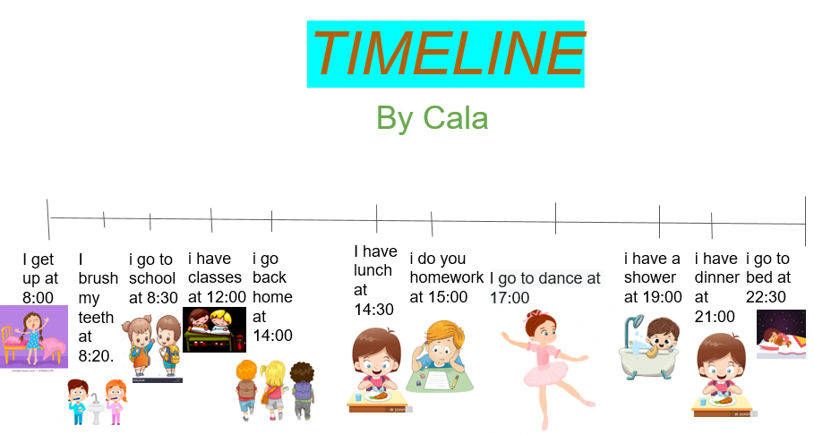

I **leave** work at 5 o’clock.

I usually **wake** up at 7:30.

1. Repeated habits.

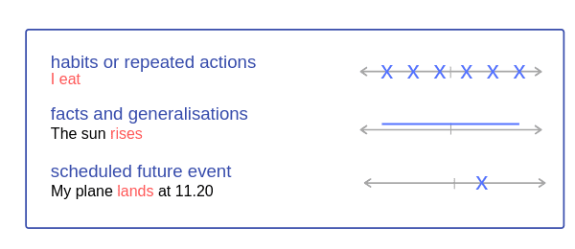

She **goes** to the gym every evening.

He usually **goes** swimming on Sundays.

1. General truths and laws of nature. ( Facts)



The sun **sets** in the west.

Water **freezes** at 0 C.

1. Time tables which we can’t change.



The first flight to London **leaves** at 9 am.

The match **finishes** at 7:45.

Time expressions used with the present simple:

Every hour /day / week / month / summer / year.

**(Adverbs of frequency):-**

Always (100%)

Usually ( 75 %)

Often ( 50 %)

Sometimes (25%)

* Adverbs of frequency are used before main verbs but after verb to be.

He **always** goes to school.

He is **always** late.

---------------------------------------------------------------------

Q) Complete the questions, then ask your partner to answer.

1. You/ play/ football/ on Saturdays?

-----------------------------------------------

2. your parents / work in an office?

-----------------------------------------------

3. your school bus / leave / 8 am?

-----------------------------------------------

1. your best friend / play music?

-----------------------------------------------

1. you/ live / big house?

-------------------------------------------

**Q2) Write the verbs in the correct form of simple present.**

1. I seldom --------------the younger. (imitate)

2. The headmaster ------------- always busy. (be)

3. The girl -------------- often late. (**not**/**be**)

4. ----------- they sometimes --------------- in the restaurant? (**eat**)

5. ------------ she usually-------------- alone? (**study**)

6.The agency (it) --------------- more requirements every year. (**not** / **need**)

7.The woman always --------------- mistakes. **(have)**

8. Children --------------- early every day. (**not**/ **sleep**)

9. The ministry (it) ----------------- a new plan yearly. (**apply )**

10. Water (it) -------------------- at 100 C. (**boil)**

Coordinator’s Signature: _________________

Teacher: Mirna Nawaf Al-Sahawneh.