

**Scratch-3 - Study Sheet#1**

**Name: Date:**

**Grade 6 ……. 1st Semester 2022/2023**

**Objectives –**

Create a simple clicker game.

To understand the use of the Event & Control Blocks.

**Create a Clicker Game**

1. Create a new project.
2. Name your new project (Clicker Game - Add your name)

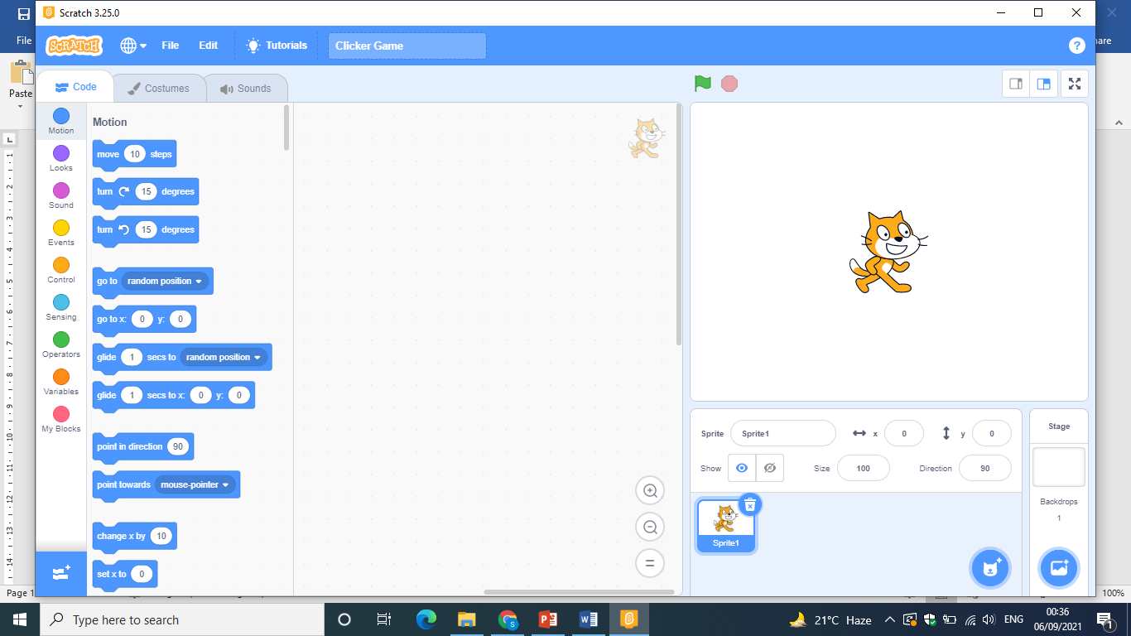

1. Remove Sprite1 from the stage.
2. Add the **(Woods)** backdrop.
3. Add the two sprites: **Hare** and **Butterfly1**.

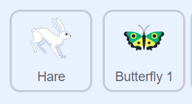

1. Add a new variable **(Score)** for all sprites.

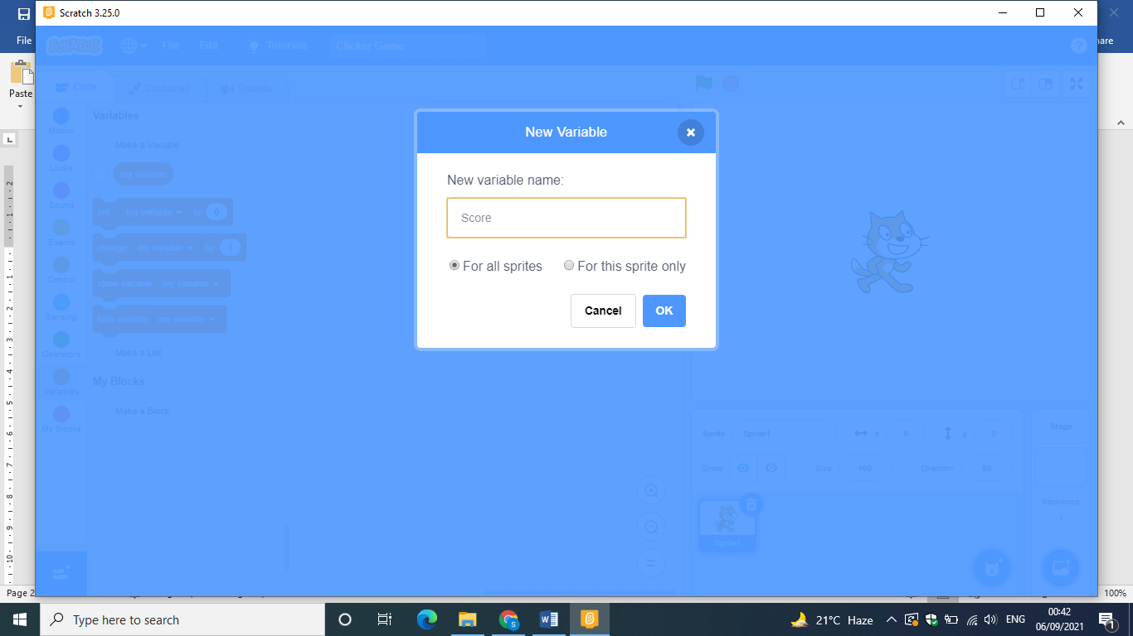

Score

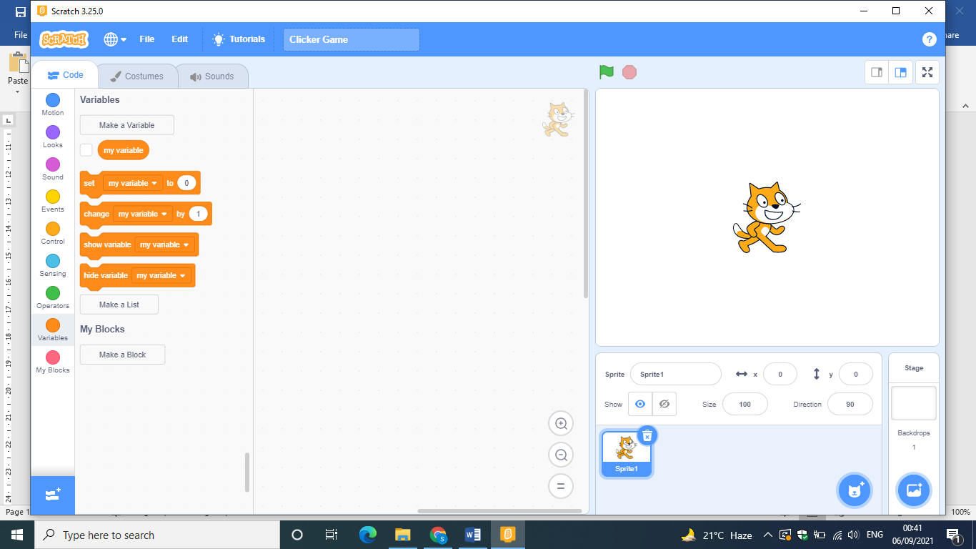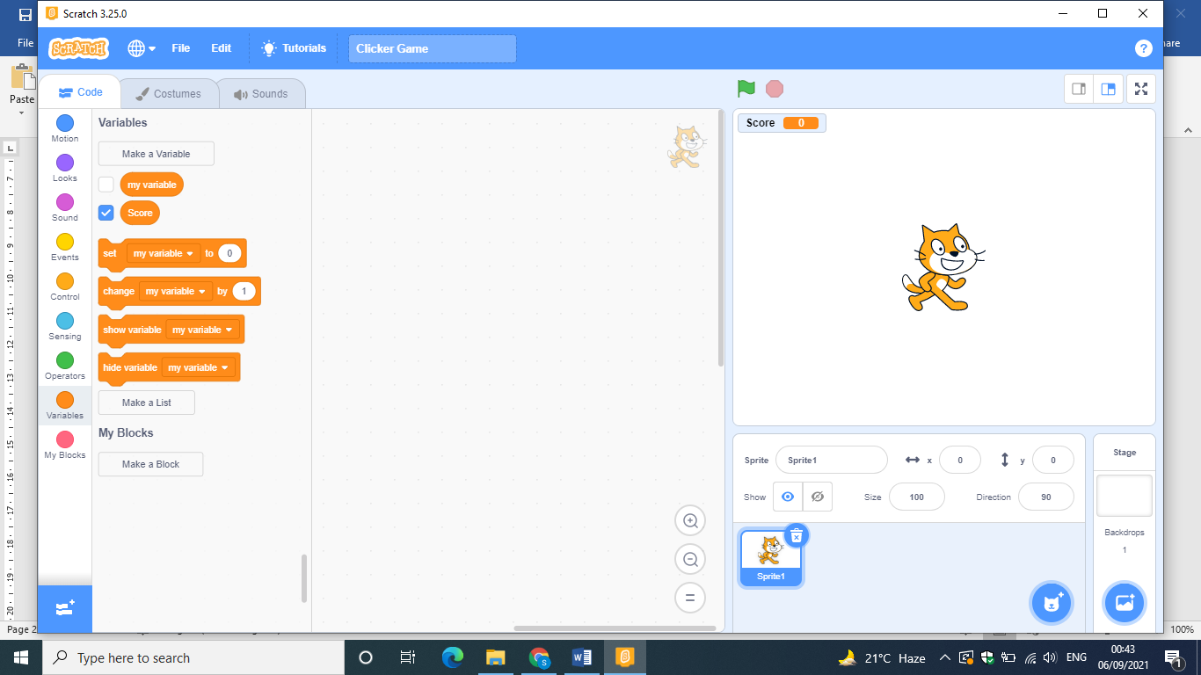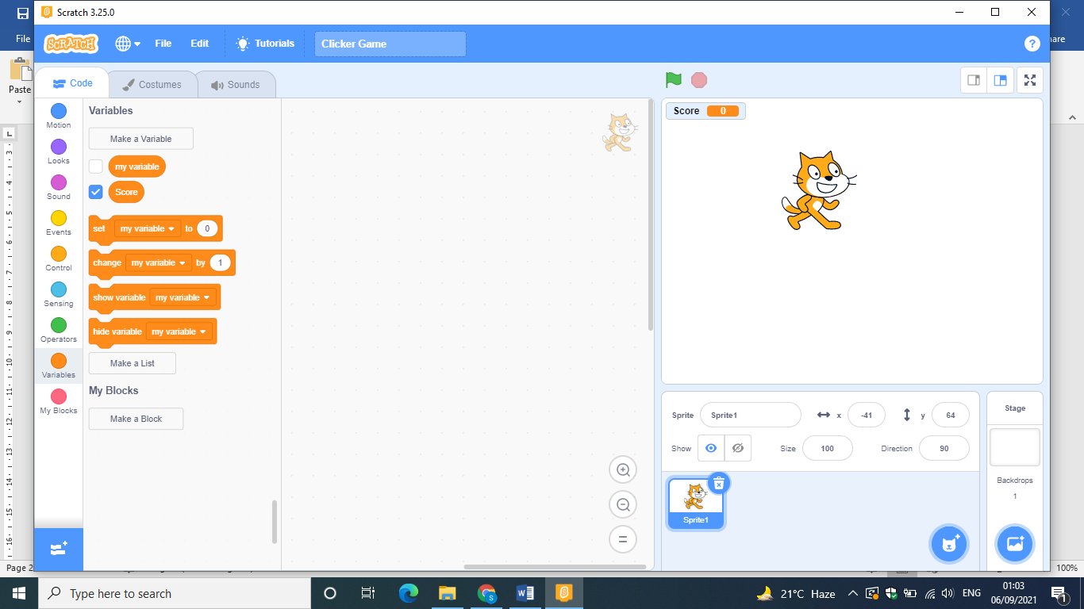

1. For this sprite **(Butterfly1):**

* 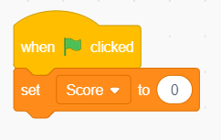Set the size to 60.
* Add (When flag clicked) from the Event Blocks.

Add **(Set the score to 0)**

* Add (When flag clicked) from Event Blocks.
* 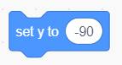Add Forever Loop from Control Blocks.
* Set Y to (-90)
* Go to random position.
* Wait 0.7 Second.
* Add a block to change the Costume (Next Costume).
* 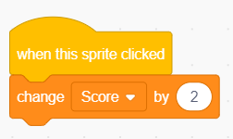If on Edge Bounce
* When clicks the butterfly

Change the score by 2.

1. For the Sprite **(Hare)**

* Add (When flag clicked)
* Go to X (-200) Y (-75).
* Add Forever Loop.
* 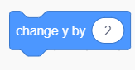Move 10 steps.
* Change y by 2.
* Next costume.
* Wait 0.2 seconds.
* If on edge bounce.
* Set rotation style (left to right)
* IF Touch the Butterfly then:
  + Say (Oh…Oh) for 2 sec
  + Wait for 1 sec

1. Save and Run your project.
2. Open the word document Clicker.docx.

Type your name on the top.

1. Take a screenshot for the **Butterfly** Code and paste below.
2. Take a screenshot for the **Hare** Code and paste below.
3. Save the word document.