** Vocabulary _ Unit 1**

Value: A loving heart is the truest wisdom.

**No (2)**

**(Dreaming of Dodos)**

**Name………………… Grade (5)**

|  |
| --- |
| **Objectives**  **1. Identify the meaning of new words.**  **2. Identify the synonyms of the words.**  **3. Practice using the new words in sentences.** |

**Verbs**

|  |  |  |
| --- | --- | --- |
| **Word** | **Meaning /Synonym** | **Example** |
| Survive | To continue to **live** or exist, especially in spite of danger. | If the industry doesn’t modernize, it will not survive. |
| Exploit | To make full **use** of and derive benefit from. | We must exploit every opportunity to learn new things. |
| Swish | To **move** with a hissing or rushing sound. | The horse’s tail swished back and forth. |
| Gush | To flow out of something in a rapid and plentiful stream/**burst.** | I wished Mummy wouldn’t gush over Peter’s little success at school, it makes him feel a fool in front of his friends. |
| Emerge | To **stand out** | Several facts started to emerge from my investigation. |
| Stumble | To **trip.** | Be careful! Don’t stumble over these stones. |
| Peer | To **stare.** | He peered from behind the tree. |

**Adjectives**

|  |  |  |
| --- | --- | --- |
| **Word** | **Meaning /Synonym** | **Example** |
| Extinct | Having no living members. **Dead**/vanished | It is 250 years since the wolf became extinct in Britain. |
| Endangered | Seriously **at risk** of extinction. | Pandas are endangered species. |
| Sleepy | Needing or ready for sleep. /**Dozy**. | The soft background music made her feel sleepy. |
| Miserable | **Unhappy** or uncomfortable. | We were cold, wet and thoroughly miserable. |
| Fiery | **Bright red, like fire.** | The sun was now sinking, a fiery ball of light in the west. |

**Nouns**

|  |  |  |
| --- | --- | --- |
| **Word** | **Meaning /Synonym** | **Example** |
| Dodo | **A large extinct flightless bird.** | It’s difficult to find dodo birds these days. |
| Quagga | **A South African extinct zebra.** | The quagga was a beautiful variant of the zebra. |
| Species | A group of living organisms. /**kind** | That species disappeared in the Ice Age. |
| Sea wolf | **Wolf fish.** | I read a book about sea wolves. |
| Woolly mammoth | A cousin of today's Asian elephant. | The woolly mammoth became extinct at the end of the last Ice Age some 11.000 years ago. |
| Habitat | The natural **home** of an animal or plant. | This creature’s natural habitat is the jungle. |
| Elephant birds | A huge, extinct, flightless birds. | Elephant birds died out hundreds of years ago. |
| Sanctuary | A nature **reserve**. | This island is maintained as a sanctuary for endangered species. |
| Puddle | A small **pool** of liquid, especially of rainwater on the ground. | The puddle evaporated rapidly in the sun. |

1. **Write the synonym of each of these words**:
2. Survive Live
3. Exploit use
4. Swish move
5. Gush burst
6. Emerge stand out
7. Stumble trip
8. Peer stare
9. Extinct dead
10. Endangered at risk
11. Miserable unhappy
12. Fiery bright red, like fire
13. Species kind
14. Habitat home
15. Sanctuary reserve
16. Puddle pool
17. **Write the correct word under each picture.**

|  |
| --- |
| Survive _ Exploit _ Swish _ Gush _ Emerge _ Stumble _ Peer_ Extinct_  Endangered _ Sleepy _ Miserable _ Fiery_ Dodo_ Quagga_ Species_  Sea wolf_ Woolly mammoth_ Habitat_ Elephant bird_ Sanctuary_ Puddle |

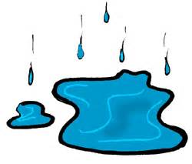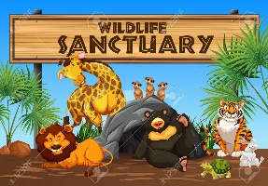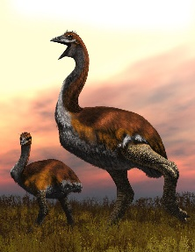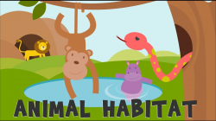

puddle sanctuary elephant bird habitat

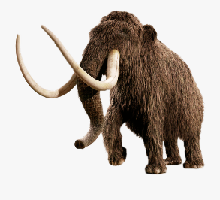 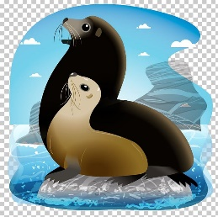 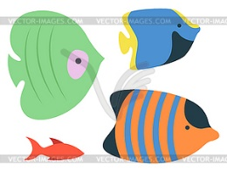 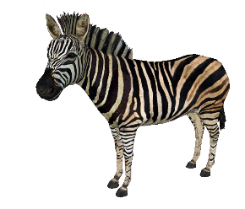

Woolly mammoth sea wolf species quagga

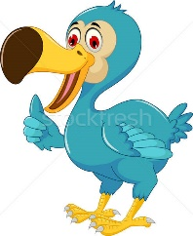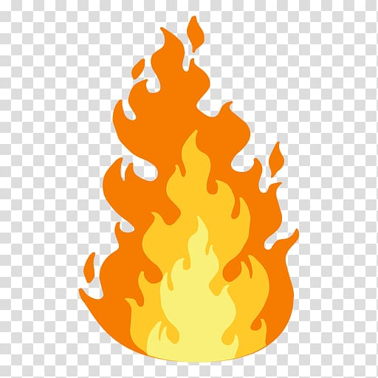 

Dodo fiery miserable sleepy endangered

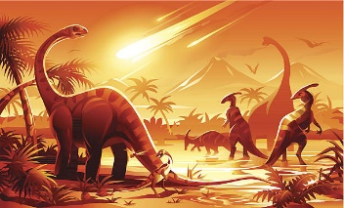 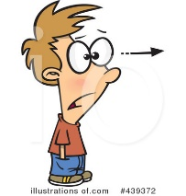 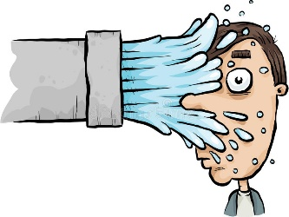

Extinct peer stumble emerge swish

  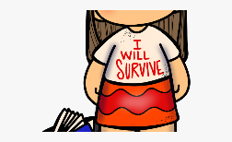

gush exploit survive

1. **Fill in the gaps with the correct words from the box.**

|  |
| --- |
| Peer_ Extinct_ Endangered _ Sleepy _ Miserable _ Fiery_ Specie_  Woolly mammoth_ Habitat_ Sanctuary_ Puddle. |

1. There was a puddle of water on the kitchen floor.
2. The park is the largest wildlife sanctuary in the US.
3. Some animals are in danger because their habitat is being destroyed.
4. Hunters were able to kill woolly mammoth and bears.
5. This specie of bird now exists only in Africa.
6. The sun was a fiery ball, low on the hills.
7. She’s miserable living on her own.
8. She had just awakened, her eyes were sleepy.
9. Mountain gorillas are an endangered specie.
10. I tried to peer in but it was getting too dark to see properly.
11. **Find the synonyms of the following words in the crossword and write them down.**

|  |  |  |  |  |  |  |  |  |  |  |  |
| --- | --- | --- | --- | --- | --- | --- | --- | --- | --- | --- | --- |
| v | e | c | l | i | v | e | e | g | f | i | n |
| a | w | d | u | s | e | p | p | e | a | r | y |
| s | t | a | r | e | k | u | t | l | b | n | m |
| s | f | u | n | d | e | a | d | o | n | a | d |
| g | r | u | n | h | a | p | p | y | o | r | h |
| r | a | w | c | h | o | m | e | n | g | e | n |
| e | c | g | a | r | e | s | e | r | v | e | c |
| t | p | o | o | l | l | u | t | i | o | n | v |

1. Survive ------------- 2. Exploit ------------------
2. Peer -------------- 4. Extinct -------------------
3. Miserable ----------- 6. Habitat ----------------
4. Sanctuary ----------- 8. Puddle ------------------

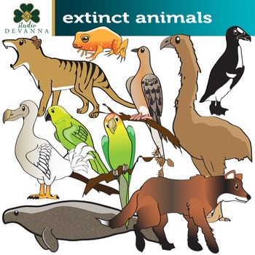

Coordinator’s Signature: ______________

Teacher: Mirna Nawaf Al-Sahawneh.