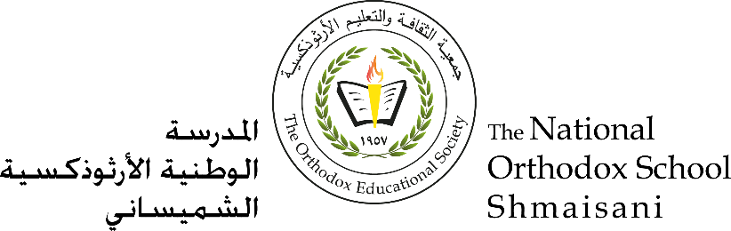

**Figurative Language**

**Study Sheet**

**Name: ____________  
Grade: 8 National**

**Figurative Language:** The opposite of literal language is figurative language. Figurative language is language that means more than what it says on the surface.

* It usually gives us a feeling about its subject.
* A writer’s tool
* It helps the reader to visualize (see) what the writer is thinking

It puts a picture in the reader’s mind

**What is figurative language?**

Whenever you describe something by comparing it with something else,   
you are using figurative language.

* **Types of Figurative Language: Simile**
* **Metaphor**
* **Personification**
* **Alliteration**
* **Assonance**
* **Consonance**
* **Repetition**
* **Onomatopoeia**
* **Hyperbole**
* **Imagery**
* **Idioms**



**Simile:** a direct comparison between two unlike things or a way of describing something by comparing it to something else, usually using the words “like” or “as” .

**Example:**

I am hungry **as** a horse.

You run **like** a rabbit.

**Metaphor:** A way of describing something by comparing it to something else; implied comparison between two unlike things.

**Example:** The road was a ribbon wrapped through the desert.

**Personification**: to give human characteristics to something that is not human (i.e., animals, objects, or ideas).

**Example:** The flowers **danced** in the wind

***Alliteration:*** repetition of the first consonant sound at the beginning of words

**Example:**

**P***eter* ***P****iper* ***p****icked a* ***p****ickled* ***p****epper.*

**Consonance:** When consonants repeat in the middle or end of words.

Vowels: *a*, *e*, *i*, *o*, *u*, and sometimes *y*.

Consonants: all other letters.

**Examples:**

**M**ammals na**m**ed Sa**m** are cla**mm**y.

**Repetition:** Repeating a word or words for effect.

**Example:**

Nobody

No, nobody

Can make it out here alone.

Alone, all alone

Nobody, but nobody

**Onomatopoeia:** When a word’s pronunciation imitates its sound.

**Examples**

Buzz Fizz Woof

Hiss Clink Boom

Beep Vroom Zip

**Hyperbole:** An exaggerated statement used to heighten effect. It is not used to mislead the reader, but to emphasize a point.

**Example**: She’s said so on several million occasions**.**

**Imagery:** Language that appeals to the senses. Descriptions of people or objects stated in terms of our senses.

• Sight

• Hearing

• Touch

• Taste

• Smell

**Idioms**: An idiom or idiomatic expression refers to a construction of words or expression different from the ordinary meaning of the words.

**The context can help you understand what an idiom means.**

**Example**: "She has a bee in her bonnet," meaning "she is obsessed," cannot be literally translated into another language word for word.

Rhythm: When **words are arranged in such a way that they make a pattern or beat.**

**Example**

There once was a man from Peru,

Who dreamed of eating his shoe?

He awoke with a fright,

In the middle of the night