I went to the supermarket. I bought a T-shirt……….

I went to the party last night. I didn’t enjoy myself.

I lost weight. I had been exercising hard.

I exercised hard. I became fit.

I was ill. I went to school.



Who



1. My father helped the man. He lives next door.



1. My father helped the man. I gave the man my sandwich.



1. The girl is now in hospital. She was injured in the accident.



1. The girl is now in hospital. I saved thegirl.

***************************************



1. I read the **book**. **It** is on the table.



1. I read the **book.** I bought **it** yesterday.



1. **The picture** was beautiful. She was looking at **it.**



1. **The picture** was beautiful. **It** was hanged above my head.



**\*\*\*\*\*\*\*\*\*\*\*\*\*\*\*\*\*\*\*\*\*\*\*\*\*\*\*\*\*\*\*\*\*\*\*\*\*\*\*\*\***

1.I know the man. I met him yesterday.

2. The man was away on a holiday. I wanted to see him.

3.Did I tell you about the man? I met him last night.

****************************************



1. I visited the company. I used to work there.



1. The hotel wasn’t very clean. We stayed there.

*************************************



1. I still remember the day**.** The day I saw you.

************************************

1. Farah is trying to get a job. Her children are at school.



1. I congratulated the man. His brother had won the lottery.



I congratulated the man whose brother had won the lottery.

1. My father helped Peter. He lives next door.



2. My father helped Peter. I gave him my sandwich.



My father helped Peter, who /whom I gave …..



1. Mary is now in hospital. She was injured in the accident.

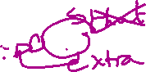

Mary, who was injured in the accident, is now ……

4. Mary is now in hospital. I saved the girl.

Mary, who/whom I saved, is now in hospital.



***************************************

1. I read Great Expectations. It is on the table.

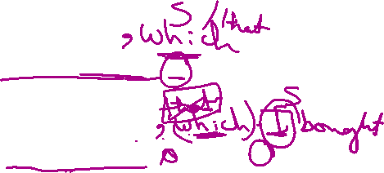

I read Great Expectations, which I bought yesterday.

1. I read Great Expectations. I borrowed it from a friend.



1. The Mona Lisa is beautiful. It was hanged above my head.



1. The Mona Lisa is beautiful. She was looking at it.

\*\*\*\*\*\*\***Defining relative clause**

1. (**Who /which**) Can be replaced by **that**.



1. Can leave out the pronouns (Who/which) when they function as objective pronouns.



1. **Can’t omit** the defining clause because it defines (gives necessary information).
2. **Commas** are not needed to enclose the defining clause.

\*\*\*\*\*\***Non-defining clause**

1. (**Who /which**) Can’t be replaced by that.



2. Can’t leave out the pronouns (Who/which) when they function as objective pronouns.

3. Can omit the non-defining clause because it gives unnecessary information EXTRA INFORMATION).



4. Commas are needed to enclose the non-defining clause.