**Using technology in the classroom**

*Young people love learning, but they like learning even more if they are presented with information in an interesting and challenging way. Today, I am going to give a talk about how you can use technology in* *Jordanian classrooms.*



***Here are some idea****s:*

*Many classrooms now use a whiteboard as a computer screen. As a consequence, teachers can show websites on the board in front of the class. Teachers can then use the Internet to show educational programmes, play* *educational games, music, recordings of languages, and so on.*

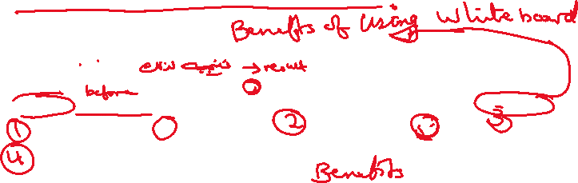

*In some countries, tablet computers are available for students to use in class. Therefore, students can use* *the tablets to do tasks such as showing photographs, researching information, recording interviews and creating diagrams.* ***Tablets are ideal for pair and group work.***



*Teachers can perhaps ask their students to start writing a blog (an online diary), either about their own lives or as if they were someone famous. They can also create* *a website for the classroom. Students can contribute to the website, so for example* ***they*** *can post work, photos and messages.*



*Most young people communicate through social* *media, by which they send each other photos and messages via the Internet. Some students like to send messages that are under 140 letters for anyone to read. Teachers can ask students to summarise information about what they have learnt in class in the same way. If* ***students learn to summarise quickly, they will be able to use this skill in future.***



*We all like to send emails, don’t we? Email exchanges are very useful in the classroom. Teachers can ask students to email what they have learnt to students of a similar age at another school****. They could even email students in another country****. As a result, students can then share information and help each other with tasks.*



*Another way of communicating with other schools is through talking to people over the computer. Most computers have cameras, so you can also see the people you are talking to. In this way, students who* *are studying English in Jordan can see what students in England are doing in the classroom while they are speaking to them. You can also use this system to invite guest speakers to give talks over a computer.* ***For example, scientists or teachers from another country could give a lesson to the class****. If you had this type of lesson, the students* *would be very excited.*



*Students often use computers at home if they have them. Students can use social media on their computers to help them with their studies, including asking other students to check and compare their work, asking questions and sharing ideas. The teacher must be part of the group, too, to monitor what is happening.*



*Thank you for listening. Does anyone have any questions?*