**What is an embedded clause?**

An embedded clause is essentially a [dependent clause](https://lemongrad.com/dependent-clause/) – noun, relative, or adverb – that is part of another clause.

-Most scientists believe that megalodon went extinct nearly two million years ago. [Noun clause]

-Megalodon, which was a giant version of modern-day great white shark, went extinct nearly two million years ago. [Relative clause]

-Most scientists believe that megalodon, which was a giant version of modern-day great white shark, went extinct nearly two million years ago. [Noun clause + Relative clause]

**Embedded clause is one of the two ways to expand a sentence**

Let’s take an example to understand how embedded clauses can expand a sentence.

- Megalodon went extinct nearly two million years ago.

* Megalodon, which was a giant version of modern-day great white shark, went extinct nearly two million years ago. [Embedded relative clause]
* Megalodon, which was a giant version of modern-day great white shark, went extinct nearly two million years ago because its prey base migrated to colder regions. [Embedded relative clause + Embedded adverb clause]

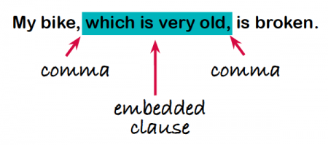

*Commas are usually (but not always) used to separate the clause that has been embedded from the main clause

. 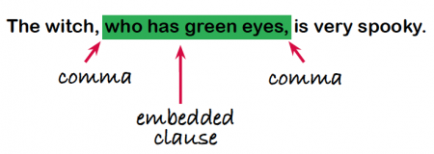  
If you removed the embedded clause the main clause would stand alone as a complete sentence. However, the embedded clause is reliant on the main clause so it does not make sense on its own (it's a [subordinate clause](https://www.theschoolrun.com/what-is-a-clause)).

**An embedded clause usually begins using the words which, who, with, that, whose or where and relates to the noun or pronoun in the main clause.   
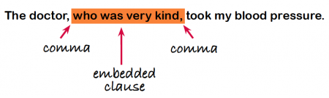  
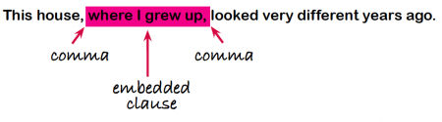

Who 🡪 people

Where 🡪 places

Which 🡪 things/objects/animals

When 🡪 time

That 🡪 instead of who or which

Whose 🡪 belongings and possessions

**Practice: Place brackets around each subordinate clause.**

1. Deta shook hands with her companion and stood still while Barbara

     approached the tiny, dark-brown mountain hut, which lay in a

     hollow a few steps away from the path.

2. I prophesy that you will learn it in a very short time, as a great many

     other children do that are like you and not like Peter.

3. The people in the village called to her now more than they had

     on her way up, because they all were wondering where she had

     left the child.

4. Clara was looking forward to this visit, and told Heidi so much

     about her dear grandmama that Heidi also began to call her by

     that name, to Miss Rottenmeier's disapproval, who thought that

     the child was not entitled to this intimacy.