**The National Orthodox School /Shmaisani**

**Subject: Science/ Physics Title: Motion**

**Name: Grade-Section: 9G (IB)**

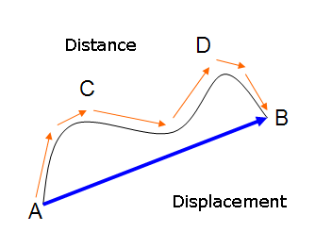

**Distance vs Displacement:**

In physics the **distance** traveled by a body moving from position A to position B is the length of the path from A to B.

On the other hand, **displacement** is the change in position of an object in a specified direction.

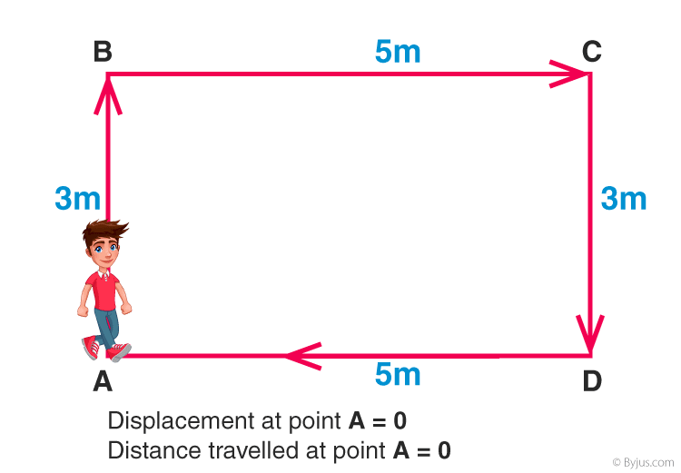If a person moves from A to D along the path ABCD, the distance covered by the person is 3 m + 5 m + 3 m =11 m. If the person continues moving towards A along DA, another 5 m will be added to the distance.

Whereas the displacement of the person all over the trip from A to D is 5 m which is nothing but the length of the line segment AD, joining the starting point of the journey with the end point.

Displacement is a vector with a tail at the starting point and head at the end point. The path is not taken into consideration; its only the starting point and the end point that count.

**Using a number line in one dimensional motion:**

When dealing with one dimensional motion (1D), it may be helpful to use a number line.

**Activities:**

1. Complete the following table, knowing that x1 and x2 are the initial and final positions of a moving particle:

|  |  |  |  |
| --- | --- | --- | --- |
|  | x1 (cm) | x2 (cm) | Δ x(cm) |
| 1 | + 2.0 | + 4.0 |  |
| 2 | + 4.0 | + 2.0 |  |
| 3 | - 2.0 | + 1.0 |  |
| 4 | - 6.0 | - 3.0 |  |
| 5 | + 2.0 | - 1.0 |  |

1. An ant moves along a stick. At time t0 the ant was observed at position x1=10.0 cm moving to position x2=25.0 cm at which it turned back and moved to point x3=-5.0 cm.
   1. Find the displacement of the ant in each phase.
   2. Find the net displacement.
   3. Find the total distance covered by the ant.
2. In each of the following questions, refer to the adjacent figure to find the distance and the displacement.
   1. A boy runs along the edge of the field from A to E to B.
   2. A boy runs along the edge of the field from A to B to E

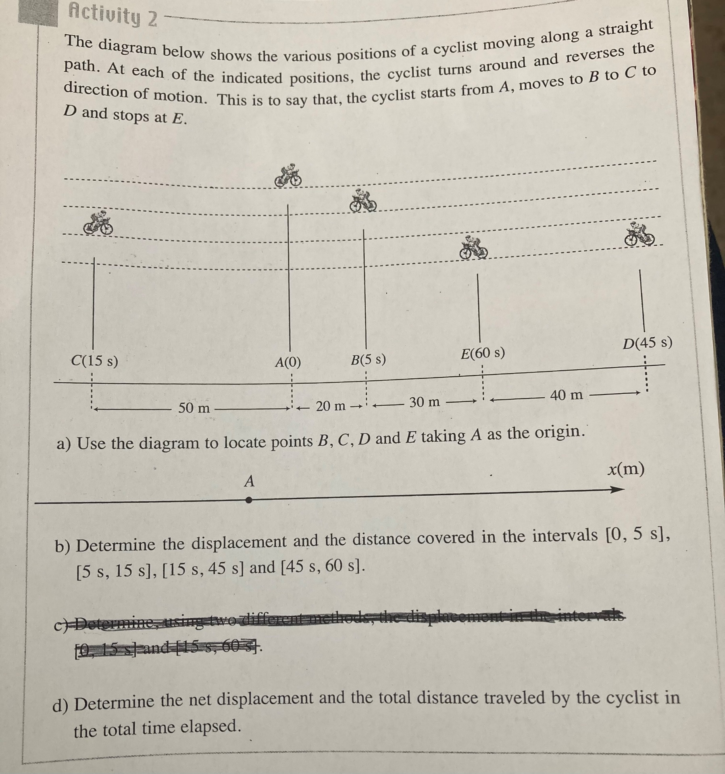**Homework 1:**

**Average Speed Vs Average Velocity:**

In everyday language, the terms “velocity” and “speed” are used interchangeably. In physics, there is a remarkable difference between the two terms; speed tells us how fast a body is moving, hence speed is simply a positive number, with units, while velocity gives us the speed and the direction in which the body is moving, so, velocity is a vector quantity.

Complete the following table:

|  |  |  |
| --- | --- | --- |
|  | Average Speed | Average Velocity |
| Definition |  |  |
| Symbol |  |  |
| Equation |  |  |
| SI Unit |  | |

**Activities:**

1. Back to the example of the ant, if x1, x2 and x3 correspond to t= 0, 5.0s, 11.0s respectively, find the average velocity and average speed in the intervals [0,5s], [5s,11s] and [0,11s].
2. In a flight from airport ‘Departure’ to airport ‘Arrival’, a jet airplane flies a distance of 4800 km. The flight is scheduled to be a 12-hour long flight. What is the average speed of such a trip?
3. Use the given of the previous homework to determine the average velocity and average speed in the intervals [0,5s], [5s,15s], [15s,45s], [45s,60s] and [0s,60s].

**Instantaneous Speed Vs Instantaneous Velocity**

Suppose that in a race the average speed of a car is 40m/s. The information that we may retrieve from this figure is not of remarkable importance; this may help to compare for example the average speed of that car with its competitors. Average speed does not tell us how fast was the car moving past a point at a specific instant; of course, the speedometer of the car was continuously changing during the race showing higher values than the 40m/s at some moments and dropping to much lower values at others. During the race, the passenger was able to photograph the speedometer at three different moments and got shots showing 60m/s, 40m/s, and 30m/s; each one of these values represents the instantaneous speed of the car at the instant the shot was taken.

Speed or instantaneous speed, tells us how fast a body is moving at a specific moment, in a car, the reading of the speedometer at any instant t tells the speed of the car at t. The speed of a body together with the direction of motion constitute the velocity of the body. Two bodies moving at the same speed but in opposite directions have opposite velocities. For instantaneous speed, we use the symbol s, whereas for instantaneous velocity we use the symbol *v*; moreover, when we say speed or velocity we mean instantaneous speed and instantaneous velocity respectively.

**Activities:**

1. You drive 120km along a straight road in one direction for 2.0h, then in the opposite direction back to the starting point in another 3.0h.
   1. What is your average speed?
   2. What is your average velocity?
   3. It is unlikely, even impossible that you were driving 48km/h all the time. Think of some instants where the speed is much less than that value.
   4. When is the speed necessarily zero?
   5. The speedometer should show speeds higher than 48km/h at some moments. Do you agree? Justify.
2. Why are speedometers not called velocimeters?
3. A particle P moves along a directed straight line. At t1 = 3.0s the particle is at a point of position x1 = 8.0m at time t2=8.0s the particle is at position x2= -2.0m and at time t3 =12s the particle is at a position x3= 2.0m.
   1. Find the average speed of P.
   2. Find the average velocity of P.
   3. Explain why the answers of parts (a) and (b) are not the same.