**Coordinating Conjunctions:**

A coordinating conjunction connects two independent clauses together to form a compound sentence.

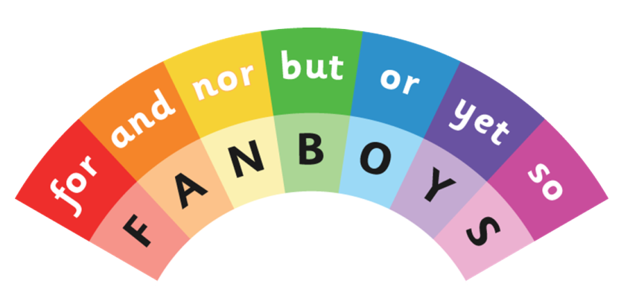

**Subordinating Conjunctions:**

A subordinating conjunction connects an independent clause to a dependent clause.

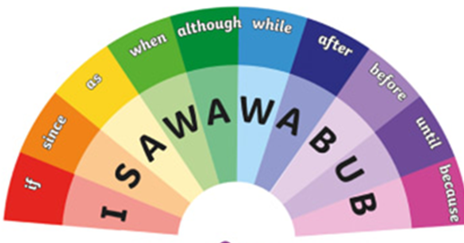

**Sentence Types:**

**Simple, Compound, Complex, and Compound-Complex**

# Simple Sentences

* A simple sentence contains a subject and a verb.
* It expresses a single complete thought that can stand on its own.

**Examples:**

* 1. The baby cried for food.

^There is a subject and a verb that expresses a complete thought.

* 1. Miss Rawan’s intelligent students completed and turned in their homework.

^ A simple sentence does not necessarily have to be short. It can have adjectives. In this case, there are two verbs “completed” and “turned in.” However, the sentence expresses one complete thought and therefore is a simple sentence.

* 1. Michael and Fares ate too much and felt sick.

^Although there are two subjects and two verbs, it is still a simple sentence because both verbs share the same subjects and express one complete thought.

# Compound Sentences

* A compound sentence has two independent clauses. An independent clause is a part of a sentence that can stand alone because it contains a subject and a verb and expresses a complete thought.
* Basically, a compound contains two (or more) simple sentences.
* These independent clauses are joined by a conjunction (for, and, nor, but, or, yet, so).

**Examples:**

* 1. The shoplifter had stolen clothes, **so** he ran once he saw the police.

^Both sides of the conjunction “so” are complete sentences. “The shoplifter had stolen clothes” can stand alone and so can “he ran once he saw the police.” Therefore, this is a compound sentence.

* 1. They spoke to him in Spanish, **but** he responded in English.

^This is also a compound sentence that uses a conjunction to separate two individual clauses.

# Complex Sentences

* A complex sentence is an independent clause joined by one or more dependent clauses. A dependent clause either lacks a subject or a verb or has both a subject and a verb that does not express a complete thought.
* A complex sentence always has a subordinator (as, because, since, after, although, when) or relative pronouns (who, that, which).

**Examples:**

* 1. **After** eating lunch at The Cheesecake Factory, Sami went to the gym to exercise.

^ The independent clause is ‘Tim went to the gym to exercise.” The subordinating clause before it is dependent on the main, independent clause. If one were to say “after eating lunch at The Cheesecake Factory,” it would be an incomplete thought.

* 1. The woman **who** taught Art History was fired for stealing school supplies.

^ The dependent clause in this sentence is “who taught Art History 210” because if removed, the rest of the sentence would stand as an independent clause. “Who taught Art History” is an adjective clause that provides necessary details about the subject, woman.

**Practice 1**

**Directions: Read each sentence and decide whether it is simple, compound, or complex. Then underline the independent clause and circle the dependent clause(s) in each sentence.**

|  |
| --- |
| 1. Since his mom often had to work late at her new job, James started taking on more of the household chores. _____________________________ |
| 1. The magnificent African lion surveyed his expansive grassland domain from atop his high, rocky perch. _____________________________ |
| 1. No one else had arrived at the park yet, so Kayla sat outside the gate to wait. _____________________________ |
| 1. Although the interpreter speaks English with a British accent, his native language is actually Italian. _____________________________ |
| 1. The dog looked straight into the photographer’s camera.   _____________________________ |
| 1. If you get the chance, you should hike to the top of Mission Peak.   ______________________________ |
| 1. Steph walks to school in the mornings, but she rides the bus on her way home. _____________________________ |
| 1. Until more drivers are hired, the bakery can only deliver cupcakes and cookies until 10 p.m. _____________________________ |

**Practice 2**

**Directions: Read each sentence and decide whether it is simple, compound, or complex. Then underline the independent clause and circle the dependent clause(s) in each sentence.**

|  |
| --- |
| 1. The group explores innovative ways to handle the volume and variety of plastics used in the community. _____________________________ |
| 1. The sky filled with clouds, and raindrops scattered across the fields.   _____________________________ |
| 1. When the particles in a solid have more thermal energy, they vibrate more quickly. _____________________________ |
| 1. You can go play basketball since you completed your project.   **______________________________** |
| 1. As soon as the generator turned on, a loud hum filled every corner of the room. _____________________________ |
| 1. The scientists were on a research expedition in frigid coastal waters when they observed the pod of whales. ______________________________ |
| 1. Humans are the only animals known to blush. ______________________ |
| 1. During the board meeting, the superintendent will consider input from the public about a ban on cell phones in the classroom. ___________________ |

**Practice 3**

**Directions: Identify the parts of the sentence on the chart.**

|  |  |  |  |
| --- | --- | --- | --- |
| **SENTENCE** | **DEPENDENT**  **CLAUSE** | **INDEPENDENT**  **CLAUSE** | **SUBORDINATING**  **CONJUNCTION** |
| 1. After we raced  to the beach, we discovered our raft was missing. |  |  |  |
| 2. Miguel disagreed until I showed him the map. |  |  |  |
| 3. Aseel caught some fish while I worked on the boat. |  |  |  |
| 4. When I started to lead the group, everyone was suspicious. |  |  |  |

**Practice 4**

**Directions: Find a book you have read recently – can you spot some simple sentences, compound sentences and complex sentences in it? Copy the sentences you find into the table below. Try and find at least two of each sentence type.**

**Book Title:** ______________________________________________________________

**Author:** _________________________________________________________________

|  |
| --- |
| Simple Sentences: |
| Compound Sentences: |
| Complex Sentences: |

**Top Tip!**

Remind yourself of the subordinating conjunctions and relative pronouns you have learned. Scan the page for words like these to help you find interesting sentences.