** Vocabulary _ Unit 1**

**(The Earthworm and the Spider) worksheet no. ( 7 )**

**Name ………………… Grade (6)**

|  |
| --- |
| **Objectives**  **1. Identify the meaning of new words.**  **2. Identify the synonyms of the words.**  **3. Practice using the new words in sentences.** |

**Verbs**

|  |  |  |
| --- | --- | --- |
| **Word** | **Synonym** | **Meaning** |
| Wriggle | Twist | To turn with quick writhing movement.  **Example**: He was able to escape because he **wriggled** through the tunnel. |
| Insist | Say firmly | To demand something forcefully.  **Example**: My neighbor **insisted** to have me for dinner in his house. |
| Admire | Adore | To love and appreciate.  **Example**: I **admire** my parent’s patience. |
| Labor | Work hard | **Example**: We **labored** all day in the field. |
| Discourage | Persuade against | To persuade someone against an action.  **Example**: His reaction **discouraged** me. |
| Depart | Leave | To move away from one place to another.  **Example**: The train will **depart** from platform 9. |

**Adjectives**

|  |  |  |
| --- | --- | --- |
| **Word** | **Synonym** | **Meaning** |
| Isolated | Remote | Far away from other places, buildings or people.  **Example**: He was **isolated** from all the other prisoners. |
| Hazardous | Risky | Dangerous.  **Example**: Talking to strangers is **hazardous**. |
| Skeptical | Doubting | Having doubts or reservations.  **Example**: The patient was **skeptical** about the result of his checkup. |
| Suspicious | Unsure | Doubtful.  **Example**: They were **suspicious** about the strange man so the called the police. |
| Exquisite | Very beautiful | **Example**: I found **exquisite** jewelry in the store. |

**Nouns**

|  |  |  |
| --- | --- | --- |
| **Word** | **Synonym** | **Meaning** |
| Strand | Shoreline | The shore of a large river.  **Example**: I found a shell on the **strand**. |
| Sapphire | A precious stone | A precious stone typically blue.  **Example**: **Sapphire** is expensive because it’s hard to find. |

1. **Write the synonym of each of these words**:
2. isolated ______________
3. Hazardous ____________
4. Wriggle ____________
5. Skeptical _________________
6. Insist _________________
7. Admire _______________
8. Labor _______________
9. Strand ______________
10. Discourage _____________
11. Sapphire ______________
12. Suspicious ______________
13. Exquisite _____________
14. Depart ______________

1. **Write the correct word under each picture.**

|  |
| --- |
| Isolated _ Hazardous _ Wriggle _ Skeptical _ Admire _ Labor _ Strand  Discourage _ Depart _ Suspicious _ Sapphire |

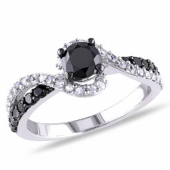   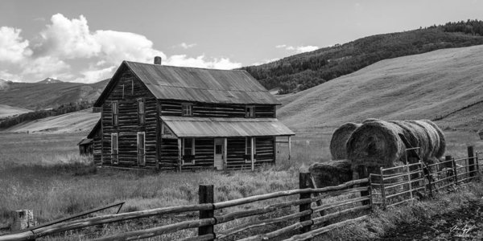

________________ _________________ _________________ ______________________

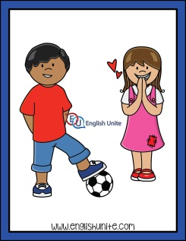 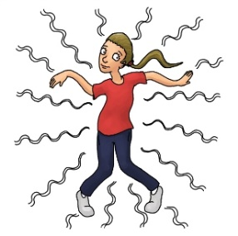 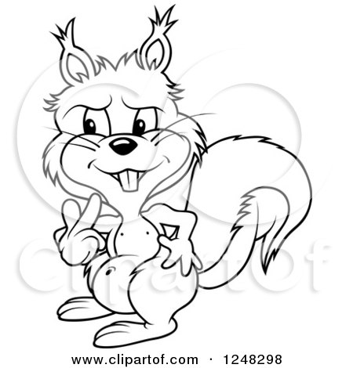 

_______________ _________________ _________________ _______________

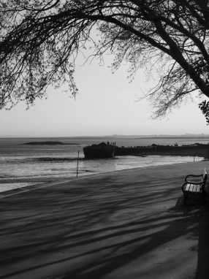 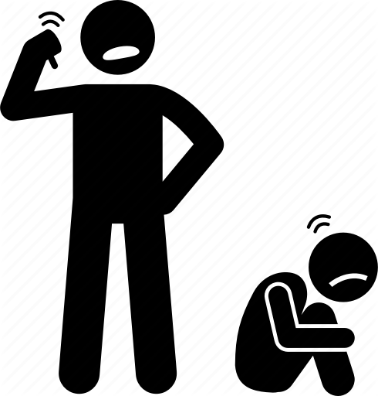 

_________________ ___________________ ________________

1. **Fill in the gaps with the correct words from the box.**

|  |
| --- |
| Isolated _ Hazardous _ Wriggle _ Skeptical _ Admire _ Labor _ Strand  Discourage _ Depart _ Suspicious _ Sapphire_ insist _ exquisite |

1. The manager forced the worker to __________ really hard.
2. He is a kind man. We all ___________ him.
3. Stay and have lunch. I ________!
4. They were __________ about how much the house cost.
5. The snake ___________ to get out of the mud.
6. Garden tools can be ____________ if you use them carelessly.
7. The castle is ___________ from the other buildings.
8. Flights for Amman ____________ from terminal 3.
9. Her wedding dress was ____________.

10.The boat was sailing towards the ____________ of the river.

11. Don’t ________________ her! She’s doing her best.

12.She had the ________________ set on a gold ring.

13.I’m _______________ about my little brother’s friend.

1. **Find the synonyms of the following words in the crossword and write them down.**

|  |  |  |  |  |  |  |  |  |  |  |  |  |  |  |  |
| --- | --- | --- | --- | --- | --- | --- | --- | --- | --- | --- | --- | --- | --- | --- | --- |
| s | u | s | p | i | c | i | o | u | s | r | s | u | i | o | s |
| q | s | d | i | c | s | f | s | r | i | c | u | o | u | s | t |
| c | a | e | s | t | a | r | e | h | b | n | e | d | l | e | r |
| s | p | p | o | i | s | k | e | p | t | i | c | a | l | x | a |
| t | p | a | l | t | h | a | z | a | r | d | o | u | s | q | n |
| r | h | r | a | p | f | p | d | s | h | a | i | e | c | u | d |
| e | i | t | t | o | c | o | p | x | i | f | c | k | e | i | e |
| a | r | h | e | b | p | p | j | o | k | e | a | x | z | s | n |
| d | e | i | d | r | s | w | r | i | g | g | l | e | e | i | t |
| m | s | r | i | p | r | s | f | g | l | a | b | o | r | t | u |
| i | e | e | t | y | d | i | s | c | o | u | r | a | g | e | m |
| r | o | t | v | h | e | a | d | g | q | p | d | h | u | h | g |
| e | q | u | d | o | h | f | m | i | n | s | i | s | t | x | z |

Remote_________ Risky ___________ Twist____________ Doubting_________ Say firmly ________ Adore __________

Work hard ________ Shoreline ________ Unsure _________

Beautiful _________ Leave __________

Persuade against__________

A precious stone __________