** Vocabulary _ Unit 1**

Value: A loving heart is the truest wisdom.

**No (2)**

**(Dreaming of Dodos)**

**Name………………… Grade (5)**

|  |
| --- |
| **Objectives**  **1. Identify the meaning of new words.**  **2. Identify the synonyms of the words.**  **3. Practice using the new words in sentences.** |

**Verbs**

|  |  |  |
| --- | --- | --- |
| **Word** | **Meaning /Synonym** | **Example** |
| Survive | To continue to **live** or exist, especially in spite of danger. | If the industry doesn’t modernize, it will not survive. |
| Exploit | To make full **use** of and derive benefit from. | We must exploit every opportunity to learn new things. |
| Swish | To **move** with a hissing or rushing sound. | The horse’s tail swished back and forth. |
| Gush | To flow out of something in a rapid and plentiful stream/**burst.** | I wish Mummy wouldn’t gush over Peter’s little success at school, it makes him feel a fool in front of his friends. |
| Emerge | To **stand out** | Several facts started to emerge from my investigation. |
| Stumble | To **trip.** | Be careful! Don’t stumble over these stones. |
| Peer | To **stare.** | He peered from behind the tree. |

**Adjectives**

|  |  |  |
| --- | --- | --- |
| **Word** | **Meaning /Synonym** | **Example** |
| Extinct | Having no living members. **Dead**/vanished | It is 250 years since the wolf became extinct in Britain. |
| Endangered | Seriously **at risk** of extinction. | Pandas are endangered species. |
| Sleepy | Needing or ready for sleep. /**Dozy**. | The soft background music made her feel sleepy. |
| Miserable | **Unhappy** or uncomfortable. | We were cold, wet and thoroughly miserable. |
| Fiery | **Bright red, like fire.** | The sun was now sinking, a fiery ball of light in the west. |

**Nouns**

|  |  |  |
| --- | --- | --- |
| **Word** | **Meaning /Synonym** | **Example** |
| Dodo | **A large extinct flightless bird.** | It’s difficult to find dodo birds these days. |
| Quagga | **A South African extinct zebra.** | The quagga was a beautiful variant of the zebra. |
| Species | A group of living organisms. /**kind** | That specie disappeared in the Ice Age. |
| Sea wolf | **Wolf fish.** | I read a book about sea wolves. |
| Woolly mammoth | A cousin of today's Asian elephant. | The woolly mammoth became extinct at the end of the last Ice Age some 11.000 years ago. |
| Habitat | The natural **home** of an animal or plant. | This creature’s natural habitat is the jungle. |
| Elephant birds | A huge, extinct, flightless birds. | Elephant birds died out hundreds of years ago. |
| Sanctuary | A nature **reserve**. | This island is maintained as a sanctuary for endangered species. |
| Puddle | A small **pool** of liquid, especially of rainwater on the ground. | The puddle evaporated rapidly in the sun. |

1. **Write the synonym of each of these words**:
2. Survive -----------------
3. Exploit ------------------
4. Swish ----------------
5. Gush ---------------
6. Emerge ---------------
7. Stumble ---------------
8. Peer -------------
9. Extinct -----------------
10. Endangered ----------------
11. Miserable ----------------
12. Fiery -----------------
13. Species ----------------
14. Habitat ----------------
15. Sanctuary --------------
16. Puddle ------------------
17. **Write the correct word under each picture.**

|  |
| --- |
| Survive _ Exploit _ Swish _ Gush _ Emerge _ Stumble _ Peer_ Extinct_  Endangered _ Sleepy _ Miserable _ Fiery_ Dodo_ Quagga_ Species_  Sea wolf_ Woolly mammoth_ Habitat_ Elephant bird_ Sanctuary_ Puddle |

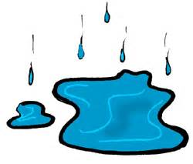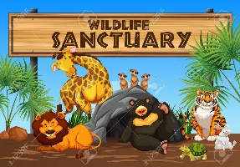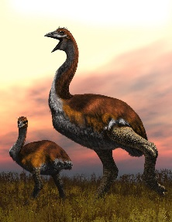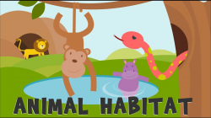

------------ ----------------- ----------- -----------------

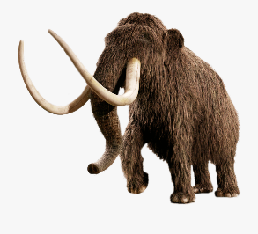 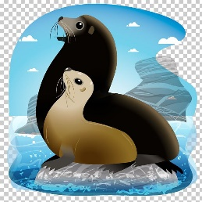 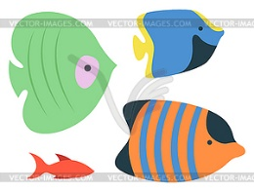 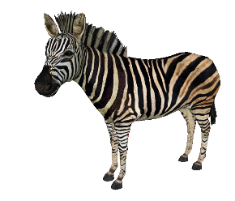

--------------- -------------- --------------- ----------------

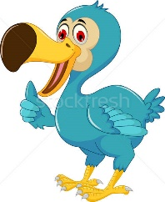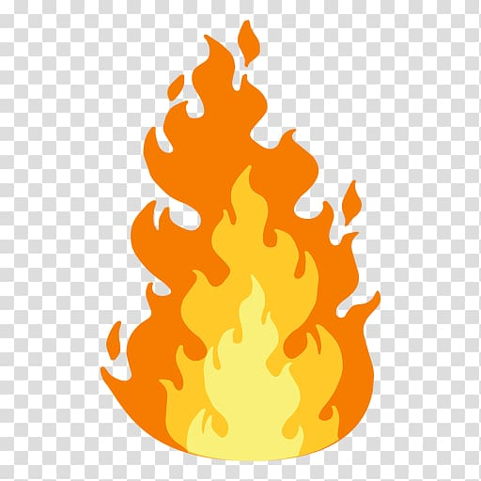 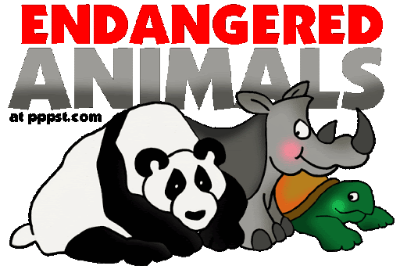

------------- ------------- -------------- ------------- -----------------

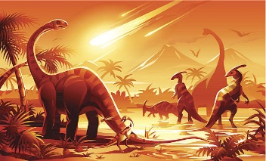 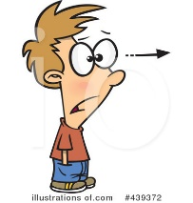 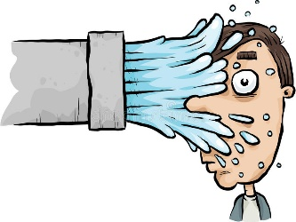

-------------- -------------- -------------- -------------- --------------

  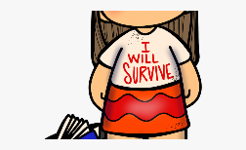

---------------------- ------------------------ ----------------------------

1. **Fill in the gaps with the correct words from the box.**

|  |
| --- |
| Peer_ Endangered _ Sleepy _ Miserable _ Fiery_ Specie_  Woolly mammoth_ Habitat_ Sanctuary_ Puddle. |

1. There was a ------------------ of water on the kitchen floor.
2. The park is the largest wildlife -------------------- in the US.
3. Some animals are in danger because their -------------- is being destroyed.
4. Hunters were able to kill ---------------------- and bears.
5. This -------------- of bird now exists only in Africa.
6. The sun was a -------------- ball, low on the hills.
7. She's ------------------ living on her own.
8. She had just awakened, her eyes were ------------------.
9. Mountain gorillas are an ------------------specie.
10. I tried to ----------- in but it was getting too dark to see properly.
11. **Find the synonyms of the following words in the crossword and write them down.**

|  |  |  |  |  |  |  |  |  |  |  |  |
| --- | --- | --- | --- | --- | --- | --- | --- | --- | --- | --- | --- |
| v | e | c | l | i | v | e | e | g | f | i | n |
| a | w | d | u | s | e | p | p | e | a | r | y |
| s | t | a | r | e | k | u | t | l | b | n | m |
| s | f | u | n | d | e | a | d | o | n | a | d |
| g | r | u | n | h | a | p | p | y | o | r | h |
| r | a | w | c | h | o | m | e | n | g | e | n |
| e | c | g | a | r | e | s | e | r | v | e | c |
| t | p | o | o | l | l | u | t | i | o | n | v |

1. Survive ------------- 2. Exploit ------------------
2. Peer -------------- 4. Extinct -------------------
3. Miserable ----------- 6. Habitat ----------------
4. Sanctuary ----------- 8. Puddle ------------------

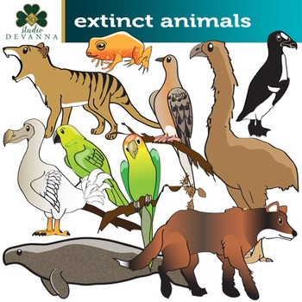

Coordinator’s Signature: ______________

Teacher: Mirna Nawaf Al-Sahawneh.