

**Scratch**

**Introduction**

**Download Scratch online**

Use the following URL - https://scratch.mit.edu/download

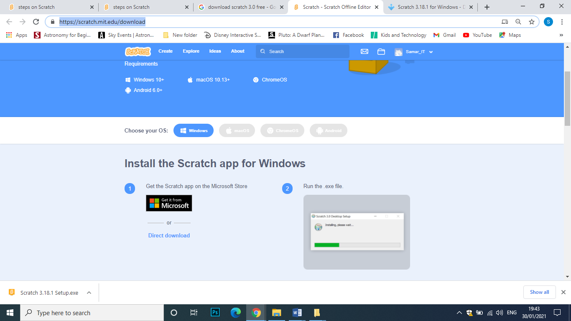

**Click to download Scratch 3**

Go to Downloads Folder and double click the scratch.exe file to install scratch.

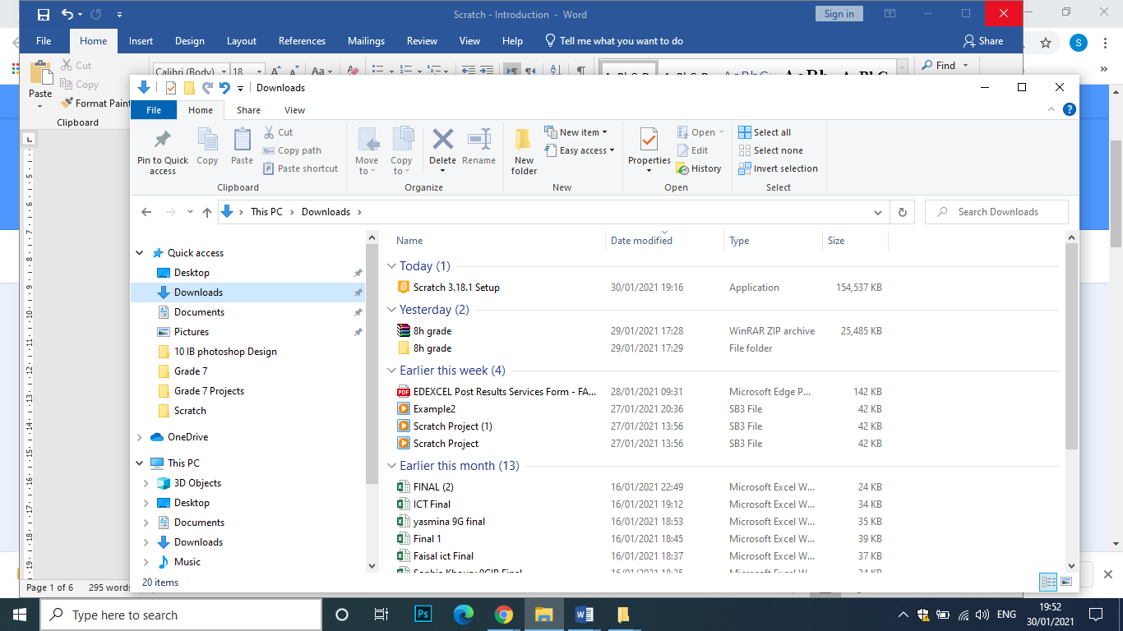

**Click to install Scratch 3**

If you can’t download the app you can create an account online, as explained below.

**Create an account online**

1. Use the google chrome browser open the URL: <https://scratch.mit.edu>.
2. The following screen will appear, select **Join scratch** to create an account,

Notice that when you create an account you will be able to save your projects.

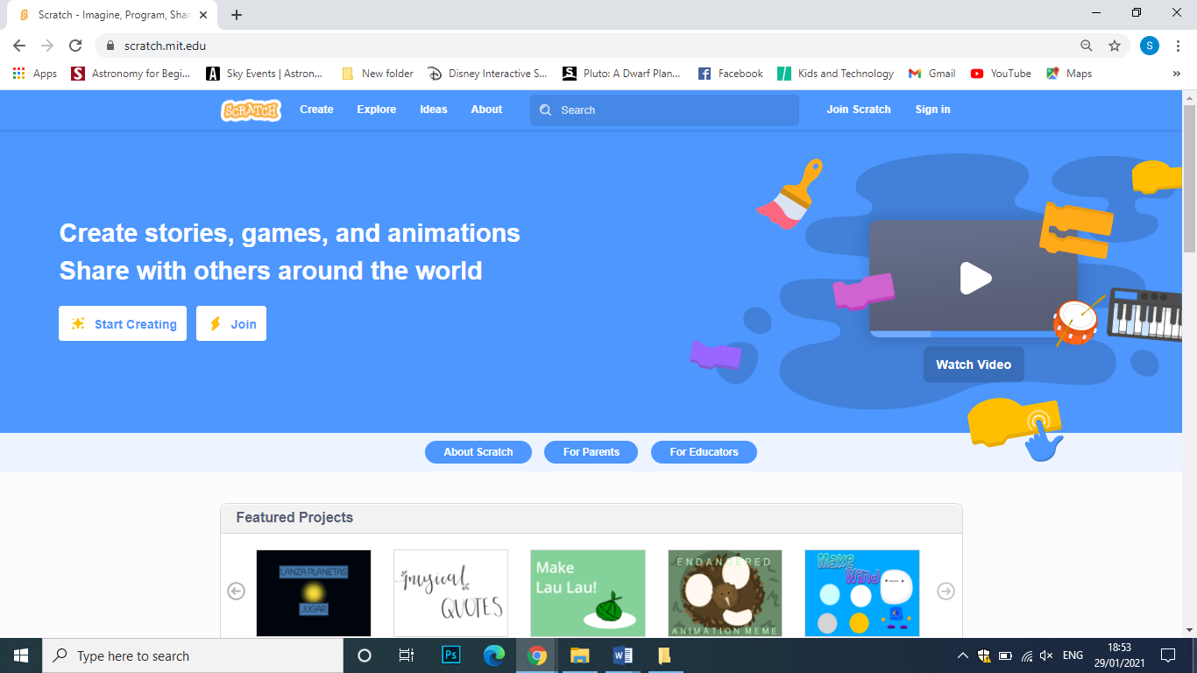

1. Select join Scratch

Type a User Name and a Password in the screen that will appear :

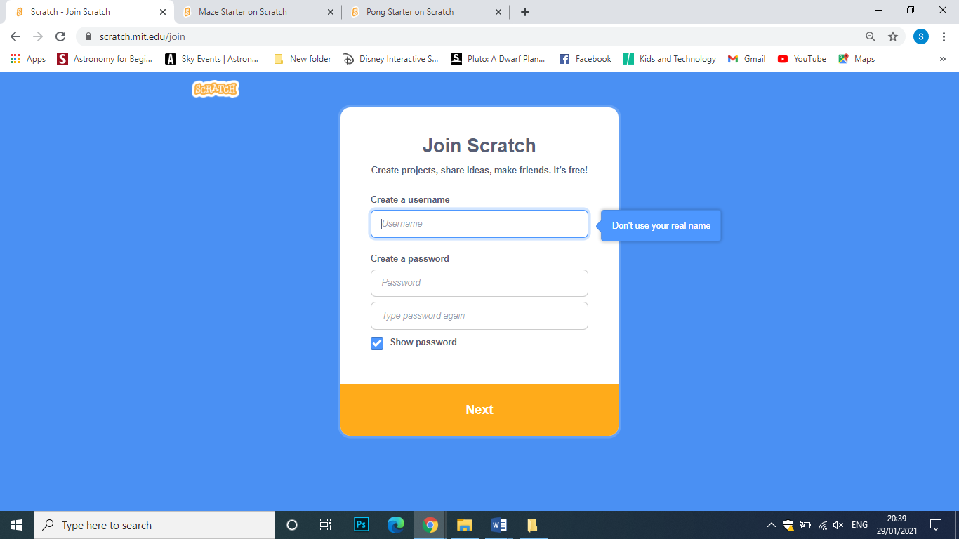

1. Input the following information:

|  |  |
| --- | --- |
|  |  |
| **Your country** | **Date of Birth (Month / Year )** |

1. Input your email (you can use your school email)

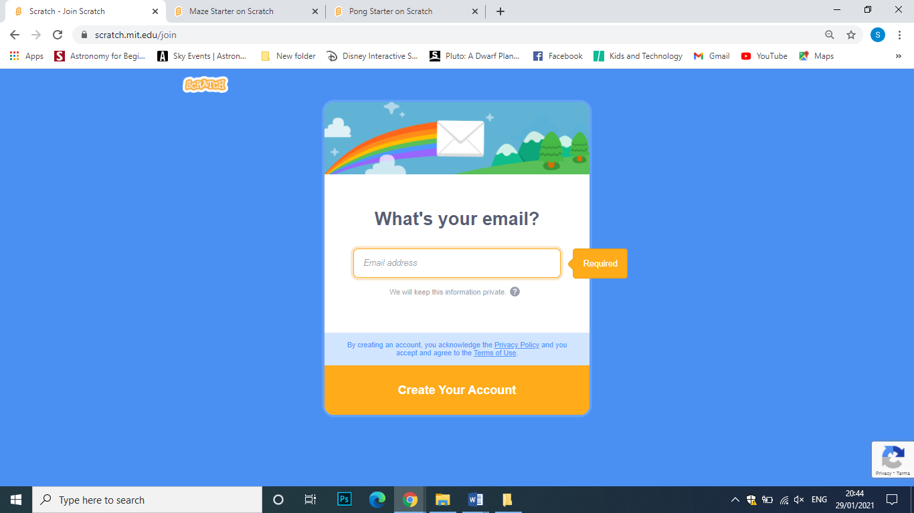

1. To start working press create in the following screen:

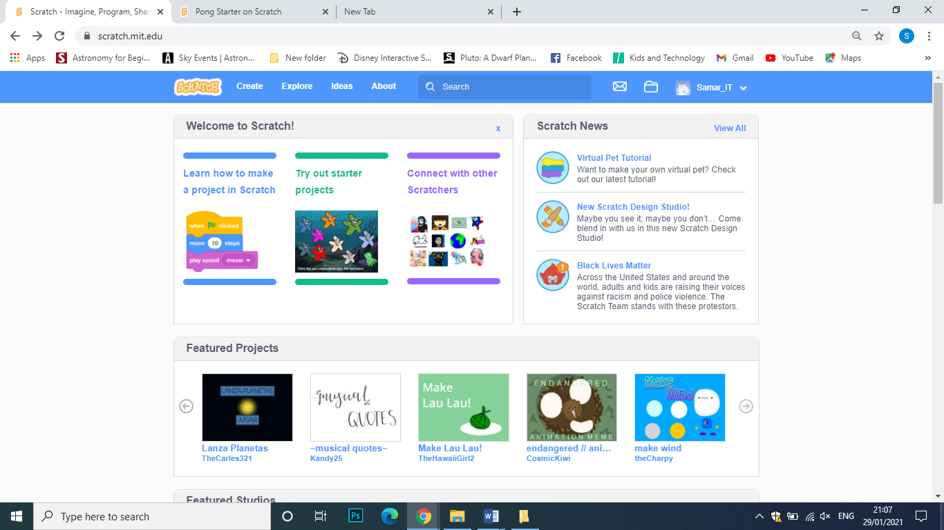

**Scratch (3) user Interface**

1. Scratch interface includes the parts that appears in the image below:-

**Menus**

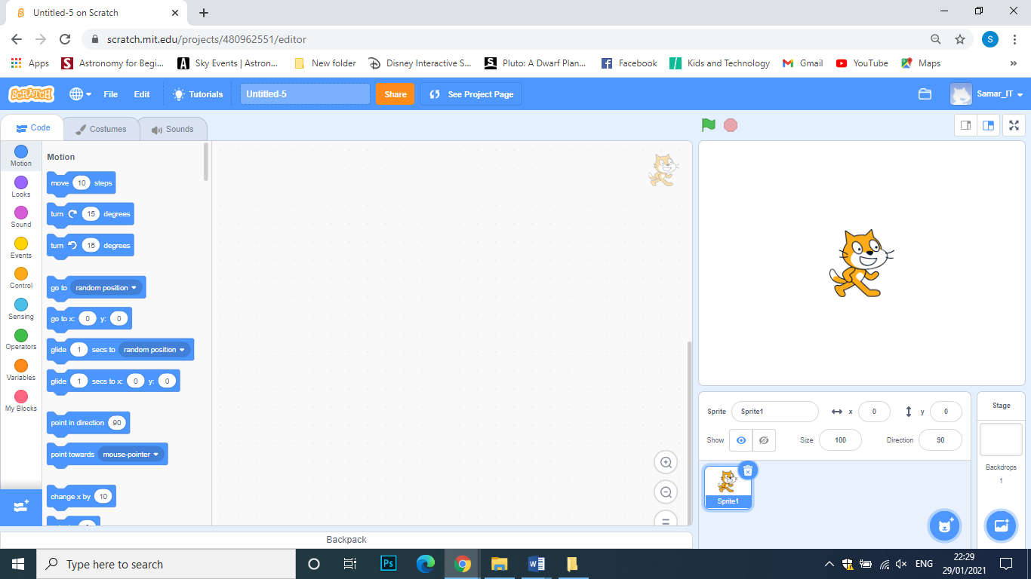

**Sprite**

**Stage**

**Script area**

**Blocks Pallets**

1. Edit the project background

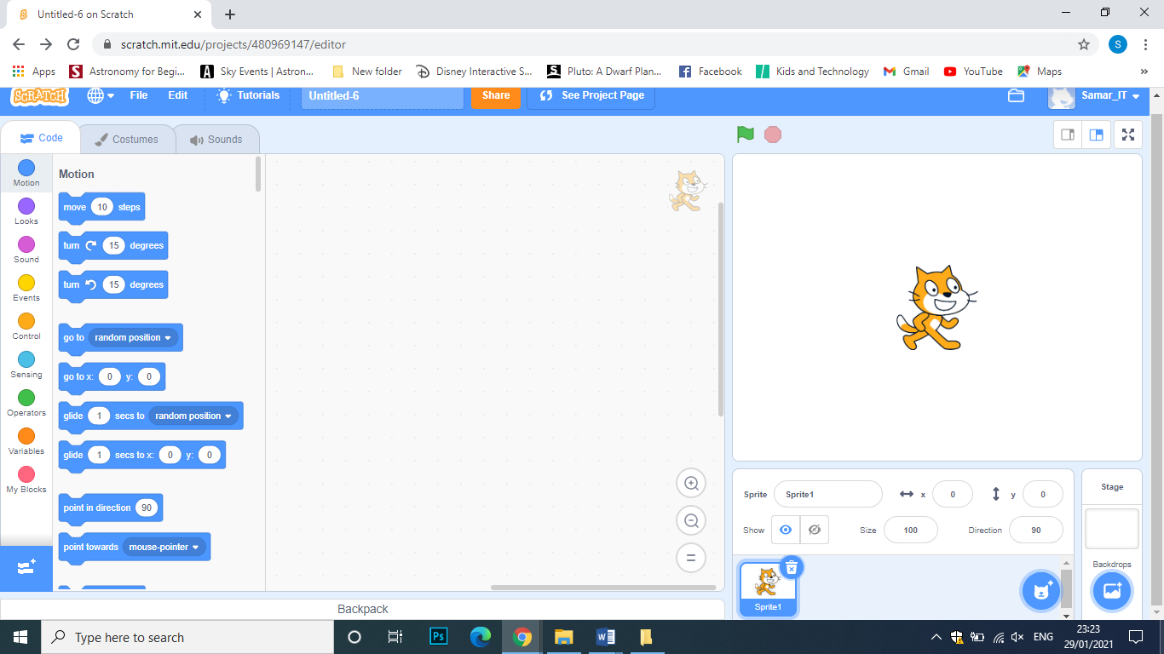

**Click to display the**

**Background tab**

**Click to select a background**

1. 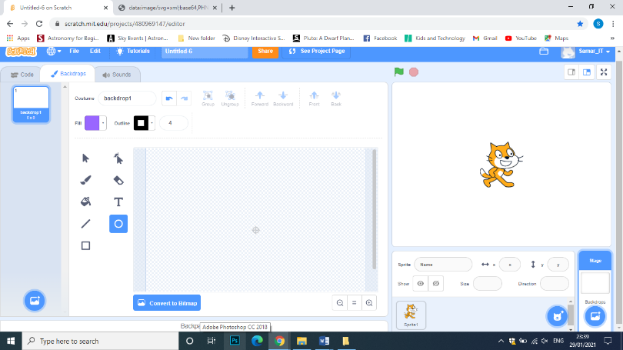Click the Background Tab to draw and edit your project background.
2. Add another sprite

**Sprite Direction**

**P**

**Sprite Size**

**P**

**Sprite Position**

**P**



**Click to Add a sprite**

**Click to Delete a sprite**

**Blocks Pallets**

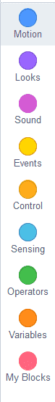Block categories have provided a user-friendly way of sorting blocks ever since the release of Scratch. Blocks are categorized based on their functionality, and blocks within the same category share the same colour. The separation of colour among categories can allow better distinction of the parts of a project, as well as increase the ease of access. The following are the block categories as of Scratch 3.0.. **[1]**

1. Motion
2. Looks
3. Sound
4. Events
5. Control
6. Sensing
7. Operators
8. Variables
9. My Blocks
10. Click  to add blocks like: Pen and Music.

1. https://en.scratch-wiki.info/wiki/Block_Categories