**Assignment 3 |** Lower Secondary

Stage (6-8)

1st Semester | 2023-2024

|  |  |
| --- | --- |
| **Subject:** ICT | **Chapter:** 3 |
| **Objectives: Identify: Input, process and output - Write a python program.** | |

Write a python program to calculate the area and the perimeter of a quadrilateral shape:

* Add a note (#) to clarify why you are creating this program.
* Add a note (#) to add your name.
* Input the shape Length (L)
* Input the shape Width (W)
* Calculate the area: Area=L*W
* Calculate the Perimeter: Per=2*(L+W)
* Print Area
* Print Perimeter
* Check if the length equals the width:

If L=W then print [square] else print [rectangle].

Use Python to type the program and then write the program in the box below:

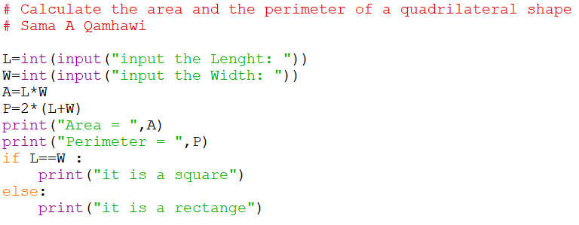

Save your file and upload it on LMS.

Save the Python file and upload it on LMS.